Project Title: Habitat enhancement for American Oystercatchers in Tampa Bay
Project location: Two large dredge material islands located in Hillsborough Bay, south of Tampa and east of the Tampa Shipping Channel, Hillsborough County, FL
Project partners (and their respective roles):
Tampa Port Authority owns and operates Hillsborough Bay Island 2D.
US Army Corps of Engineers operates Hillsborough Bay Island 3D.
Audubon Florida’s Coastal Islands Sanctuaries works with the Tampa Port Authority and the US Army Corps of Engineers through the Migratory Bird Protection Committee to protect the birds that nest on both islands.
Project Description
- Executive summary
The Hillsborough Bay Islands 2D and 3D are large (approximately 600 acres and 450 acres, respectively) dredge material deposition islands located to the east of the main shipping channel for the Tampa Port in Hillsborough Bay south of Tampa, FL. This project would install linear oyster-reef breakwaters on portions of the north and south ends along the east side of Island 2D and the eastern shoreline of Island 3D to provide foraging habitat for American Oystercatchers. The breakwater would also reduce erosion impacts, mainly from recreational boaters in the bay but also ship wakes and storm waves. The breakwater structures are composed of arrays of hollow reefballs, formulated of pH-neutral concrete designed to promote oyster attachment and to intercept waves and boat wake energy. The oyster-reef breakwater structures would be installed near to the shore in the water, parallel to the islands’ shorelines. The breakwater would allow adult oystercatchers to remain on their territories while foraging on the breakwater structures for oysters and the invertebrate animals that live on oyster reefs and provide supplemental invertebrate food for the young oystercatcher chicks to glean themselves, increasing their survival.

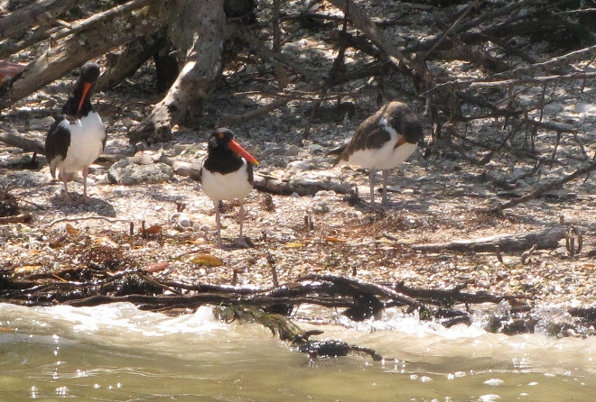 | 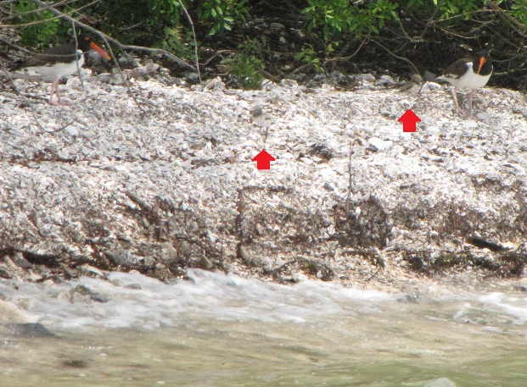
American Oystercatcher pair and large chick, Hillsborough Bay Island 2D. | American Oystercatcher pair and two small chicks, Hillsborough Bay Island 2D. Photo: Rob Heath
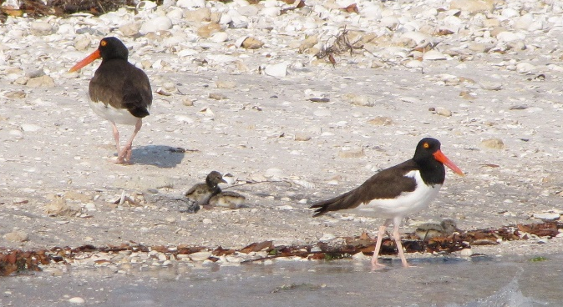 | 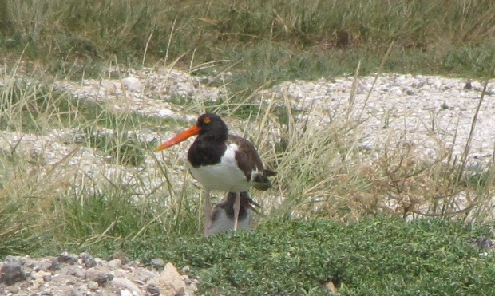
American Oystercathcer pair and three small chicks, Hillsborough Bay Island 2D. Photo: Mark Rachal | American Oystercatcher adult shading a medium-sized downy chick. Photo: Mark Rachal

- Introduction/background information
  - Description of area
The Hillsborough Bay Islands 2D and 3D are large dredge-disposal islands created by the Tampa Port Authority in the 1980s to receive the dredged material removed from the berths and channels to support shipping traffic at the Port. The islands’ substrate includes sand and limestone rock forming the shoreline and the dikes; inside the containing dikes are plateaus of the silty sand deposition materials. Generally the shorelines are unvegetated, with shell, sand, and some limestone rock although a mangrove forest vegetates portions of the east side of Island 2D. Shoal seagrass grows in patches on the east side of both islands. Oysterbars are located in shallow waters on the east side of Hillsborough Bay and on mangrove roots. The main Tampa Port Ship Channel is located to the west and large ship traffic sends high-energy wakes that sweep the west sides of both islands causing large scale erosion. This erosion is being addressed by the Tampa Port Authority and the Army Corps of Engineers by installation of limestone and concrete riprap on the exterior slope of the dike. The riprap hardening of the shoreline precludes nesting by oystercatchers and other beach-nesting birds. On the east side of the islands, onshore waves from storms and recreational boaters causes some erosion. Oystercatchers nest on the islands shorelines, defending linear territories. This project proposes to install nearshore oyster-reef breakwaters to improve foraging habitat for oystercatchers, with the goal of increasing the reproductive success of pairs nesting on the Hillsborough Bay Islands 2D and 3D. The breakwater would also deter erosion and provide a quiet water “living shoreline”.
  - Relevant bird management issues
The islands have proven to be valuable nesting habitat for beach-nesting birds, including American Oystercatchers. The nesting population of American Oystercatchers on Hillsborough Bay Islands 2D and 3D is the largest in Florida and the entire southeast United States but survival of young on these islands is limited by the lack of oysterbars adjacent to nesting territories. The north shoreline areas on Island 2D that have rocky substrate with oysters growing on the rocks support closely packed territories of American Oystercatchers and these pairs raise some young most years. Currently adult oystercatchers with territories that have no rocky substrate and no nearby oysterbars must travel from their territories to forage for food, leaving their young vulnerable to predation by crows, Laughing Gulls, and other birds that nest on islands in Hillsborough Bay. Oystercatcher chicks that live in areas with oysterbars in their natal territories are able to collect the small crabs, shrimp, isopods, and other invertebrates that live among the oysters, supplementing the oysters brought to them by their parent and increasing their growth rate and survival. Oystercatcher chicks that hatch out on territories without oysterbars generally disappear at about the mid-size growth stage, possibly due to predation or exposure as their parents must leave their territory to collect oysters and because the chicks are not able to supplement their diet and food supply.

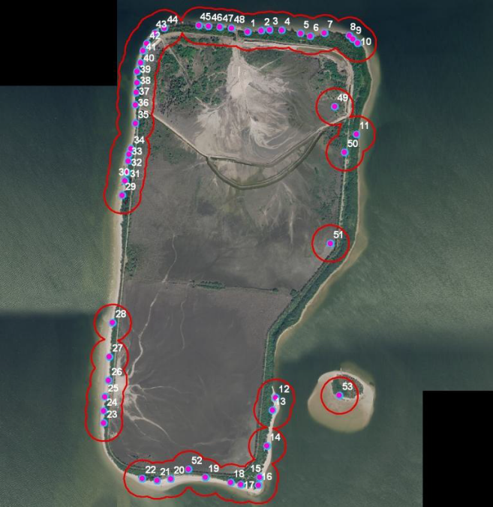 | 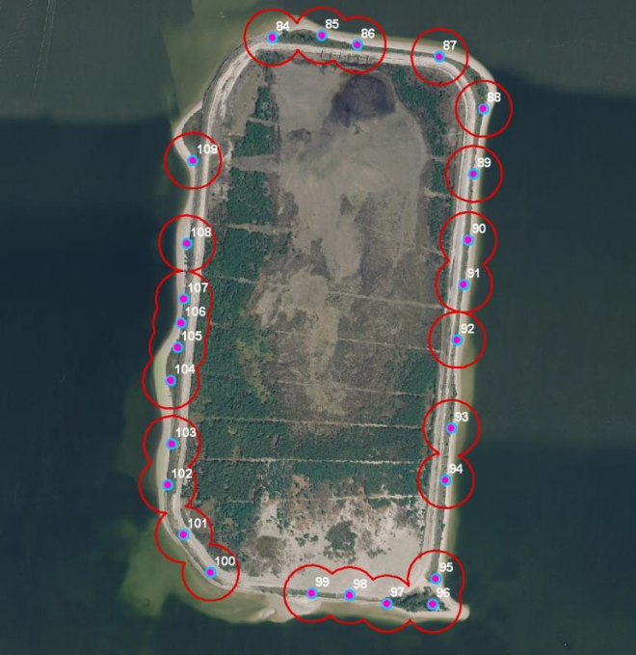
Nesting territories used by American Oystercatchers on Hillsborough Bay Island 2D | Nesting territories used by American Oystercatchers on Hillsborough Bay Island 3D

  - Description of threat to be addressed
Audubon proposes to install oyster-reef breakwaters close to the shorelines on portions of the north and south ends along the east side of Island 2D and the eastern shoreline of Island 3D where oystercatcher territories occur but where rocky shoreline is lacking. Installation of oyster habitat next to occupied oystercatcher territories should promote survival of oystercatcher chicks. The breakwaters will also intercept incoming wave energy and create a quiet water “living shoreline”.
- Restoration implementation
  - Project implementation
Audubon would design, permit, and install oyster-reef breakwaters near shore along portions of the shorelines of Hillsborough Bay Islands 2D and 3D to provide foraging habitat for American Oystercatchers near their traditional territories. Adults will have oyster reefs in their own territories, allowing them to stay close to dependent young, protecting the chicks from predation and exposure. Chicks will have oyster-reef habitat to forage for invertebrates and thus supplement the food provided by their parents, improving growth rates and survival. The breakwaters will also intercept wave and wake energy from ship traffic in Tampa Bay shipping channels. Audubon will design the oyster-reef breakwaters appropriate to the onshore wave energy with the assistance of a local engineer experienced with erosion control projects and conduct seagrass surveys so that the breakwaters are placed without impacting seagrass. Linear arrays of concrete, hollow reefballs would be installed parallel to the island shoreline. The reefballs are made of pH-neutral, rough-sided concrete to promote and support oyster attachment. Audubon will submit permits to the appropriate agencies, contract with a company for reefball construction and installation, and conduct post installation surveys and reports as required by the approved permits.
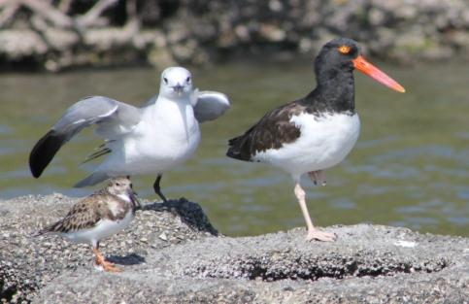 | 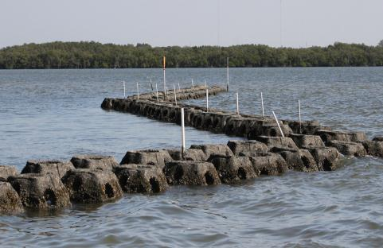
Oystercatcher, Ring-billed Gull, and Ruddy Turnstone on oyster-reef breakwater installed in Hillsborough Bay. | Oyster-reef breakwater arrays calm waters, creating a quieter water shoreline habitat.
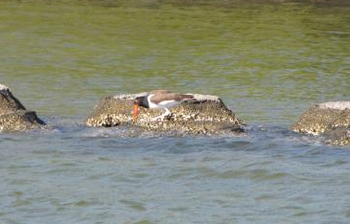 | 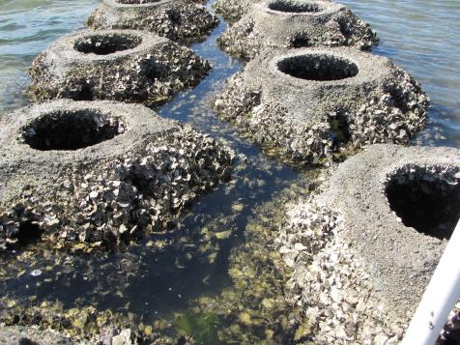
American Oystercatcher foraging on an oyster-reef breakwater project in Tampa Bay. | Reefballs are constructed of rough-sided pH-neutral concrete to promote rapid encrustation with oysters and barnacles. They are hollow and arranged in double lines to intercept and absorb onshore wave energy.
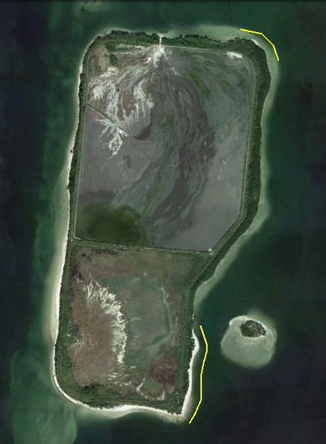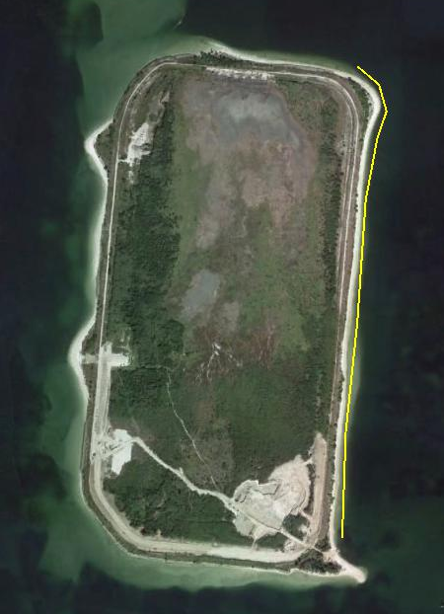
Hillsborough Bay Islands 2D and 3D with approximate locations of the proposed oyster-reef breakwaters.

