Rough sketch of proposed oyster reef location for Cortez Key Bird Sanctuary
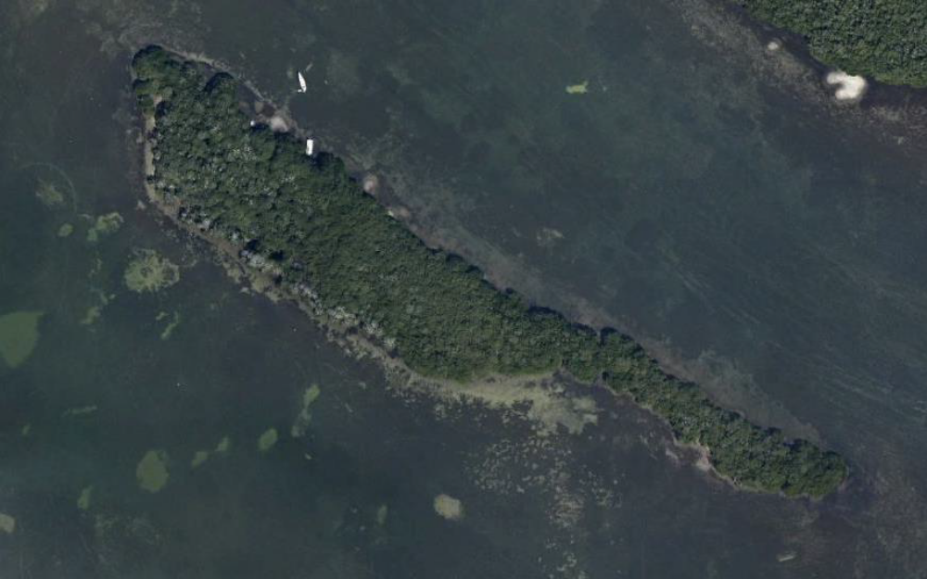
This project is in the Sarasota Bay Estuary Program’s five-year plan. The SBEP is currently designing the erosion-control, living shoreline breakwater project in preparation of permit applications. Audubon and the SBEP are seeking funding for the installation. 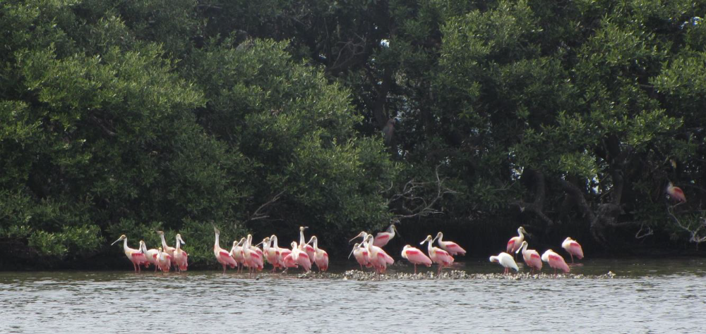
Red mangroves and oysterbars at Cortez Key, a roosting Reddish Egret, courting Roseate Spoonbills, and an adult White Ibis.

