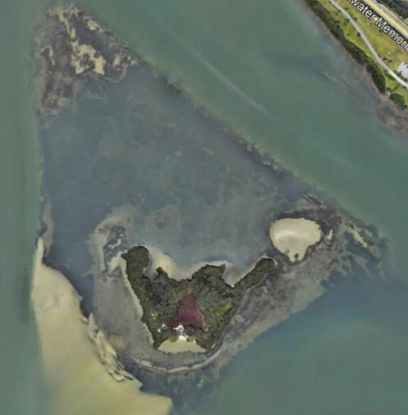
Clearwater Harbor Bird Island I-25, surrounding seagrass and sand flats, and existing limestone breakwater

