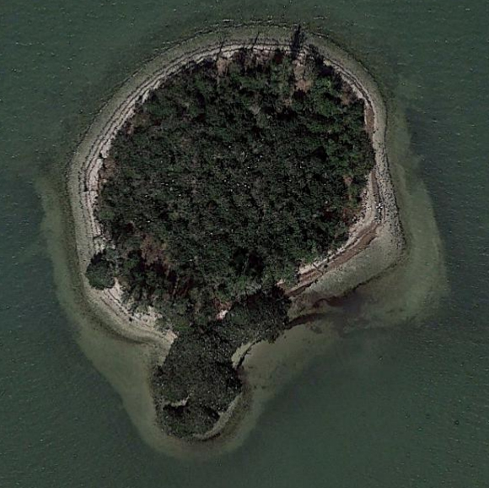 |  | Marker 26 Google Earth aerial, January 2019. White dots on the aerial are nesting Great Egrets present at this time of year.  Brazilian pepper monoculture  Mangrove area

