Material and Methods
Insert Data Collection methodology
Statistical Analysis
Variations in seagrass coverage, expressed as growing season total submerged aquatic vegetation (SAV) abundance Braun-Blanquet (BB) score, as a function of sampling location was analyzed using the Chi-squared test. Temporal trend analysis was conducted using Kendall tau (τ) correlation analysis with mean growing season total SAV abundance BB scores and year as variables. Both regional (i.e. bay-wide) and site specific correlation trend analyses were performed.
All statistical operations were performed using R© (Ver 3.1.2, R Foundation for Statistical Computing, Vienna Austria) with the critical level of significance was set at α = 0.05.

Results
Seagrass coverage significantly varied between sampling locations (Figure 1, χ² = 82.4, df = 16, ρ<0.01) from growing season 2006 to 2013. Sites EB02 and EB03 observed the highest mean BB score at 3.60 ± 0.34 and 3.48 ± 0.28 respectively indicating overall the highest benthic coverage between the other monitoring sites. Sites EB01 and EB05 observed moderate BB scores throughout the course of the eight years of surveys with BB scores of 2.67 ± 0.40 and 2.40 ± 0.27, respectively. EB04 observed the lowest BB score of 1.97 ± 0.16. This grouping of mean BB scores corresponds generally to the spatial distribution of monitoring stations within Estero Bay (Figure 2). These differences in BB scores could be the result of water quality conditions, both optical (i.e. turbidity, total suspended solids, chlorophyll, etc.) and nutrient (i.e. phosphorus, nitrogen, etc.) related water quality within each respective region of Estero Bay (EBAP, unpublished data).
Regionally growing season seagrass coverage has significantly declined during the eight year monitoring period (Figure 3; τ = -0.64, N = 8, ρ<0.05). However this regional trend is not consistent station by station. Stations EB03 and EB04 experienced significant declining trends in seagrass coverage while the remaining stations did not experienced statistically significant trends (Figure 4 and Table 1). Furthermore station EB04 experienced relatively low BB scores with little year-to-year variability. Unlike the mean BB Score spatial distribution (Figure 2), trends are not spatially clustered (Figure 5) presumably due internal or external driving forcing including but not limited to watershed influences, boat traffic, circulation, hydrodynamics, herbivory and/or water quality conditions.
Figure 1. Mosaic plot of growing season (Month – Month) total submerged aquatic vegetation (SAV) abundance Braun-Blanquet (BB) score for each monitoring location from 2006 to 2013.
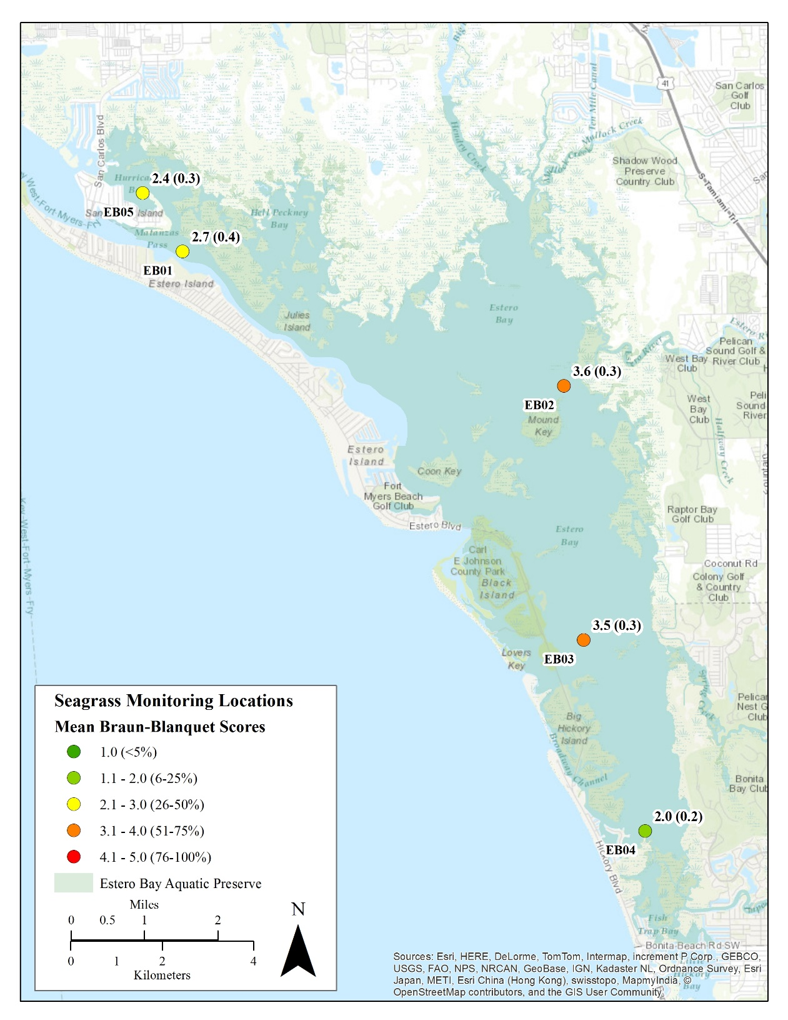
Figure 2. Estero Bay Aquatic Preserve seagrass monitoring locations with growing season mean (standard error) total submerged aquatic vegetation abundance Braun-Blanquet score for each monitoring location from 2006 to 2013.

Figure 3. Regional growing season mean total submerged aquatic vegetation abundance Braun-Blanquet score from 2006 to 2013. Points indicate mean ± standard error of the five station monitoring network within Estero Bay. The blue-dashed line indicates the locally weighted scatterplot smoothing (LOWESS) line representing the general trend in the data.
Figure 4. Stations specific growing season mean total submerged aquatic vegetation abundance Braun-Blanquet score from 2006 to 2013. The red line indicates the locally weighted scatterplot smoothing (LOWESS) line representing the general trend in the data. * indicate statistically significant trends based on Kendall tau correlation analysis.
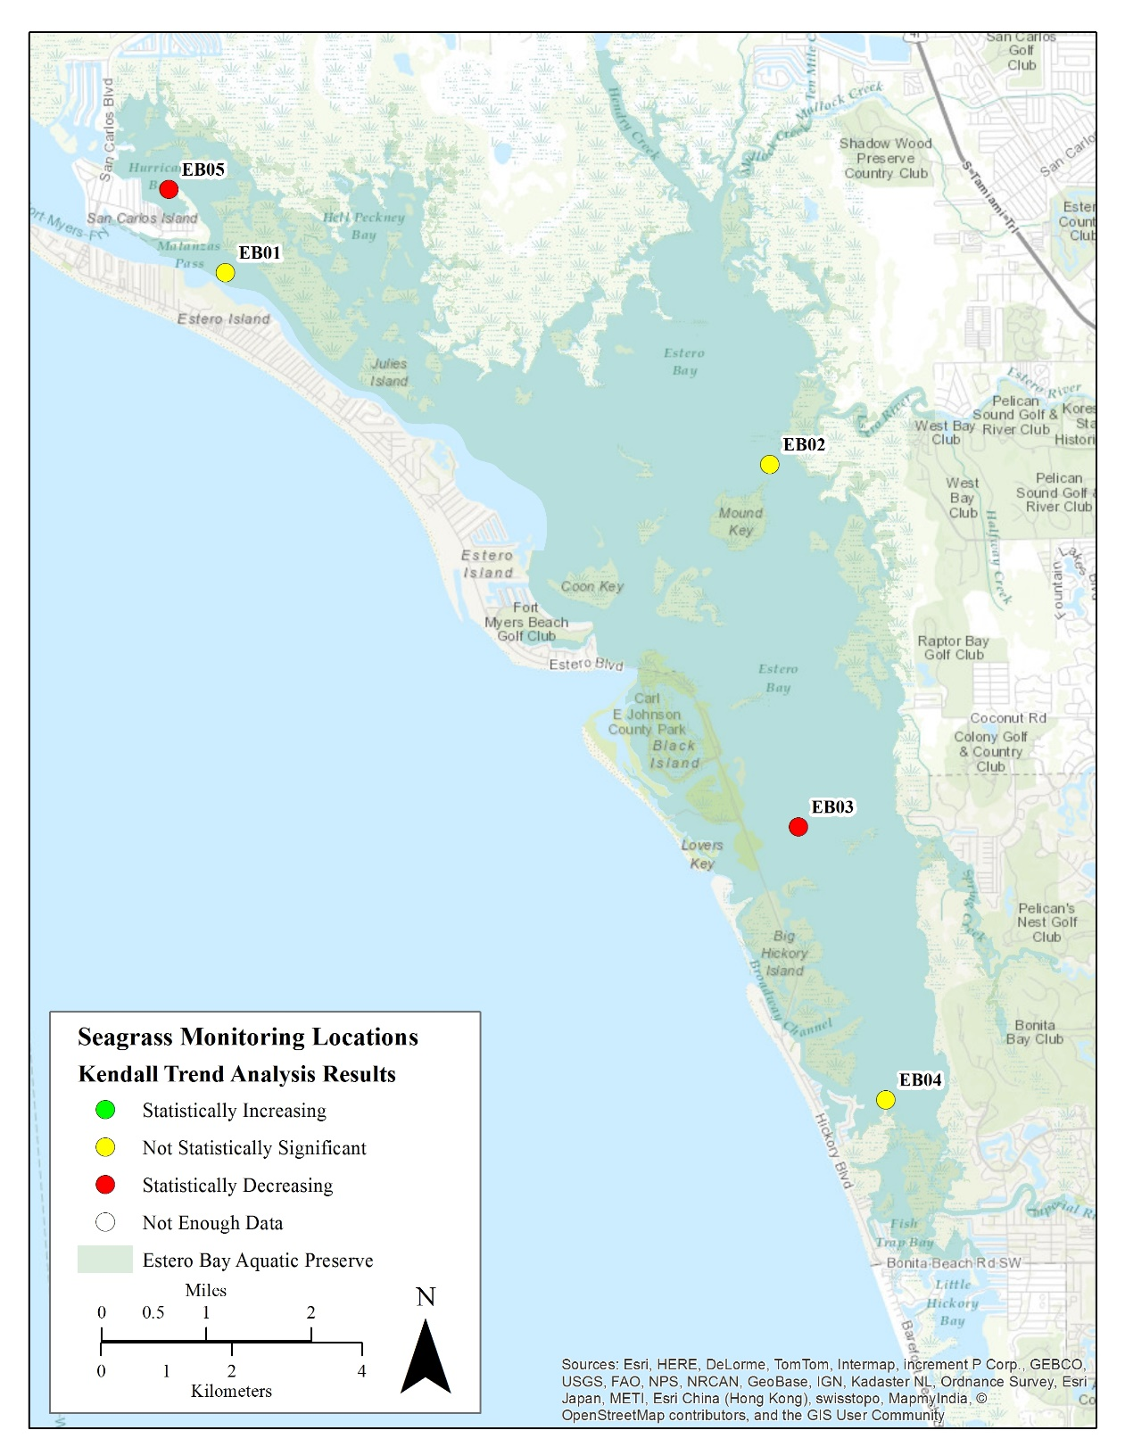
Figure 5. Stations specific growing season mean total submerged aquatic vegetation abundance Braun-Blanquet score Kendall trend analysis results using data from 2006 to 2013.

Table 1. Kendall’s τ growing season mean total submerged aquatic vegetation abundance Braun-Blanquet score trend analysis for each station using data between 2006 and 2013. Statistically significant ρ-values are italicized.
Station | T Statistic | Kendall’s τ | N | ρ-value
EB01 | -0.89 | -0.26 | 8 | 0.37
EB02 | 6.00 | -0.57 | 8 | 0.06
EB03 | -2.87 | -0.84 | 8 | <0.01
EB04 | 11.00 | -0.21 | 8 | 0.55
EB05 | -2.37 | -0.70 | 8 | <0.05

