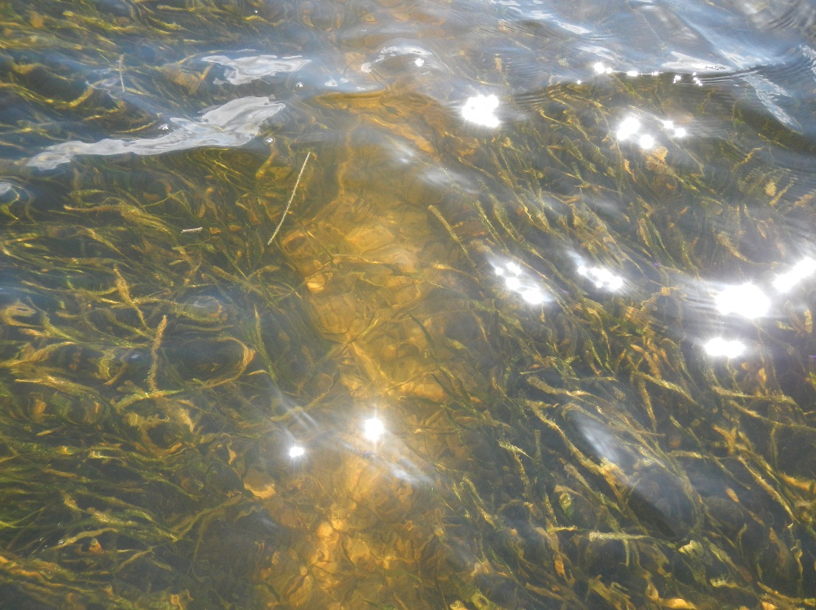

Seagrass Protection and Restoration Plan
June 30, 2015


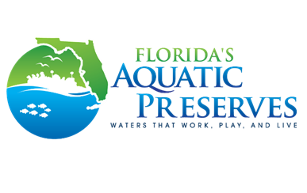

Estero Bay Aquatic Preserve
700-1 Fisherman’s Wharf
Fort Myers Beach, FL 33931
(239) 530-1001
www.dep.state.fl.us/coastal/estero

Florida Department of Environmental Protection
3900 Commonwealth Boulevard, MS 41
Tallahassee, Florida 32399-3000www.dep.state.fl.us
TABLE OF CONTENTS
1.0 Introduction 8
1.1 Seagrass Communities and Ecosystem Health 9
2.0 Estero Bay Aquatic Preserve 10
2.1 Florida Department of Environmental Protection and Florida Coastal Office 10
2.2 General Preserve History 11
2.2.1 Geographical Location 12
2.2.2 Physical Features 14
2.2.2.1 Climate 14
2.2.2.2 Topography and Geomorphology 14
2.2.2.3 Hydrology 15
3.0 Seagrass in Estero Bay Aquatic Preserve 16
3.1 Biology 16
3.1.1 Nutrient and Sediment Requirements 17
3.2 Threats to Seagrass in the Bay 18
3.2.1 Natural Disturbances 19
3.2.2 Anthropogenic Disturbances 20
3.2.3.1 Nutrient Loading 20
3.2.3.2 Vessel Traffic 20
3.2.3.3 Dredging 24
4.0 Current Management 24
4.1 Ecosystem Science Management 25
3.3 Seagrass Coverage Mapping 25
3.3.1. Aerial Mapping 25
3.3.1.2 Ground Survey Mapping Technologies 26
3.3.2 Propeller Scar Mapping 26
3.3.2.1 Grid Mapping Method 29
3.3.2.2 GPS/Trimble Method 29
3.3.2.3 High Resolution Aerial Photography 29
4.1.1 Seagrass Monitoring 31
4.1.2 Water Quality 38
4.1.2.1 Water Quality Monitoring 39
4.1.2.1 Light Attenuation 41
4.1.2.2 Oyster Mapping and Monitoring 43
4.3 Resource Management 44
4.3.1. Noticed General Permit and No Internal Combustion Motor Zones 44
4.4 Education and Outreach Management 46
4.5 Public Use Management 46
5.0 Seagrass Protection and Restoration 47
5.1 Purpose 48
5.2 Goals and Objectives 48
5.3 Restoration Project Protocol 50
5.4 Proposed Restoration Techniques 53
5.4.1 Sediment Tubes 53
5.4.2 Seagrass Transplantation 53
4 55
5.4.2.1 Sprigs 55
5.4.2.2 Seeds 56
5.4.2.3 Cultivated Plants 56
5.5 Proposed Methods to Monitor Post Restoration 57
5.5.1 Survival 57
5.5.2 Aerial Coverage 57
5.5.3 Number of Shoots 58
5.6 Future Habitat Protection Methods 58
5.6.1 Education 58
5.6.2 Channel marking and signage 59
5.6.3 Effective Enforcement of Boating Regulations 59
4.1.1 Limited-motoring-zones 60
5.0 Review and Permitting 60

LIST OF FIGURES
Figure 1: Loss of seagrass and the impact on the overall health of the ecosystem 9
Figure 2: Seagrass species present in Estero Bay 15
Figure 3: Propeller Scar (prop scar) in a seagrass bed in Estero Bay 21
Figure 6: Left: Aquatic preserve staff conducting seagrass surveys in Matanzas Pass. Right: Underwater view of quadrant used to calculate seagrass abundance 31
Figure 7: Left: Aquatic preserve staff conducting seagrass surveys in Matanzas Pass. Right: Underwater view of quadrant used to calculate seagrass abundance 31
Figure 8: New Pass NICMZ at low tide 45
Figure 9: Lab propagated widgeon grass coconut mats being secured on site. 55
Figure 10: Photograph of a turtle grass seed in Estero Bay. 56
Figure 11: Example of SCCF’s peat pots before being transplanted on site 56

LIST OF MAPS
Map 1: EBAP Boundary (1966+1983), rivers, creeks, streams. 13
Map 2: The density of boating routes per acre outside of navigation channels in Estero Bay 22
Map 3: Rental boat traffic recorded from boats leaving Fishtail Marina on Fort Myers Beach. 23
Map 4: Seagrass scarring (%) for light, moderate, and severe in Estero Bay. 28
Map 5: Monitoring locations for seagrass, rookery, and water quality programs 30
Map 6: Estero Bay Aquatic Preserve seagrass monitoring locations with growing season mean (standard error) total submerged aquatic vegetation abundance Braun-Blanquet score for each monitoring location from 2006 to 2013. 34
Map 7: Stations specific growing season mean total submerged aquatic vegetation abundance Braun-Blanquet score Kendall trend analysis results using data from 2006 to 2013. 37
Map 8: Predictions of the median annual percent of surface light available at the bottom throughout Estero Bay. 42
Map 9: Predictions of the percent of the year that 25% or more of surface light is available at the bottom throughout Estero Bay. 43
Map 10: Habitat suitability ranking for Estero Bay obtained by combining the predicted amount of bottom light, the percent of the year sufficient light is available, and the boating density outside of channels. 50
Map 11: Priority areas designated by the EBAP seagrass stakeholder group for seagrass restoration. 51

LIST OF TABLES
Table 1: Seagrass acreage in Estero Bay Aquatic Preserve 25
Table 2: Acreage of seagrass persistence over time 25
Table 3: Seagrass scarring in Estero Bay in 2003. flnessav03 represents the total acres of seagrass mapped in 2003. The scarring represents acres scarred from the 2003 mapping 27
Table 4: Average Frequencies for all seagrass species in Estero Bay Aquatic Preserve by site, 2006-2009 32
Table 5: Kendall’s (τ) growing season mean total submerged aquatic vegetation abundance Braun-Blanquet score trend analysis for each station using data between 2006 and 2013. 35

LIST OF GRAPHS
Graph 1: Frequencies for all species within each station for the Estero Bay Aquatic Preserve. 32
Graph 2: Mosaic plot of growing season (April-October) total submerged aquatic vegetation (SAV) abundance Braun-Blanquet (BB) score for each monitoring location from 2006 to 2013 33
Graph 3: Regional growing season mean total submerged aquatic vegetation abundance Braun-Blanquet score from 2006 to 2013. 35
Graph 4: Stations specific growing season mean total submerged aquatic vegetation abundance Braun-Blanquet score from 2006 to 2013. 36

APPRNDIX
Appendix 1: Matrix detailing Goals, Objectives, and Strategies and the associated time, cost, and possible funding. 68
Appendix 2: Northwest Florida Aquatic Preserve Ruppia maritima Subdivision Protocol 75
Appendix 3: Northwest Florida Aquatic Preserve Protocol for Ruppia maritima mats 77
Appendix 4: Estero Bay Seagrass Restoration Workshop Attendees 78
Appendix 5: Estero Bay Seagrass Protection and Restoration Plan Stakeholder Contact List 82

Executive Summary
Seagrasses are ecologically and economically important habitats, and they play an integral role in estuarine environments. Seagrasses provide a number of ecosystem services; they are highly productive, provide shelter for many important species, and they contribute to nutrient cycling and habitat stabilization. For these reasons, EBAP has adopted seagrass protection and restoration goals as part of its overall management plan. EBAP staff gratefully acknowledge the receipt of Coastal Zone Management funds that provided the resources necessary to coordinate this plan.
In order to support seagrass protection and restoration efforts in Estero Bay Aquatic Preserve this plan reviews background information, the issues affecting seagrass in Estero Bay, current management practices, and protection and restoration goals. Restoration and protection protocols outlined in the plan offer guidance on potential projects that may be undertaken in Estero Bay.
Each of the proposed protection and restoration goals can be implemented as funding allows. A matrix of projected partners, estimated time commitments, costs, and potential funding resources is presented in Appendix 1 to assess the feasibility and tangibility of projects.

Introduction
Seagrasses are marine flowering plants that flourish in shallow, coastal waters. Florida’s coastal waters support approximately 2.7 million acres of seagrass habitat, and they are one of the most productive ecosystems on earth (Orth et al., 2006; Sargent et al., 1995; Thayer et al., 1997). They are an integral part of estuarine environments and serve several important ecological functions (Costanza et al., 1997; Orth et, al., 2006).
High Productivity: Seagrass plants can have growth rates of up to 5mm per day (Zieman & Zieman, 1989). They have high levels of productivity, and a bed can produce four to ten times the weight of organic matter as that is produced by a corn field of the same size (U.S. Fish and Wildlife Service [USFWS], 2014).
Food and Feeding Pathways: Grazers feed directly on the living plant material of seagrasses. Additionally, seagrasses also provide a substrate for algal epiphytes, which are an important food source for some grazers. Organisms may also utilize the detritus from decaying seagrass, mainly leaves (Zieman & Zieman, 1989).
Shelter: Seagrasses serve as important nurseries to many species, including both commercial and recreational shellfish and finfish (Hemminga & Duarte, 2000). Any degradation of seagrass communities that harbor the juveniles of commercially or recreationally important species is expected to have direct consequences on the adult individuals of that species’ cohort in surrounding or offshore waters. This has economic implications in terms of the fishing industries that depend on these species.
Habitat Stabilization: Seagrass communities also have the ability to reduce particle loads in the water and stabilize sediments. The leaves slow down the current flow and reduce the water velocity near the sediment-water interface. This promotes the sedimentation of particles and, at the same time, prevents the re-suspension of organic and inorganic material (Zieman and Ziemen, 1989). In doing so, seagrass effectively improves the water quality of its ecosystem (Hemminga & Duarte, 2000). Seagrasses also develop a matrix of interlocking roots and rhizomes that helps to bind and stabilize sediment and hinder erosion (Zieman & Zieman, 1989; Hemminga & Duarte, 2000).
Nutrient Dynamics: Seagrasses play a significant role in carbon and nutrient cycling. They are primary producers that convert sunlight and carbon dioxide into usable organic carbon, and have long been identified as an important carbon sink for the ocean (Smith, 1981). Seagrass biomass contributes a large amount of carbon to the detrital pool, and promotes the sedimentation of organic matter. This aids in maintaining an active nutrient cycle; that is to say that seagrasses take up nutrients from the sediment, transport them through the plant and release them into the water column from the leaves (Hemminga & Duarte, 2000). Epiphytic algae and faunal organisms, which colonize on the seagrass, are known to fix nitrogen, and hereby, add to the local nutrient pool (Zieman & Zieman, 1989).

Seagrass Communities and Ecosystem Health
Seagrasses are submerged photosynthetic plants, requiring sunlight to flourish; therefore, seagrass beds are usually found in shallow, clear waters (Short & Coles, 2001). Seagrass health is inextricably linked to water quality; the clearer the water, the deeper seagrasses can grow. Actions that negatively impact water clarity, like nutrient loading from urban, industrial, agricultural development and turbidity created by dredging, may severely limit the growth of seagrasses (Stevenso, Staver, & Staver; 1993).
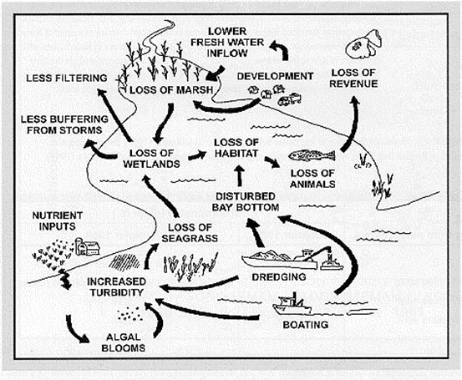
Seagrass species vary in their salinity tolerance levels, light and nutrient requirements, and changes in water quality can directly affect the seagrass range, abundance and distribution (Short & Coles, 2001). As seagrass composition changes, there is an impact on floral, faunal, and algal species that depend on this ecosystem. Even the most subtle variations can produce major structural changes within the community (Zieman & Zieman, 1989).
Figure 1: Loss of seagrass and the impact on the overall health of the ecosystem (Texas Parks and Wildlife, 1999)
The health of seagrasses, or submerged aquatic vegetation (SAV), acts as an overall indication of the health of an ecosystem. The flowchart in Figure 1 depicts how loss of seagrass negatively impacts the ecosystem as a whole. Given that seagrasses provide the ecosystem services detailed in the above section, seagrass loss, by any means, signals the loss of these services that they provide. For this reason, there are several coastal areas that have developed and implemented seagrass monitoring and/or restoration plans, including Estero Bay Aquatic Preserve.

Estero Bay Aquatic Preserve

Florida Department of Environmental Protection and Florida Coastal Office
The Florida Department of Environmental Protection (DEP) serves to protect, conserve and manage Florida's natural resources and enforces the State’s environmental laws. DEP is the lead agency for environmental management and stewardship, and it plays an integral role in protecting Florida’s air, water and land. It is divided into three primary areas: Regulatory Programs, Land and Recreation, and Water Policy and Ecosystem Restoration. Hence, one of Florida's environmental priorities is ensuring the quality and quantity of our state's water resources.
Florida is rich with freshwater and marine ecosystems. There are abundant surface water resources, and Florida also sits atop a plentiful freshwater aquifer that supplies water to hundreds of springs and provides low water flow to many of Florida’s rivers and streams. These surface and ground waters provide our drinking water and support the agriculture industry, wildlife habitat, and recreation. These waters are vast and complex, and the DEP distributes the management responsibilities into three offices: Office of Water Policy, Office of Ecosystem Projects, and the Florida Coastal Office.
The Office of Water Policy implements the DEP’s water supply and water quality protection programs under the Florida Water Resources Act (Chapter 373, Florida Statutes). In coordination with the five regional water management districts and other agencies, the office addresses statewide water planning and management issues, develops policies on water management issues, ensures all programs are consistent with the provisions of the Florida Resources Act and the Florida Water Plan, and assists the with issues pertaining to water supply, flood protection, floodplain management, water quality, and protection of natural systems.
The Office of Ecosystem Projects is focused primarily on DEP’s technical, planning, and regulatory responsibilities under the Everglades Forever Act, the Comprehensive Everglades Restoration Plan, the Northern Everglades and Estuaries Protection Program, and related efforts in Florida waters.
The Florida Coastal Office (FCO) is a unit within the DEP that manages more than four million acres of the submerged lands and select coastal uplands. There are 41 aquatic preserves under FCO management. In coordination with the National Oceanic and Atmospheric Administration (NOAA), the FCO manages three National Estuarine Research Reserves (NERR), the Florida Keys National Marine Sanctuary, and the Coral Reef Conservation Program.
The aquatic preserves are areas within coastal waters, marshes and estuaries. The aquatic preserves are distributed throughout the state of Florida with four freshwater and inland aquatic preserves, while the remaining 37 are located along the 8,400 miles of Florida’s coastlines. These waters serve as critical nurseries for many of the nation's recreationally and commercially important species, including snook, redfish and trout. In 1975, with growing appreciation for the ecological importance and aesthetics of these ecosystems, Florida enacted the Aquatic Preserve Act to ensure that these areas that have ‘exceptional biological, aesthetic, and scientific value [are] set aside…as aquatic preserves… for the benefit of future generations’ (Florida Aquatic Preserve Act of 1975, §258.36, F.S).

General Preserve History
Estero Bay Aquatic Preserve (EBAP) is a shallow estuary that is fed by five minor freshwater tributaries, and it is heavily influenced by tidal action. There are diverse habitats within the preserve and these include seagrass beds, mangrove islands, salt marshes, tidal flats, and oyster bars.
Southwest Florida has seen incredible growth since the 1950’s; it has become the destination spot for travelers, investors, and retirees (City of Fort Myers [CFM], 2015). Increasing coastal development threatened to destroy the natural conditions of the area. For this reason, there was overwhelming local support for the creation of an offshore preserve to protect the area. The Lee County Conservation Commission (LCCC), a local group composed of fishermen, conservationists, and other concerned citizens, voiced the most concern. The outspoken actions of the LCCC combined with the leadership in Tallahassee led to the establishment Estero Bay as an aquatic preserve in 1966.
EBAP, Florida's first Aquatic Preserve, predated the formation of the DEP, and it also precedes the establishment of the Florida Aquatic Preserve Act of 1975.
The boundary of EBAP was extended in 1983 to include the southern half of Estero Bay down to the Lee/Collier county line (Section 258.39, Florida Statute (FS)). This marks the current boundaries for the preserve which, along with significant portions of the bay’s tributaries included, encompasses approximately 11,200 acres of submerged lands (Map 1).
All aquatic preserves are also designated as an Outstanding Florida Water (OFW). OFW is a waterbody designated worthy of special protection because of its exceptional ecological or recreational significance. In an OFW, the DEP cannot issue permits for direct discharges that would lower the existing water quality and impact flora and fauna within the waterbody, or for indirect discharges that would significantly degrade a nearby OFW.
To further protect the water quality of Estero Bay, the surrounding land, now known as Estero Bay Preserve State Park (EBPSP), was set aside for conservation to buffer the bay from encroaching development in the watershed. This state park encompasses over 10,000 acres along the northern and eastern edges of the Estero Bay shoreline.

Geographical Location
EBAP is located in Lee County in Southwest Florida between Bonita Springs and Ft. Myers Beach and adjacent to the Gulf of Mexico. The entire preserve is about 24 Km (15 miles) south of Fort Myers and 26 Km (16 miles) north of Naples.
The bay is nearly 11 miles long, and it ranges from 1.75 to 7 miles wide. Several rivers, creeks, and streams feed in to the bay; Cow Creek, No Name Creek, Hendry Creek, Ten Mile Canal, Mullock Creek, Estero River, Mud Creek, Halfway Creek, Spring Creek, and the Imperial River (Map 1). The western and southern areas of the bay are mainly influenced by tidal exchange with the Gulf of Mexico’s marine waters through several passes including Matanzas, Hurricane, Big Carlos, Big Hickory, and New Pass. The aquatic preserve accounts for state-owned sovereign submerged lands that occur below the mean high water line. Uplands and manmade canals are excluded from the aquatic preserve, with a couple of exceptions including areas near Lovers Key.
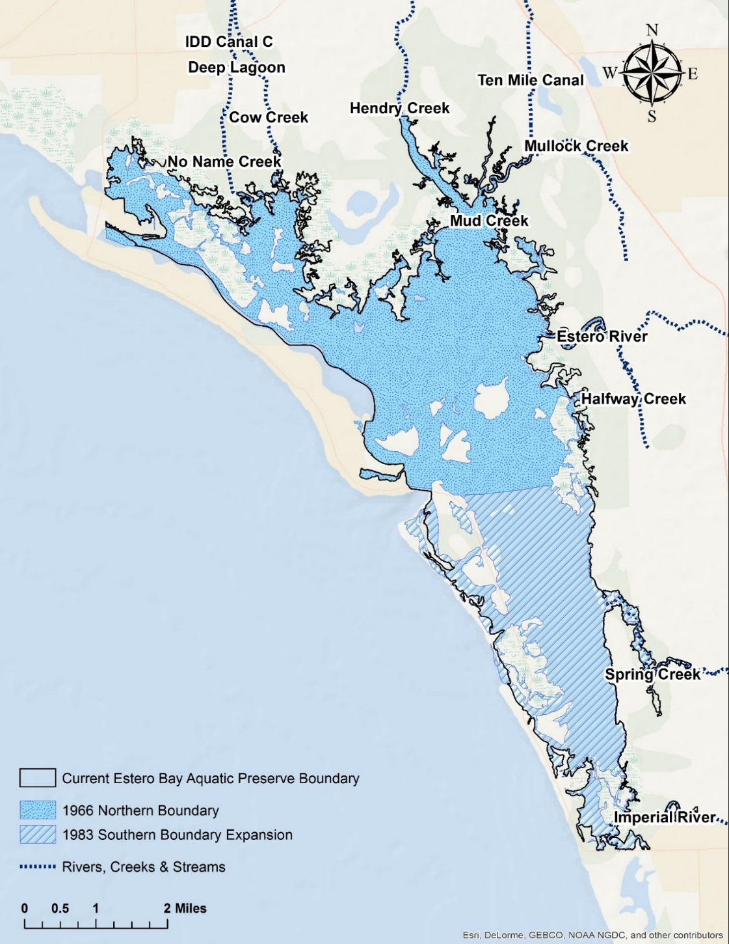
There are many public access points to the preserve: Five private and nine public boat ramps, more than 30 marinas, and numerous locations where the public can rent personal watercrafts (PWC), kayaks, and boats. In addition, there are numerous single and multi-family boat docks and slips.
Map 1: EBAP Boundary (1966+1983), rivers, creeks, streams.

Physical Features

Climate
EBAP experiences a subtropical climate which allows for the great diversity of animal and plant life within Estero Bay and its watershed. It also is marked by a pronounced wet and dry season. The average annual rainfall for Lee County is 57.9”, with the majority occurring during the wet season, between the months of May and September (CFM, 2015). The dry season runs from November through April when the area experiences little rainfall.
In addition to greater rainfall during the wet season, there is also increased cloud cover which greatly influences the growth of aquatic plants. There is also increased freshwater runoff, and therefore, increased organic loads. With this in mind, the wet season is likely to have lower oxygen levels, lower salinity, and higher temperatures. These factors place a great amount of physiological stress on estuarine ecosystems, and lowers the species diversity during this season (Tabb, et al., 1974).

Topography and Geomorphology
Topography is defined as the surface configuration, including changes in elevation and the various positions of the area’s natural and man-made features. The topography of the area surrounding and including EBAP is relatively flat and ranges in elevations from sea level to a maximum of about 30 feet (EBAP, 2014). As a result of the natural topographic features of the surrounding area, several watersheds drain into Estero Bay.
Geomorphology pertains to the physical and chemical processes that form topographic features. Southwest Florida is divided into ten major physiographic provinces which are based on features such as terrain, texture, rock type, and geologic structure and history. EBAP lies within the Caloosahatchee Valley physiographic province. This province is located in northern Lee County and portions of Charlotte, Glades, and Hendry counties. This region is characterized by a gently south-westward sloping plain composed of clastic sediments. These offshore sediments were transported south by longshore currents, and they were deposited as barrier islands that bound present Estero Bay. It also filled the bay to its present shallow depth (Missimer, 2011).

Hydrology
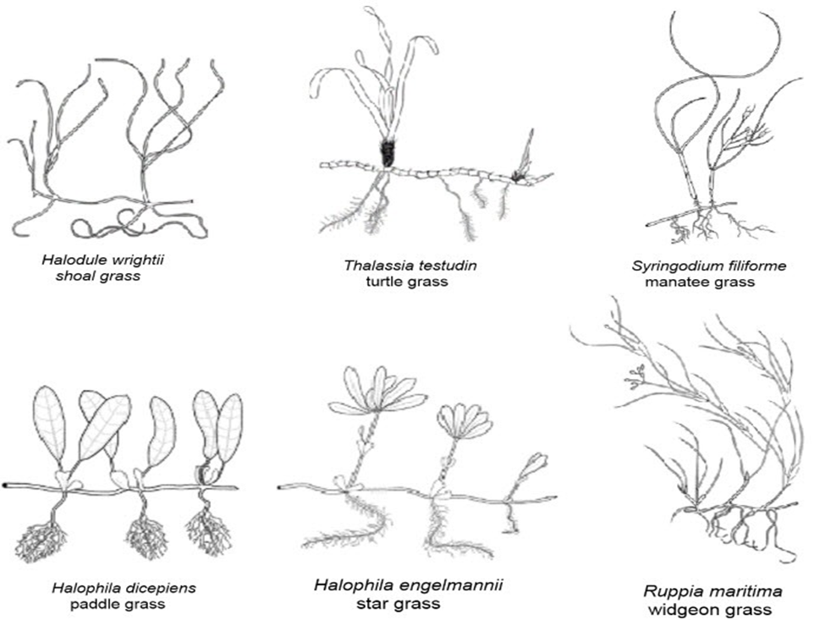
The watershed of Estero Bay Aquatic Preserve is approximately 295 square miles and includes the Big Cypress Watershed located within the Everglades West Coast Basin. Estero Bay is dominated by tidal action with circulation driven by tides at Matanzas Pass, Big Carlos Pass, and Big Hickory Pass. However, unlike many estuaries that receive freshwater input from one or two major tributaries, Estero Bay receives freshwater from several different sources along its northern and eastern boundaries. Five tributaries feed directly into Estero Bay: Hendry Creek, Mullock Creek, Estero River, Spring Creek, and Imperial River (Map 1). Hendry Creek drains primarily urban, commercial, and suburban lands. The upstream portion of Mullock Creek is connected to a structure called Ten Mile Canal that receives runoff from the City of Fort Myers. Estero Bay also receives runoff from the Estero River, as well as from residential neighborhoods, golf courses, and agricultural lands between Fort Myers and Bonita Springs. The Imperial River drains into the extreme southern end of the bay. This is the largest drainage area in Estero Bay, and it is considered vital in maintaining the environmental integrity of freshwater ground sources and wildlife habitats of the Big Cypress Basin. Spring Creek drains into the southern quarter of the bay from both the residential areas and increasing development along the creek.
Figure 2: Seagrass species present in Estero Bay (adapted from DEP, 2013a)
It is important to note that the developments of a Minimum Flow Level (MFL) for Mullock Creek, Hendry Creek, Estero River, Spring Creek, Imperial River, and Estero Bay is a priority for the South Florida Water Management District. A MFL is defined in Chapter 373.042 F.S. as ‘The minimum water level for a given watercourse that shall be the limit at which further withdrawals would be significantly harmful to the water resources or ecology of the area.’ If a MFL is established and met, Estero Bay will be better protected from ‘significant harm’ due to reductions in water levels or flows (Maxted and Mills, 2010).

Seagrass in Estero Bay Aquatic Preserve

Biology
There are 52 extant species of seagrass globally; seven of these species are found in Florida’s coastal waters, and 6 of these species are found within the preserve: shoal grass (Halodule wrightii), turtle grass (Thalassia testudim), manatee grass (Syringodium filiforme), paddle grass (Halophila decipiens), star grass (Halophila engelmannii), and widgeon grass (Ruppia maritima) (Figure 2). Shoal grass is the dominant species in the bay and can tolerate a wide range of temperature and salinity (Lirman and Cropper 2003, McMillan 1984). Shoal grass is known as a pioneer species, meaning that it colonizes areas that are either too shallow for other species to thrive or that have been disturbed and are no longer suitable for other species (Gallegos et al., 1994). This species is euryhaline; this means it can live in either freshwater or marine environments. With that in mind, shoal grass is able to survive some exposure during periods of low tide, and therefore, it usually dominates shallow waters (Lirman and Cropper, 2003). Additionally, since it is not as light limited as other species, it also is able to thrive in the deeper bay waters (Garrote-Moreno, 2015).
Turtle grass follows shoalgrass in terms of abundance in Estero Bay. It has the largest mass and has deeper root systems than any other seagrass species (DEP, 2013a). Turtle grass does not tolerate large swings in or low levels of salinity; and also, it is speculated that salinities less than 20 ppt will have deleterious effects (Moore, 1963). Finally, manatee grass has cylindrical leaves that are both brittle and buoyant. For this reason, they are frequently broken off from the parent plant and widely dispersed by winds and currents (DEP, 2013a). Optimum salinity range for manatee grass is about 20.0 - 25.0 ppt and greater (Phillips 1960). Manatee grass does not occur in freshwater or in waters with low salinities, but it can withstand periods of low salinities down to 10 ppt (Phillips, 1960).
Both species of Halophila are smaller, more fragile seagrasses (DEP, 2013a). They have a shallow rhizome structure that are easily uprooted. They also have higher tolerance to limited light availability than do other seagrasses (Altsman, 2004). Additionally, in areas of reduced salinity, widgeon grass is often found intermixed with shoalgrass. Widgeon grass is truly euryhaline; it can thrive in freshwater and has a salinity tolerance as well; its occurrence in estuaries with lowered salinities is commonplace Florida (Fish and Wildlife Conservation Commission [FWC], 2003).

Nutrient and Sediment Requirements
Seagrasses mainly grow on soft substrata like mud and sand that are easily penetrated by the seagrass roots. Given that there is a slow diffusion of oxygen into the sediment layers and there is a high microbial oxygen demand, the sediment is anaerobic just below the sediment surface (Terrados et al., 1999). Additionally, the presence of seagrass beds increase the organic inputs to the sediments through their own detritus and by trapping suspended particles. Seagrass act to counterbalance this stressor by releasing organic carbon and oxygen through their roots, allowing for their rhizomes to remain relatively oxygenated (Hemminga & Duarte. 2000).
Seagrasses have a lacunar system that connects leaves, rhizome, and roots that allows for the transport of oxygen within the plant (Terrados et al., 1999). The transport of oxygen from leaves to roots and rhizomes has been documented and is highly dependent on the photosynthetic activity of the leaves. Seagrasses can also release oxygen from their roots into the sediments to create a thin, oxidized layer surrounding the roots.
Nitrogen and phosphorus are found in both the water column and the porewater (Hemminga & Duarte, 2000). Since nutrient levels in the water column are typically low, nutrient uptake through the leaves are limited. Taking in nutrients from the sediments, where the porewater has higher concentrations of these nutrients, is significant (Hemminga & Duarte, 2000; Erftemeijer & Middleburg, 1993). Nutrient levels in the porewater are variable and highly dependent on the supply of detritus to the sediment layer and the rates of microbial mineralization.
It has been documented that seagrass growth increases after sediment fertilization. This suggests that growth is often limited by nutrient availability in the sediments, specifically nitrogen and phosphorous (Duarte, 1990; Hemminga & Duarte, 2000). Hence, nutrient limitation lowers the overall biomass of seagrass beds. It is important to note that Estero Bay, specifically, is not nutrient limited.
Even though increased nutrient levels have been shown to have a positive impact on seagrass biomass, they can also have an adverse effect through the simulation of phytoplanktonic, epiphytic and macroalgal growth. These competing primary producers bloom in a nutrient enriched water column, and can lead to reduced light availability to seagrass. Since Estero Bay is not nutrient limited, increased nutrient content in the water column of Estero Bay is expected to threaten seagrass growth in the bay.

Threats to Seagrass in the Bay
In 1950, the estimated extent of seagrass in Estero Bay was 3,769 acres. By 1999, seagrass coverage had dramatically decreased to 2,488 acres. About 107 acres of the lost seagrass is regarded as no longer restorable due to irreversible damage (Estero Bay Agency for Bay Management [EBABM, 2014]). That is to say, the unvegetated areas are no longer a suitable habitat for seagrass growth due to poor water quality, excessive prop scarring, or dredge and fill activities (EBAP, 2014). Seagrass coverage in the bay between 1999 and 2004 increased to 3,409 acres. However, this was followed by a decline in 2006 to 3,298 acres (Gray & Beaver, 2009). EBAP’s seagrass monitoring program, which is based on five transects, analyzed growing season data collected from 2006-2013 and noted a significant decline in seagrass in Estero Bay (p<0.05). Persistence of seagrass has also been tracked and appears to be linked to water depth, with the most persistent areas being shallower and near shore (EBABM, 2014). The results from both the EBAP analysis and the persistence mapping are discussed further in section 3.3.1.2.
Since the proliferation in seagrass research in the 1970’s, there have been many reports of large-scale seagrass decline worldwide. There is an array of both natural and human-induced disturbances that are the cause of such declines (Hemminga & Duarte, 2000; Orth et al., 2006). With stressors like nutrient loading, turbidity, coastal development, and intensified boating activity in Estero Bay, the seagrass health and stability in this preserve are threatened (EBAP, 2013). Section 3.4 contains recent data documenting the decline in Estero Bay’s seagrass communities.
Seagrasses are considered one of the most productive ecosystems in the world, and seagrass communities provide an array of ecosystem services. These services are valued at 28,916 2007$/ha/yr (Costanza et al., 2014), and they benefit the overall functioning of coastal ecosystems. A single acre of seagrass may support as many as 40,000 fish and, so, the multimillion-dollar recreational and commercial fishing industries depends on healthy seagrass beds (DEP, 2013b). Seagrasses are subjected to two main types of disturbances that threaten the overall health of seagrass communities: Natural and Anthropogenic.

3.2.1 Natural Disturbances
Natural causes of large-scale decline can be associated with geological and meteorological events and specific biological interactions (Hemminga & Duarte, 2000). For example, severe wind and wave action due to storm activity results in increased turbidity and erosion in seagrass beds. Large storms, like hurricanes, can uproot seagrasses completely.
Climatic events can alter salinity regimes by changing the freshwater inflow; this also plays a role in habitat loss for seagrass. This type of natural disturbance may also exhibit the opposite effect. During the drought-like conditions that occurred in EBAP in 2006, for example, there was less inflow of freshwater from tributaries and sheet flow. Less freshwater coming into the bay increased the salinity, but not to a level that was intolerable for marine seagrasses. Due to the reduced amount of flow into the bay, nonpoint source pollution like excessive nutrients, pesticides, and fecal coliforms levels also diminished. The seagrass communities then began to rebound (EBAP, 2014).
Natural disturbances are ephemeral, hence the effects on seagrass habitats are typically short lived. Seagrass communities are adapted to cyclic natural phenomenon, and so, they are better able to rebound after natural events.

Anthropogenic Disturbances
Anthropogenic, or human induced, disturbances are typically continuous or episodic. Seagrass communities are not adapted to these types of events, like nutrient loading, increased vessel traffic, and dredging. Therefore, anthropogenic disturbances can greatly disrupt seagrass habitat to a point from which seagrass communities are not able to rebound.

Nutrient Loading
Nutrient loading, or eutrophication, occurs when there is an additional input of nutrients, like nitrogen and phosphorous, into the watersheds that flow into coastal waters. An influx of nutrients can cause macroalgae species, phytoplankton, and microalgal epiphytes to proliferate quickly. When these blooms occur, the seagrass communities can be overrun and when the sunlight is blocked the seagrass is, effectively, smothered. The algal species are able to outcompete the seagrass for sunlight. This lowers the rate of photosynthesis occurring, reduces the seagrass biomass, and decreases the overall health of the seagrass community.

Vessel Traffic
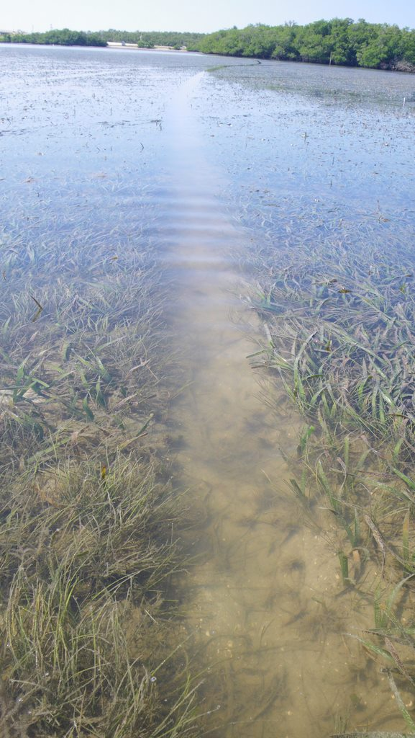
Water-dependent activities are very popular with both residents and tourists. Boats, kayaks and PWCs are commonly found in the estuary; recreational fishing and nature photography and observation are common activities that people partake in throughout the bay. Spatial boating patterns in Estero Bay were modeled using digitized routes of 474 boating trips taken in the bay (Hotaling, 2014). Routes were from a map-based questionnaire mailed in three waves between May 2005 and March 2006 to a random sample of boaters who were observed at local ramps, kept their boat at a local marina or dry storage facility, or owned a boat docked at a local waterfront parcel (Sidman et al., 2005, 2006). Survey respondents marked on a 1:160,000-scale map the start and end points and favorite destinations, and drew the routes of their last two boating trips. From this information a map was created to display the routes that are frequently used outside of the marked channels in Estero Bay (Map 2). When boats travel outside of the marked channels, in shallow waters and where seagrass is present, depending on the boat draft, there is an increased chance to damage the seagrass beds.
Figure 3: Propeller Scar (prop scar) in a seagrass bed in Estero Bay (Photo Credit: FGCU Vester Marine Station)

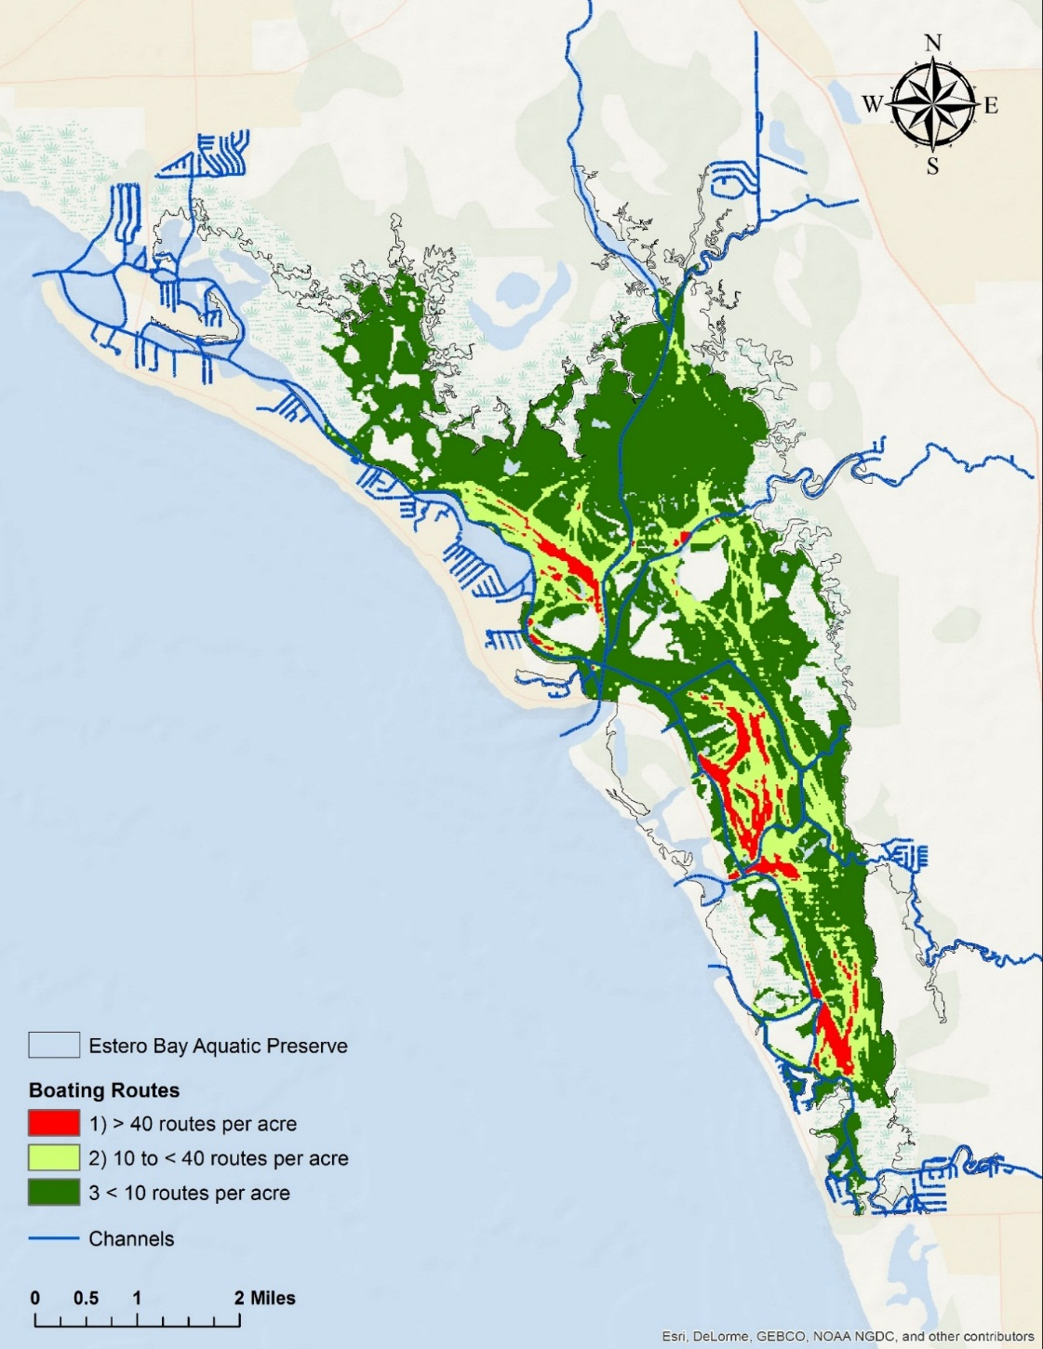
More recently, GPS units in enclosed cases were placed on rental boats out of Fishtail Marina on Fort Myers Beach to collect data on rental boat traffic (Map 3). This study is still underway, and, if funding allows, can be expanded to include other Estero Bay marinas and data collection over a longer period of time (Robert Swett, Personal Communication, June 4, 2015).

Map 2: The density of boating routes per acre outside of navigation channels in Estero Bay
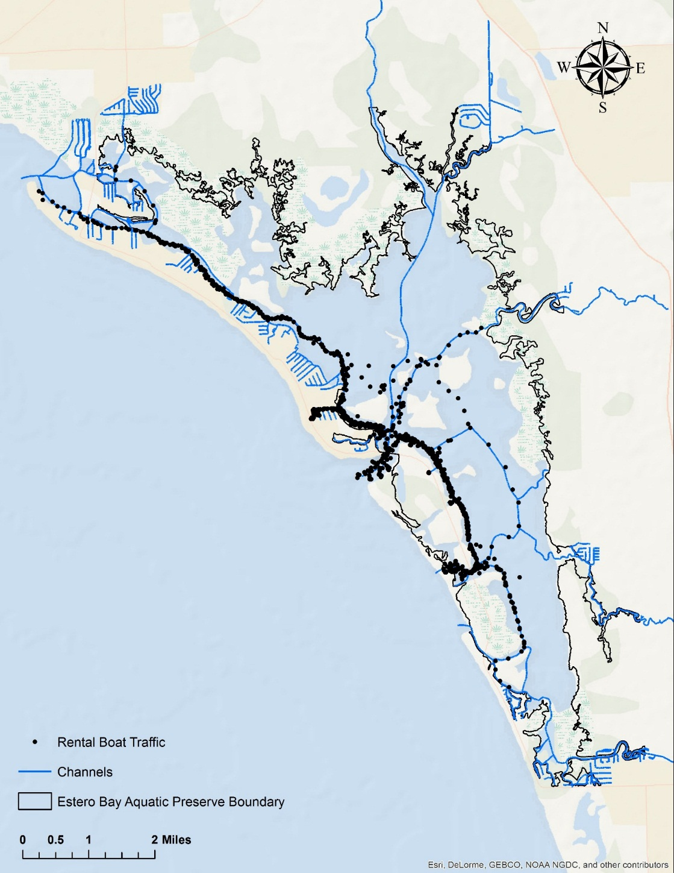
A propeller scar (prop scar) is a narrow, linear feature that is the direct result of a vessel’s propeller moving through the seagrass bed (Zieman, 1976). Being in shallow waters, seagrass communities are especially vulnerable to prop scars by boats, and they are scarred as the boat passes through the community (Figure 3). Since propeller scarring mechanically injures the plants, the entire estuary is impacted (Sargent et al., 1995). Most of the large-scale estimates of vessel-induced seagrass damage have come from studies using aerial images. These aerial studies provide useful information regarding patterns and relative densities of scarring. Prop scars can take up to 10 years to heal, and this time period may be much greater in areas with poor water quality and where scarring is severe or frequent (Durako, Hall, Sargent, & Peck, 1992; Lewis & Estevez, 1988; Zieman, 1976). Also, the unstable sediments of a newly damaged seagrass bed are susceptible to erosion and this prevents the establishment of new plants.
Map 3: Rental boat traffic recorded from boats leaving Fishtail Marina on Fort Myers Beach.

Dredging
Dredging and filling is a major anthropogenic activity that contributes to loss of seagrass biomass. The immediate impact of dredging is the physical removal of seagrass or burial of seagrass beds with sediment (Newell et al., 1998). There are also indirect effects that are the result of disturbed sediments from dredging operations (Texas Parks and Wildlife, 1999). Dredging and the deposition of the dredged material can increase the amount of suspended matter in the water and the rates of sedimentation. This increases the turbidity and decreases the light availability. The change in turbidity commonly associated with dredging activities has varying effects on seagrass depending on the species (Erftemeijer & Lewis, 2006).
Dredging may also have an effect on the physical attributes of the system. By changing the bathymetry and altering the current velocities and wave action, dredging can affect the sediment system of a seagrass bed, and ultimately, cause erosion and more seagrass loss (Erftemeijer & Lewis, 2006).

Current Management
The FCO has four management programs, and EBAP’s operational activities for seagrass restoration and management are explained within them: Ecosystem Science, Resource Management, Education and Outreach, and Public Use. The ecosystem science management program is based on sound science; it provides resource mapping, modeling, monitoring, research, and scientific oversight. Seagrass management in EBAP is accomplished through both mapping and monitoring the seagrass communities.

Ecosystem Science Management

Seagrass Coverage Mapping

    - Aerial Mapping
Table 1: Seagrass acreage in Estero Bay Aquatic Preserve (Robert Swett, Personal Communication, April 17, 2015)
Name of Seagrass Layer (SFWMD) | Year | Acres | Acres of Seagrass Only Present This Year
flnessav99 | 1999 | 2,428 | 113
flnessav03 | 2003 | 2,328 | 21
flnessav04 | 2004 | 3,320 | 44
flnessav06 | 2006 | 3,213 | 72
flnessav08 | 2008 | 3,536 | 753
Determining the distribution of seagrass in Estero Bay is a priority, and a monitoring program cannot be effective if a seagrass coverage map is unavailable. With this in mind, keeping abreast of up-to-date methods to define the boundaries, extent, and density of seagrass meadows in Estero Bay is a goal in the current management plan. Both the scale and the level of detail required for the mapping project need to be considered when choosing a method to map seagrass coverage.
Table 2: Acreage of seagrass persistence over time (Robert Swett, Personal Communication, April 17, 2015)
Years of Persistence ('99, '03, '04, '06, '08) | Acres of Seagrass present each year | Percent of Total
1 | 1,003 | 22%
2 | 769 | 17%
3 | 589 | 13%
4 | 662 | 14%
5 | 1,574 | 34%
Total | 4,597 | 100%
Mapping at a large scale provides a spatial framework for seagrass coverage. Large areas can be mapped by aerial surveys. At this level, seagrass boundaries can be delineated. In previous years the South Florida Water Management District (SFWMD) obtained aerials and mapped seagrass extent biennially, however, this has been cut back to every 5 years. It is important to note that aerials are typically flown in the winter (dormant season for seagrass) when there is less chance of rain and reduced water quality. EBAP contributes to the SFWMD mapping program by providing information on both ambient and water conditions on the survey day and groundtruthing afterwards. Since EBAP recommends that aerial surveys be flown every two years, and the Southwest Florida Water Management District (SWFWMD) consistently maps seagrass biannually, EBAP will explore options to expand the aerial surveys conducted by the SWFWMD to include Estero Bay.
The EBAP boundaries used to determine coverage are based on the aquatic preserve
descriptions in Section 258.39, Florida Statutes. The boundaries are approximate, and they are based on interpretation of aerial maps. The most recent aerial survey and mapping done by the SFWMD was conducted in 2008 and the seagrass coverage from 1999-2008 is detailed in Table 1. Using the seagrass extent mapping obtained from the SFWMD for 1999, 2003, 2004, 2006, and 2008; a seagrass persistence analysis was recently performed; only 34% of all seagrass persisted for all 5 years (Table 2).

3.3.1.2 Ground Survey Mapping Technologies
Interpreting imagery from aerial surveys is a preferred method for mapping seagrass in intertidal areas, although in submerged areas, aerial surveys are limited by water clarity, cloud coverage and sea surface wind and wave conditions (Vis, Hudon, & Carignan., 2003) and frequently results in systematic underestimation of the extent of seagrass (McCarthy and Sabol, 2000). Having access to aerial maps for multiple years, like those described in section 3.3.1.1, provides insight into the variation in seagrass distribution. Ground surveys, however, are also important in examining the bathymetric range of seagrass. Determining the density of seagrass in a specific area and delineating exact boundaries of seagrass beds necessitates adapted techniques, such as hydroacoustic mapping (Walker, 1989).
Using a Differential GPS, hydroacoustic technologies can collect data on bathymetry, submersed plants, and substrate composition from a vessel by following a predetermined transect. There is a high frequency acoustic signal sent towards the seafloor, and the intensity at which the signal is sent back to the device is dependent on the morphology of the bottom (Berne, Casting, Drezen, & Lericolais; 1993). Hydroacoustic technologies have been successfully used to map seagrass beds, and they can be implemented in EBAP if funding allows to supplement field observations.

Propeller Scar Mapping
The Fish and Wildlife Research Institute (FWRI) uses aerial photography to assess prop scarring in shallow, coastal waters of Florida. FMRI utilizes a combination of high-resolution aerial photographs and groundtruthing. A bounding polygon is drawn around groups of scars, not single isolated prop scars. Scarring is categorized by intensity: Polygons that contain areas with less than 5% scarring are classified as light scarring, polygons classified as moderate have between 5% and 20% scarring, and those labeled as severe have greater than 20% scarring (Sargent et al., 1995).
The polygons are transferred to the NOAA nautical charts using a zoom transfer scope (ZTS). Sargent et al. (1995) details that ‘the ZTS superimposes an image onto a base map of a different scale, providing for accurate transfer of the hand-drawn polygons from the photograph overlays onto the NOAA base maps.’ For Estero Bay, a 1:40,000- scale NOAA chart is used as a base map. There is extensive scarring in Estero Bay, with 47.4% (1,135 acres) of seagrass acres demonstrating some level of scarring (Madley et al., 2004; Map 4, Table 3).
Name of  Seagrass  Layer  (SFWMD) | Acres | %
flnessav03 | 2,394 | 100%
Severe | 806 | 33.70%
Moderate | 272 | 11.40%
Light | 57 | 2.40%
All Scarred | 1,135 | 47.40%
To distinguish between levels, Madley et al. (2004) identified 33.7% severe (806 acres), 11.4% moderate (272 acres), and 2.4% light (57 acres). It is important to note that these numbers represent the percent of scarred acres of the total seagrass acreage in Estero Bay (Map 4).
Table 3: Seagrass scarring in Estero Bay in 2003. flnessav03 represents the total acres of seagrass mapped in 2003. The scarring represents acres scarred from the 2003 mapping (Madley et al. 2004; Robert Swett, Personal Communication, April 17, 2015)
The most recent FWRI propeller scar map that includes Estero Bay was produced in 2003; updating this map is recommended, and this mapping effort should be conducted more frequently to assess trends in scarring and evaluate areas where propeller scarring remains severe. Private firms may also be employed to determine seagrass scar mapping.
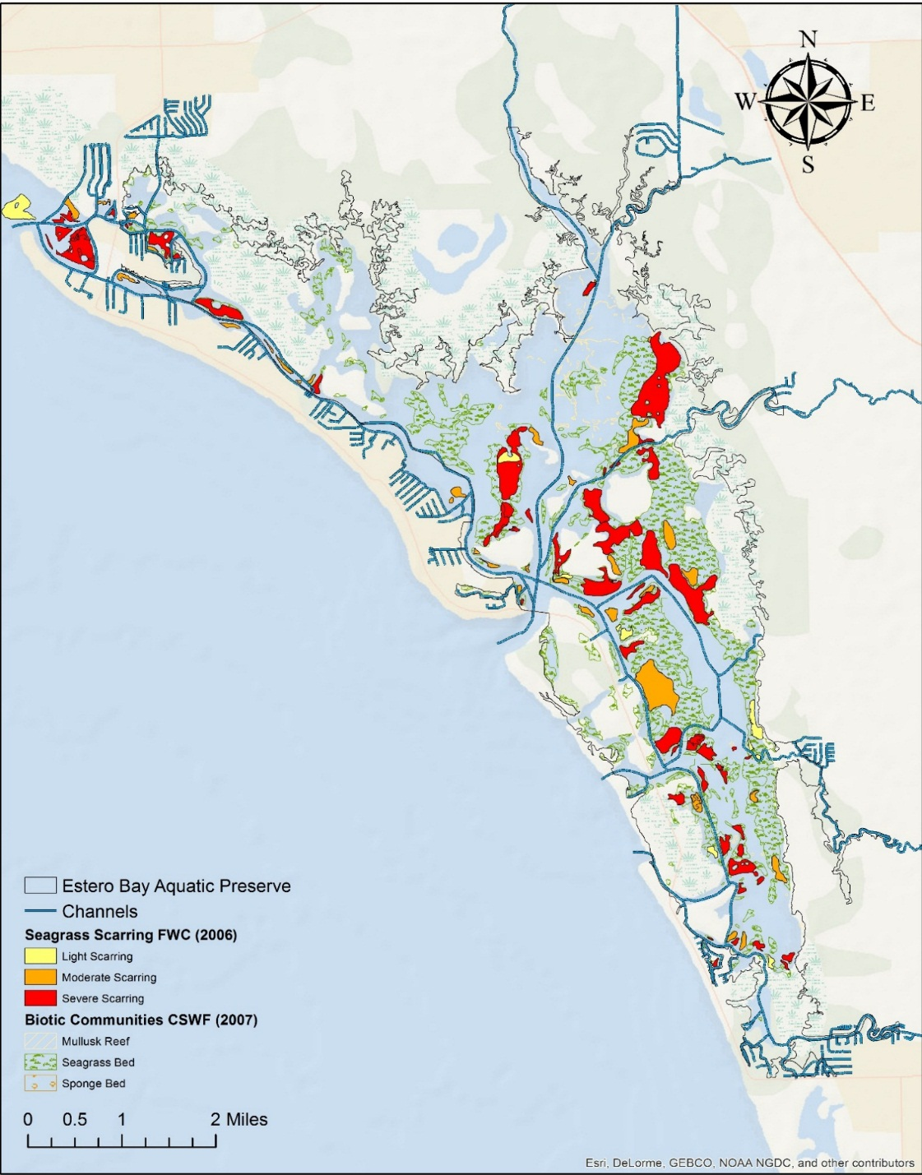
There are three other propeller scar survey methods that can be used to determine the extent of prop scarring in Estero Bay: Grid Mapping Method, GPS/Trimble Method, and High Resolution Aerial Photography. Along with the aerial mapping just discussed, EBAP staff, volunteers, and those participating in restoration efforts within Estero Bay may find the following methods, useful in assessing the state of prop scarring in the preserve both before and after restoration projects begins or a damaged area is marked for protection.
Map 4: Seagrass scarring (%) for light, moderate, and severe in Estero Bay.

Grid Mapping Method
This method is used to calculate area of prop scars that are no greater than 10m² and it is best used when scarring is linear. This method is similar to the fishbone method developed by Hudson and Goodwin, and it has been used previously by both NOAA and DEP to document seagrass injury (Kirsch et al., 2005).
A fiberglass measuring tape is extended down the midline of the scar from two anchor points located at each end of the scar. At specified intervals (~1 m) length measurements are taken at right angles from the centerline to the edges of the scar Hudson & Goodwin, 2001. Using this information, a graphical representation of the injury can be made by plotting measured points on a Cartesian plane from which the area of the scarring can be calculated. While this method does not need special equipment, it does require considerable time and staffinf to get a detailed graph (Kirsch et al., 2005). This method is best used where scarring is linear.

GPS/Trimble Method
The Trimble Method or the Mini-312 program is used in areas ranging from 10m2 to 100m2 and is best used on wide scars, or scars that may have merged to form large, irregular patches. NOAA and the Florida DEP utilize this method to collect data about areas with high boat traffic. The Trimble receiver collects points while being walked around the perimeter of the scar or being dragged in a float. The total number of points recorded is dependent on the complexity of the scar; more complex features will require more points to accurately represent the shape. The points are then connected to create a polygon feature in ESRI ArcView or Trimble Pathfinder Office. From that, the area of scarring can be calculated. Kirsch et al., 2005 states that this method requires less manpower, lends itself to a rapid acquisition of accurate mapping information in a digital format, and allows for the electronic transfer of data to a Geographical Information System (GIS). This method is best used on wider scars, or scars that may have merged to form large, irregular patches.

High Resolution Aerial Photography
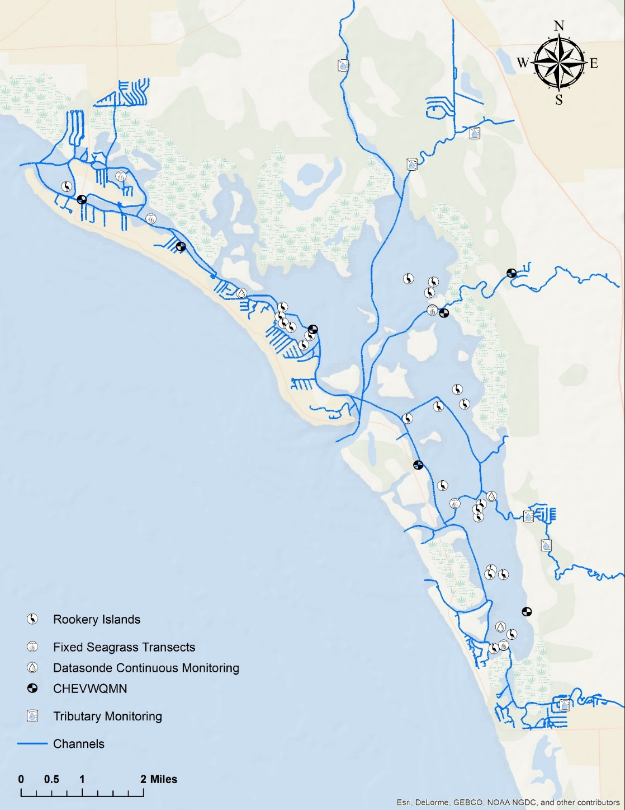
High-resolution aerial photography can be used for very large, geometrically complicated injuries (Kirsch et al., 2005), and it can be used to determine the overall presence of prop scars in Estero Bay. This method is used when the area of injury is greater than 100m², the water is calm and clear, and the depth is no greater than 4.5 meters (Hudson & Goodwin, 2008). Brightly colored aerial targets, like white PVC table tops mounted on vertical poles, can be put out in the seagrass scar just before flying over the area. GPS coordinates would be taken, and afterwards, the coordinates of the markers need to be retaken to make sure none of them had moved throughout the process. The injuries can then be delineated in geo-rectified vertical photographs to show the extent of scarring in the area (Hudson & Goodwin, 2008).
Map 5: Monitoring locations for seagrass, rookery, and water quality programs in EBAP

Seagrass Monitoring
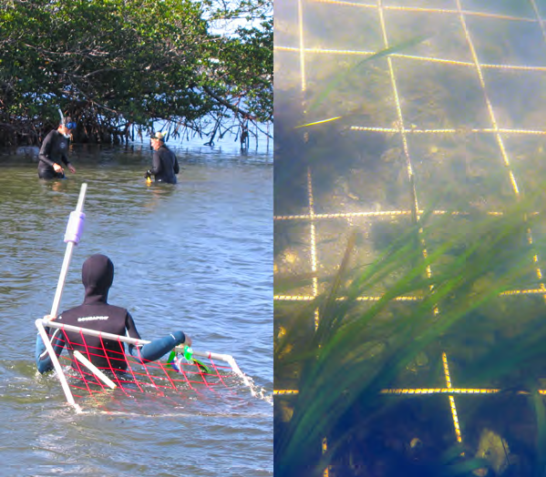
There are five seagrass transects throughout the bay that are monitored by EBAP staff (Map 5); they are monitored twice a year—once in the growing season and again in the dormant season. This allows the data collection to coincide with the yearly minimum and maximum seagrass densities. The growing season is marked from April 1st-October 31st to coincide with the rainy season. Collecting data during the growing season provides agencies with the maximum aerial extent of seagrass, peak above ground biomass, and greatest diversity of seagrass (FWC, 2011). For this reason, data collected during the growing season is considered when analyzing seagrass coverage over time in Estero Bay.
Figure 6: Left: Aquatic preserve staff conducting seagrass surveys in Matanzas Pass. Right: Underwater view of quadrant used to calculate seagrass abundance (EBAP, 2014)

Figure 7: Left: Aquatic preserve staff conducting seagrass surveys in Matanzas Pass. Right: Underwater view of quadrant used to calculate seagrass abundance (EBAP, 2014)
The transect lengths at each of the sites vary from 100 meters to more than 400 meters. Most of the transect lines begin on the shoreward side of the seagrass bed and they are tagged with flagging tape; one of the transects falls between two channel markers. The start of the seagrass transect is marked with a stake and the Global Positioning System (GPS) coordinates are recorded for both the beginning and the end of the transect. The direction of the transect is followed by using a compass heading and the researcher is able to utilize a minimum of two visual reference points that are along the line. Data is collected every 50 meters along the transect, or every 10 meters depending on the total length of the transect. The parameters recorded at each station along the transect include the distance from the stake location and shore, date and time, water depth, sediment type, epiphytic type and density, blade lengths, species present, species abundance, total abundance, shoot count, sediment type, and any additional comments (Figure 6), The Braun-Blanquet (BB) method, a rapid, visual assessment of seagrass abundance, is used to estimate the total and individual percent coverage. Leary (2012) reported that from 2006-2009 H. wrightii was the most abundant species observed (73.09%), followed by T. testudinum (24.34%), Halophila spp. (1.90%), and S. filiforme (0.20%, Table 4, Graph 1). H. wrightii has also been documented in high abundances in similar surrounding estuaries like Charlotte Harbor, Sarasota Bay and Tampa Bay.
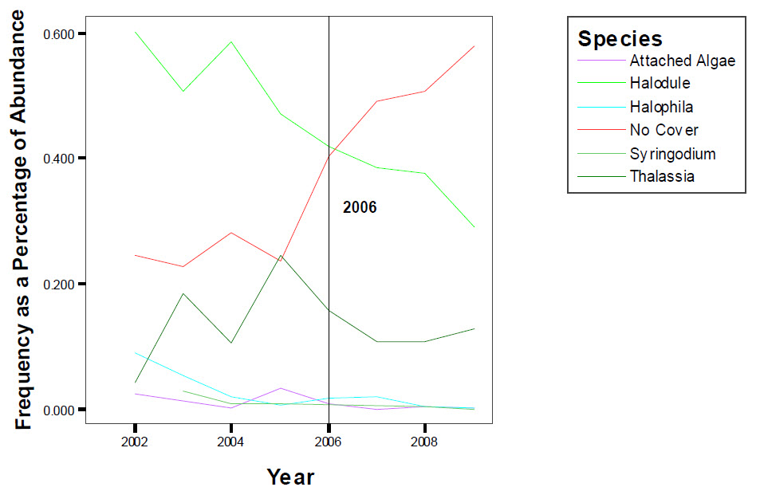
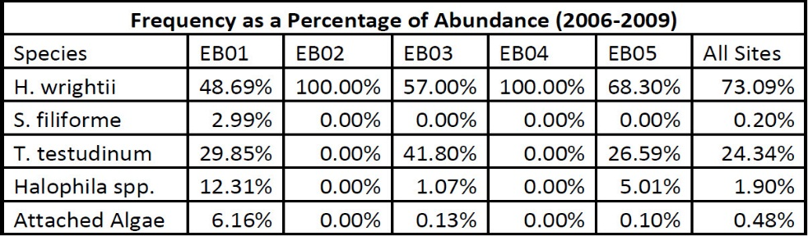
For the most recent analysis of EBAP seagrass monitoring data, variations in seagrass coverage, expressed as growing season total SAV abundance BB score, as a function of sampling location was analyzed using the Chi-squared test. Temporal trend analysis was conducted using Kendall tau (τ) correlation analysis with mean growing season total SAV abundance BB scores and year as variables. Both regional (i.e., bay-wide) and site specific correlation trend analyses were performed.
Graph 1: Frequencies for all species within each station for the Estero Bay Aquatic Preserve.
Table 4: Average Frequencies for all seagrass species in Estero Bay Aquatic Preserve by site, 2006-2009 (Leary 2012)
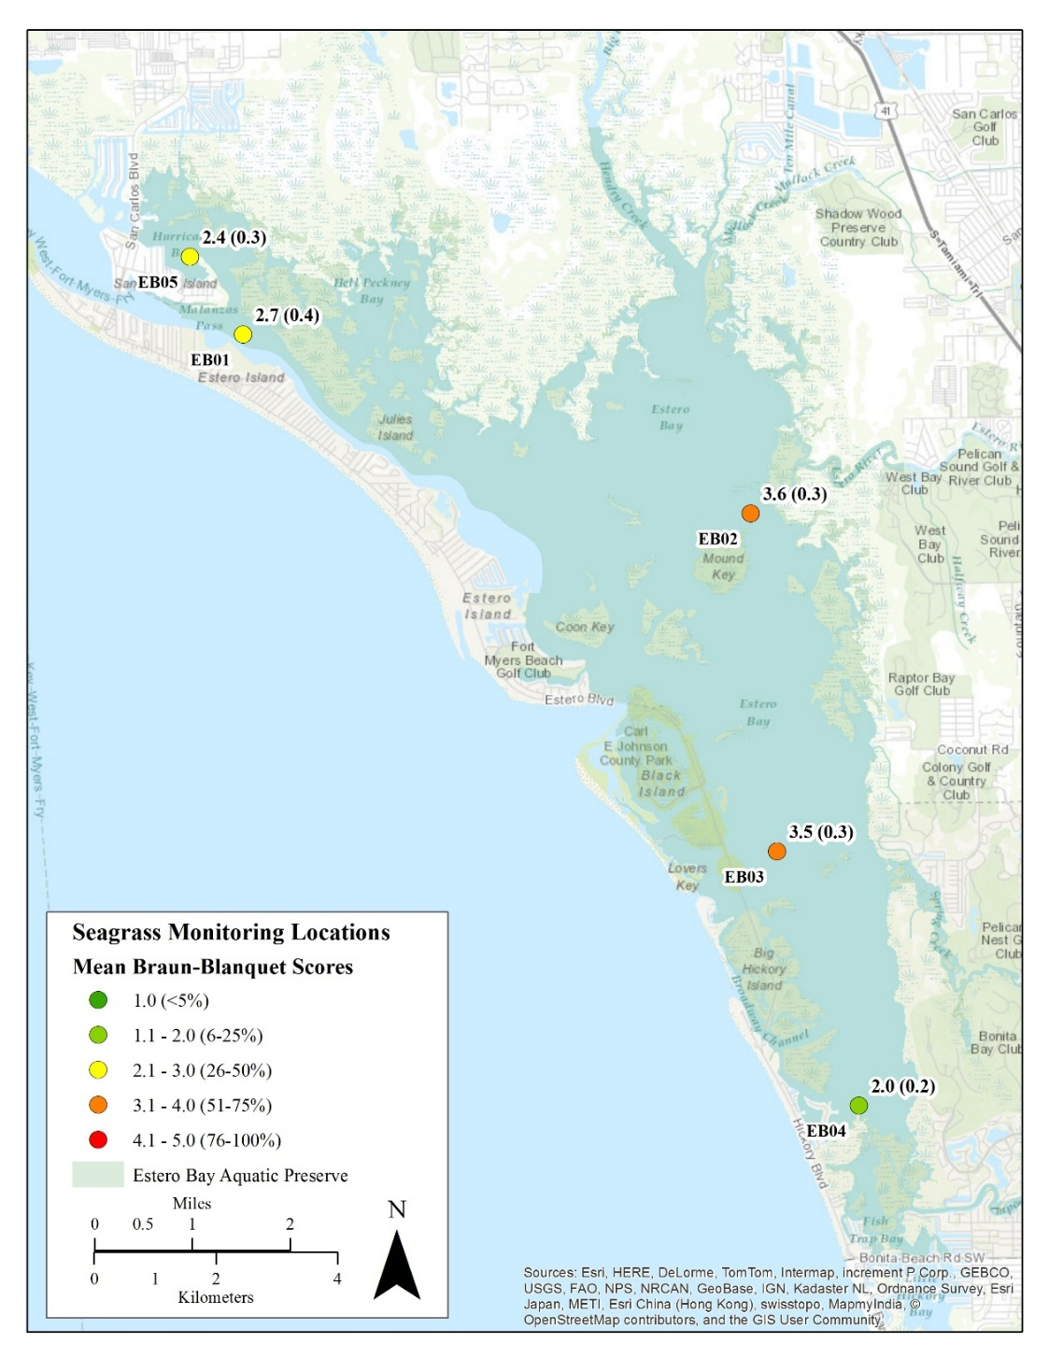
Seagrass coverage significantly varied between sampling locations (Graph 2, χ2 = 82.4, df = 16, ρ<0.01) for the growing seasons from 2006 to 2013. Sites EB02 and EB03 observed the highest mean BB score at 3.60 ± 0.34 and 3.48 ± 0.28 respectively indicating overall the highest seagrass coverage among monitoring sites. Sites EB01 and EB05 had moderate BB scores throughout the course of the eight years of surveys with BB scores of 2.67 ± 0.40 and 2.40 ± 0.27, respectively. EB04 observed the lowest BB score of 1.97 ± 0.16. This grouping of mean BB scores corresponds generally to the spatial distribution of monitoring stations within Estero Bay (Map 6). These differences in BB scores could be the result of water quality conditions, both optical (i.e. turbidity, total suspended solids, chlorophyll, etc.) and nutrient (i.e. phosphorus, nitrogen, etc.) related water quality within each respective region of Estero Bay (EBAP, unpublished data).
Graph 2: Mosaic plot of growing season (April-October) total submerged aquatic vegetation (SAV) abundance Braun-Blanquet (BB) score for each monitoring location from 2006 to 2013
Map 6: Estero Bay Aquatic Preserve seagrass monitoring locations with growing season mean (standard error) total submerged aquatic vegetation abundance Braun-Blanquet score for each monitoring location from 2006 to 2013.

Within Estero Bay, growing season seagrass coverage has significantly declined during the eight year monitoring period (Graph 3; τ = -0.64, N = 8, ρ<0.05). However this regional trend is not consistent station by station. Stations EB03 and EB04 experienced significant declining trends in seagrass coverage while the remaining stations did not experience statistically significant trends (Graph 4 and Table 5). Furthermore station EB04 experienced relatively low BB scores with little year-to-year variability. Unlike the mean BB Score spatial distribution (Map 6), trends are not spatially clustered (Map 7) presumably due to internal or external driving forcing including, but not limited to,
Station | T Statistic | Kendall’s τ | N | ρ-value
EB01 | -0.89 | -0.26 | 8 | 0.37
EB02 | 6.00 | -0.57 | 8 | 0.06
EB03 | -2.87 | -0.84 | 8 | <0.01
EB04 | 11.00 | -0.21 | 8 | 0.55
EB05 | -2.37 | -0.70 | 8 | <0.05
watershed influences, boat traffic, circulation, hydrodynamics, herbivory and/or water quality conditions.
Graph 3: Regional growing season mean total submerged aquatic vegetation abundance Braun-Blanquet score from 2006 to 2013. Points indicate mean ± standard error of the five station monitoring network within Estero Bay. The blue-dashed line indicates the locally weighted scatterplot smoothing (LOWESS) line representing the general trend in the data.

Table 5: Kendall’s (τ) growing season mean total submerged aquatic vegetation abundance Braun-Blanquet score trend analysis for each station using data between 2006 and 2013. Statistically significant -values are italicized:

Graph 4: Stations specific growing season mean total submerged aquatic vegetation abundance Braun-Blanquet score from 2006 to 2013. The red line indicates the locally weighted scatterplot smoothing (LOWESS) line representing the general trend in the data. * indicate statistically significant trends based on Kendall tau correlation analysis
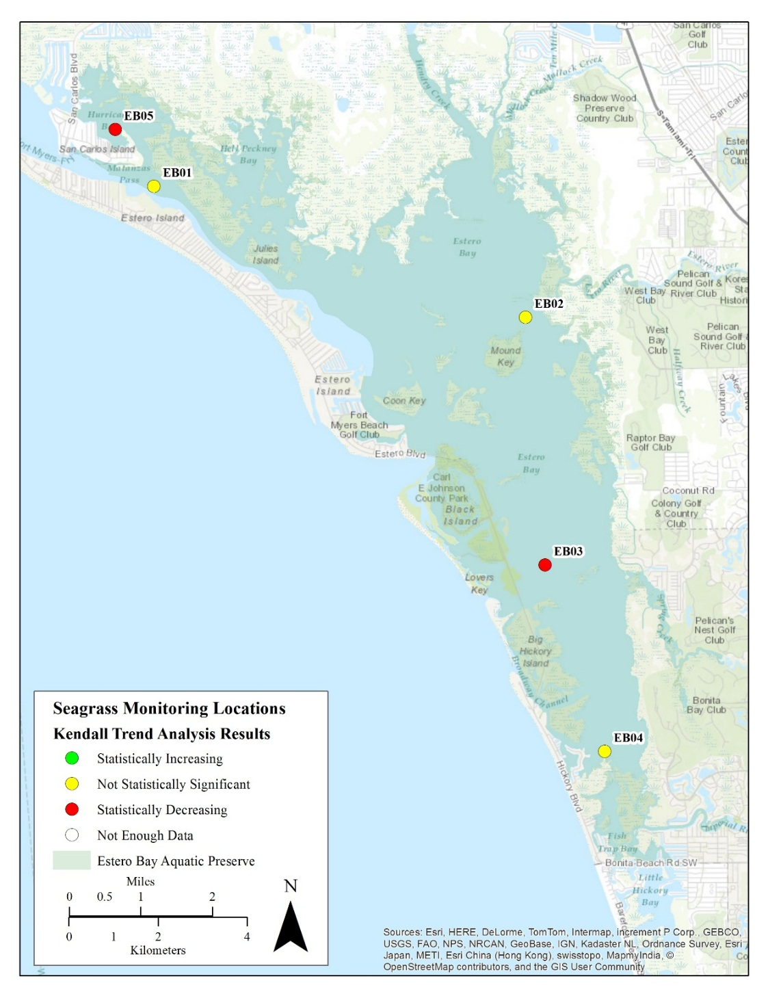
Map 7: Stations specific growing season mean total submerged aquatic vegetation abundance Braun-Blanquet score Kendall trend analysis results using data from 2006 to 2013.

Water Quality
Daily, seasonal, and long-term forces that act upon the waters of Estero Bay make this and other estuarine environments among the most dynamic systems on earth. The estuary is fed by several rivers and creeks and by sheetflow across the landscape. This drainage pattern makes the bay particularly sensitive to runoff and upland discharge. Estero Bay has a low-lying topography and a slow-moving flow of water; this has, historically, allowed rainfall to provide a consistent input of freshwater into the bay through the year. As this water flowed slowly across the landscape, it was filtered by vegetation and sediments. The nutrients and other materials were deposited in habitats like salt marshes before entering into the tributaries and into Estero Bay. Over time, however, this slow-moving sheetflow, has been increasingly diverted to area creeks and rivers that feed directly into the Bay (see section 2.2.2.3 for more details).
There are several point sources of pollution in Estero Bay, like local golf courses and water treatment facilities, however, the main source for the bay is non-point source pollution. The runoff from agriculture and development in Lee County has led to an influx of nutrients, pesticides, fecal coliforms, and other substances. Pollutants and nutrients, such as pesticides and fertilizers, are transported directly into Estero Bay through stormwater drains. Land adjacent to the bay acts as a buffer for the aquatic preserve. The land is managed by Lee County or Florida State Parks, and it has been set aside for preservation. It serves to filter the sheetflow and provides some protection from nutrients entering the bay.
As a result of the change in hydrology and increased sheetflow and stormwater runoff, nutrient loading occurrs. It is important to note that, since EBAP is designated as an OFW, the DEP cannot issue permits for direct pollution and discharges that would lower the existing water quality, or for indirect discharges that would significantly degrade the OFW (§403 F.S. Chapter 62-302).
Some portions of the tributaries that feed into the bay are listed as “impaired” under the Impaired Waters Rule, (§403 F.S. Chapter 62-303). Under this rule, impaired waters have increased levels of mercury, iron, or fecal coliform, among other pollutants. For impaired waterbodies, like those in Estero Bay, there are designated Total Maximum Daily Loads (TMDLs). TMDLs set a maximum amount of a given pollutant that a surface water can absorb and still meet the water quality standards that protect human health and aquatic life (DEP 2015). There are four TMDLs that have been set for Estero Bay: Fecal coliform not to exceed 400 colonies/100ml for Hendry Creek Marine, total nitrogen (TN) not to exceed 0.60mg/l for Hendry Creek Marine, TN not to exceed 0.60 mg/l for Hendry Creek, and TN not to exceed 0.74 mg/l for Imperial River (DEP, 2015).
The implementation of TMDLs requires the development of a Basin Management Action Plan (BMAP). A BMAP develops and executes programs and strategies that address the cause of pollutants to waterbodies. EBAP has two BMAPs, one in Hendry Creek and one in Imperial River that were implemented in November 2012 (DEP, 2015). There also are educational efforts underway to aid in reducing nonpoint sources of pollution by informing residents about the dangers of over-fertilizing their yards, and explaining how storm water drains carry polluted runoff into the bay unimpeded.

Water Quality Monitoring
During the 1990’s, the aquatic preserve began collecting data through several long-term water quality monitoring programs. One such program, the Charlotte Harbor Estuaries Volunteer Water Quality Monitoring Network (CHEVWQMN), began in 1996 and it continues to monitor the waters of Estero Bay and the greater Charlotte Harbor area. Based out of the Charlotte Harbor Aquatic Preserves (CHAP) office, the CHEVWQMN program was created as a joint effort between CHAP, the Charlotte Harbor National Estuary Program (CHNEP), and the Charlotte Harbor Environmental Center. This program has more than 80 water quality volunteers and they sample 46 fixed stations within the Greater Charlotte Harbor area (Map 5). All of the volunteers collect samples once a month at sunrise, using the same techniques, and testing for the same parameters including: wind speed, water surface conditions, tide, water depth, color, clarity, temperature, salinity, DO, pH, nitrogen levels, phosphorus, chlorophyll a, turbidity, and fecal coliform bacteria. The data collected is uploaded into the Charlotte Harbor Water Atlas online database and STORET national database for use by private citizens and local, state, and federal agencies. EBAP works as a regional coordinator for this program and oversees the seven sites in Estero Bay.
In the most recent CHEVWQMN water quality report that analyzed seasonal data from 1998-2005, Estero Bay ranked generally average compared to the other regions in the study (Duffey, Leary, & Ott, 2007). Estero Bay had the highest turbidity levels in the region studied; this ranks Estero Bay in the 60th percentile for Florida Estuaries. There were spatially and temporally isolated instances of fecal coliform bacteria; this indicates that increased levels are due to specific events or watersheds. In Estero Bay, the DO level was below average and well below the Florida Surface Water Standards of 4.0 and 5.0 mg/L. These three disparities are the major concern for the bay, but it was noted that the pH, temperature, and salinity levels significantly decreased over the study period (Duffey et al., 2007).
There has also been an ongoing local water quality monitoring effort in Estero Bay by the Lee County Environmental Laboratory (LCEL) since 1991. EBAP, in conjunction with the LCEL and DEP’s Division of Environmental Assessment and Restoration (DEAR) began a tributary monitoring program in 2003. The cooperative effort allows for the collection of water samples at seven fixed locations in the tributaries of Estero Bay (Map 5). The sites were strategically chosen to complement those already being monitored by CHEVWQMN and locations that have been sampled in the past by LCEL. EBAP staff originally collected data monthly, but this was reduced to bi-monthly monitoring, with duties being shared between both EBAP and DEAR staff. The parameters tested reflect those of the CHEVWQMN program. The analyzed data from both the CHEVWQMN and EBAP water quality monitoring programs are entered into a statewide database (STORET), and it is used in DEAR’s determination of impaired waters. This aided in the impaired waters designation referred to in section 4.1.
Most recently, in 2004, EBAP began a project to establish a baseline to determine the overall health of Estero Bay with the use of water quality monitoring devices called data sondes. The monitoring sites were selected with several factors in mind including salinity gradients, water depths, freshwater inputs, tidal circulation, and the location of navigational markers. Three data sondes were deployed in Estero Bay in null zones, areas with reduced water mixing (Map 5). The sondes record data every 15 minutes for parameters including depth, temperature, salinity, specific conductance, pH, DO, and turbidity. There are two additional sites that will be added to this data sonde program is funding allows. There are no data sonde water quality sites southwest of Mullock Creek. This area experiences great salinity fluctuations, with a monthly range from 1-32 ppt (Byrne et al., 2008). Seagrass has been documented in this area, but only at the edge of channels. Section 4.2 discusses light suitability for seagrass growth, and Hotaling et al. (2014) notes that this area is suitable for seagrass growth. Adding additional data sonde sites in this area of the bay will allow for water quality data collection to determine if the salinity fluctuation is a limiting factor for seagrass growth southwest of Mullock Creek.

Light Attenuation
The turbid conditions detailed in section 4.1 is the primary factor leading to variation in light attenuation in the bay. Photosynthetically active radiation (PAR) is the part of the light spectrum, between 400 and 700 nanometers (nm), that plants use for energy. Seagrass requires about 25% of surface PAR for photosynthetic production to occur. When the light reaching underwater plants is reduced, the SAV are less likely to receive the sufficient amount of PAR to sustain growth. This reduction in light can be caused by several factors like turbidity; both suspended sediments and algal blooms from increased nutrient loads contribute to turbidity.
The shallow waters of Estero Bay make the bay especially susceptible to wind and wave action that can cause the re-suspension of sediments. With this in mind, distinguishing areas of the bay that have a suitable light environment for seagrass, both spatially and temporally, is critical in seagrass protection and restoration. Hotaling (2014) conducted a study to determine the light attenuation throughout the bay. Stratified random sampling was used to identify 50 points in the bay to be used in the study. Data collection occurred over 2 days every 3 weeks for a year. The data recorded at each site included: PAR, water depth, salinity, water temperature, dissolved oxygen, and sampling time. The PAR readings were paired; there was one on the surface and one 25 cm from the bottom. All of the measurements were taken between 10 AM and 2 PM with three replicates measurements taken at each site.
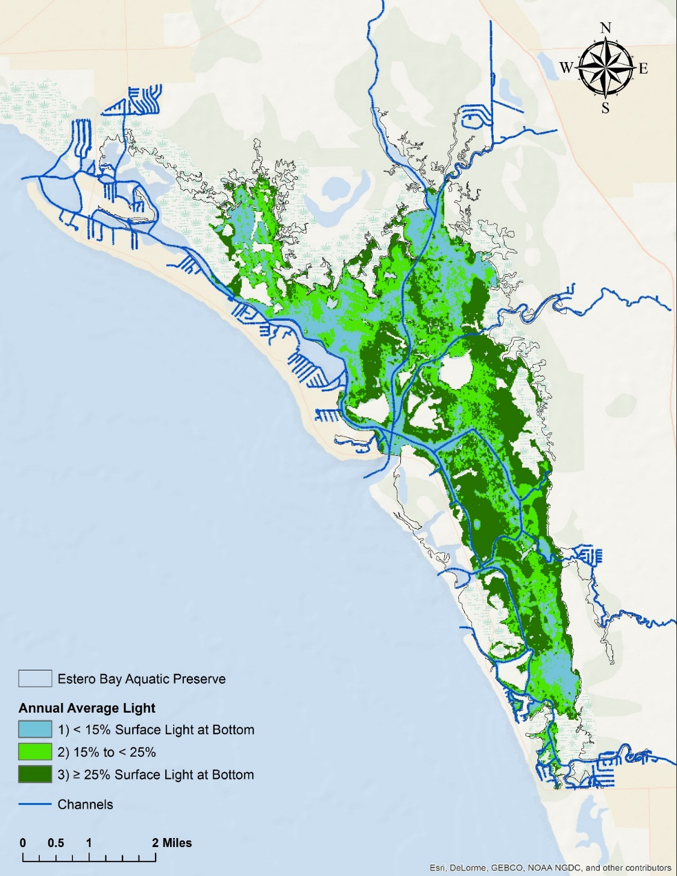
Hotaling (2015) model predicted that 39% of Estero Bay’s bottom area met or exceeded the target goal set by the Charlotte Harbor National Estuary Program, which is greater than 25% of surface irradiance (Map 8). With that in mind, it was predicted that 72% of the bay bottom received ≥ 25% of surface irradiance for at least half of the year and 58% of the bay bottom received ≥ 25% of surface irradiance for at least 62% of the year (Map 9; Hotaling, 2014).
Map 8: Predictions of the median annual percent of surface light available at the bottom throughout Estero Bay.

Oyster Mapping and Monitoring
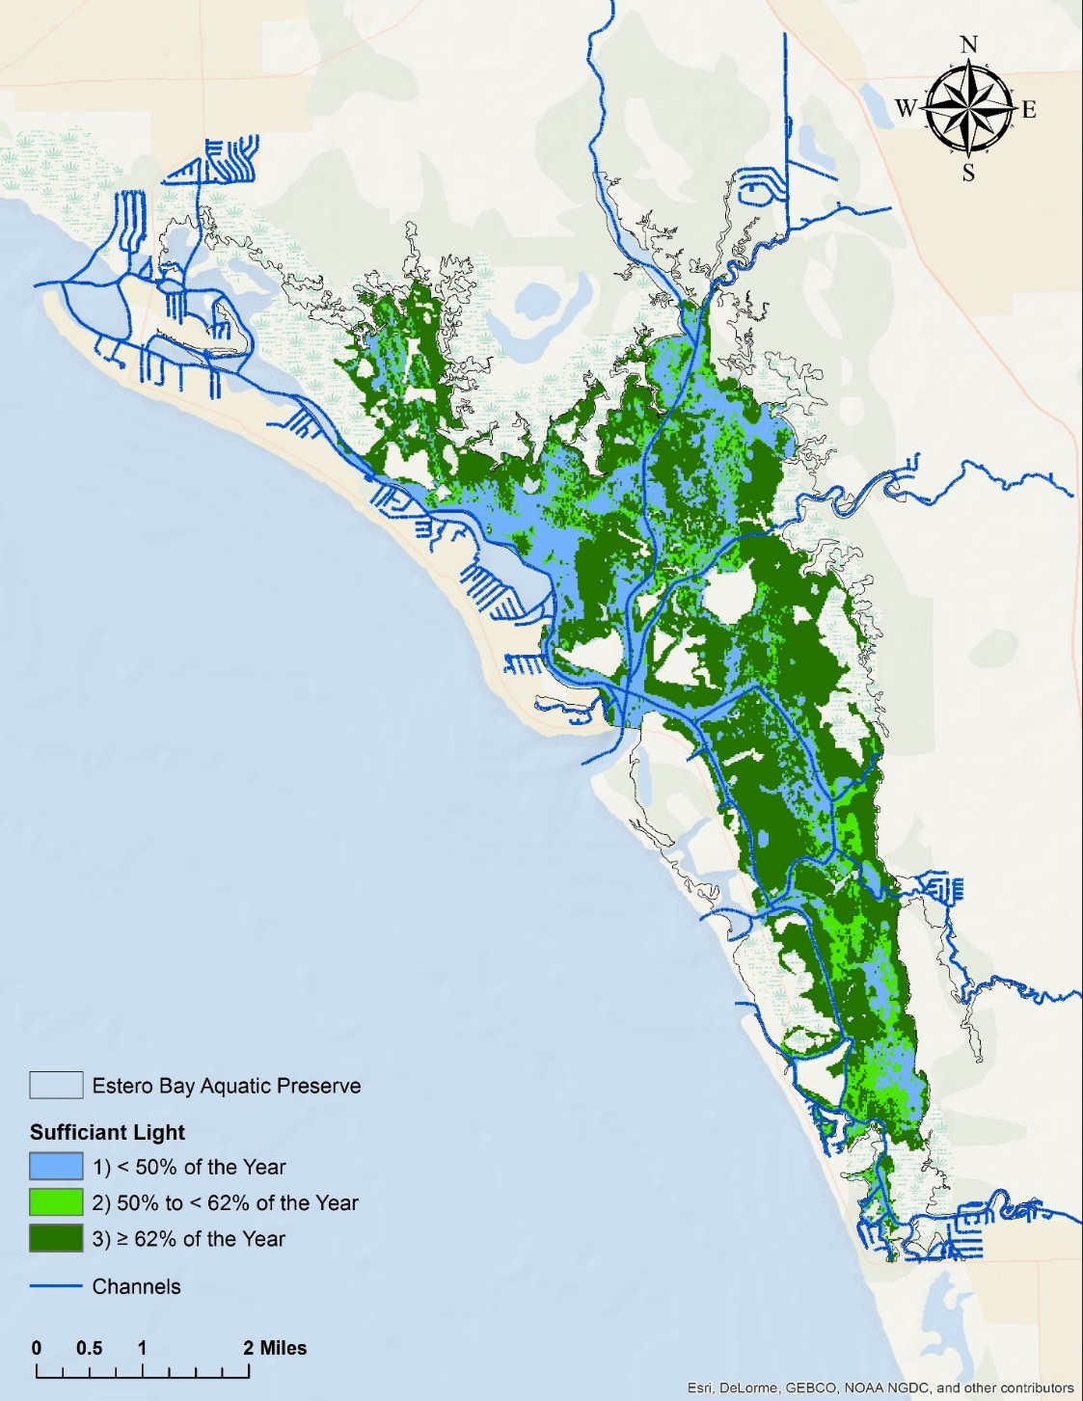
A lack of oyster field mapping was identified as a data gap by CHNEP in 2012. For this reason, intertidal oyster bars throughout the bay are currently being mapped. EBAP staff walk along the edge of each intertidal oyster bed utilizing a Trimble GPS device to map the perimeter. Mangrove areas within an oyster bed are also delineated. Oyster health is monitored using a quadrat that measures ¼ m x ¼ m. All oysters that fall within the quadrat are measured with calipers, and the length (mm) of live oysters is recorded. To date, EBAP has documented an average of 742 live oysters per meter².
Map 9: Predictions of the percent of the year that 25% or more of surface light is available at the bottom throughout Estero Bay.
The Southwest Florida Oyster Working Group, a group of local stakeholders, assisted in the development of the CHNEP’s Oyster Habitat Restoration Plan, which provides the guidelines for native oyster habitat restoration within the CHNEP study area, including Estero Bay. Oyster mapping and monitoring is a necessary action in the long term goal of restoration. Oyster restoration will aid in stabilizing sediments, shorelines, and adjacent habitats by buffering wave energy (Grabowski and Peterson, 2007) this, in turn, enhances water quality and can lead to the natural recolonization of seagrass.

Resource Management
The Resource Management Program addresses how EBAP manages its resources: specifically seagrass in this case. The management activities within this program are guided by FCO’s mission of ‘Conserving and Restoring Florida’s Coastal and Aquatic Resources for the Benefit of the People and the Environment.’ EBAP executes this management program by conducting seagrass monitoring and management activities and coordinating with relevant groups and agencies within and adjacent to the managed area that may impact the health of seagrass communities. The sound science provided by the Ecosystem Science Program is vital in the development of effective management projects and decisions.
EBAP provides resource information to Environmental Resource Permitting (ERP) staff to assist with permit application review. Additionally, EBAP assists Lee County with tributary water quality monitoring. The tributary monitoring data is entered into a statewide database.

Noticed General Permit and No Internal Combustion Motor Zones
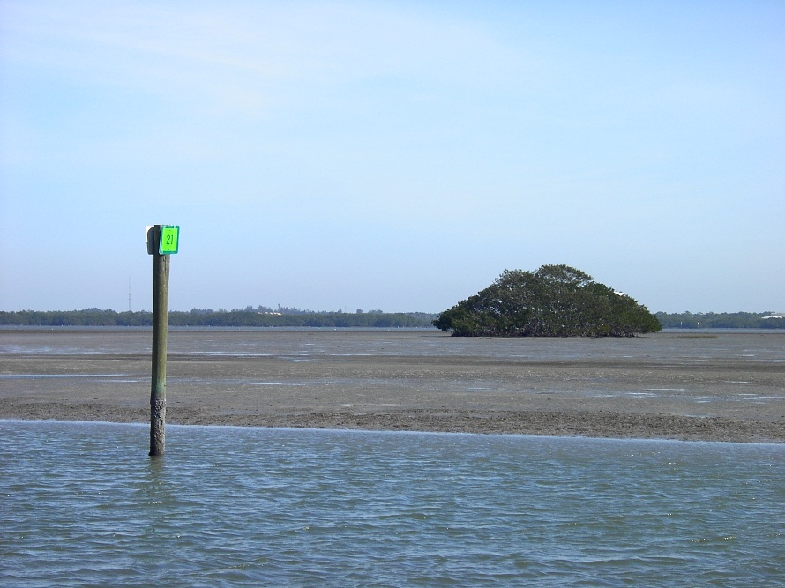
Lee County, West Coast Inland Navigation District (WCIND), Florida Sea Grant (FSG), DEP’s ERP section, and EBAP worked in a multi-year effort to establish future dredging limits in channels using the Regional Waterway Management System (RWMS). This report studied the trafficsheds within Estero Bay. Trafficsheds are areas that contain a concentration of boats that use a common channel to gain access to secondary channels and, ultimately, to deep, open water (Swett et al., 2014). The data collected included the number and type of boats, boat drafts, and channel depth. This data was used for the groups’ recommendations in the development of a Noticed General Permit (NGP) under Rule 62-341.494, F.A.C that provides authorization for dredging in existing public navigation channels within Lee County.
Figure 8: New Pass NICMZ at low tide
The RWMS collected data from more than 650 miles of channels in 147 systems, 29,000 vessels, and 6,800 signs throughout Lee County. The data was analyzed, and it was determined that many of the public navigation channels in Lee County had areas that were shallow enough to hinder existing boat traffic. The data from the trafficshed study was analyzed based on the existing boat traffic to determine the depth of dredging that would accommodate at least 95% of the existing vessels while still protecting the natural resources. WCIND, FSG, DEP, and Lee County Natural Resource staff met to determine a method to authorize dredging of those identified channels. Since some of the anticipated dredging was in Estero Bay and other areas under DEP management, DEP drafted language for this NGP.
Some of the dredging would, unavoidably, impact seagrass communities in Estero Bay. Since aquatic preserves are given some of the highest protections, a new dredging project authorized through this NGP, must mitigate to offset the impact to the aquatic preserve. That is to say that all of the projects within the preserve that fall under this NGP must mitigate their impacts, and they must provide other benefits that are “clearly in the public interest.” (Chapter 373, 403, 253 and 258, F.S.). There are four designated areas within Lee County to be marked and enforced as No Internal Combustion Motor Zones (NICMZs). Two of the four NICMZs are within EBAP.
The two zones in EBAP encompass a total of 581 acres. The zones are strategically located in shallow water (Figure 8) areas with heavy prop scars and that, when marked, are easily traversed (Map 11). The designation also considered vessel traffic patterns, visibility to boaters, enforceability, and ease of marking and regulating the zone. Once marked, NICMZs should prevent prop scarring and allow for the passive restoration of seagrass in these shallow, heavily propeller scarred areas. Non-motorized vessels, poling, and troling are permitted within these zones. Monitoring efforts are to be conducted both before and after the establishment of NICMZ to evaluate their effectiveness.

Education and Outreach Management
The Education and Outreach Management program increases public awareness and promotes informed stewardship within local communities. Staff provide information to the public at outreach events throughout the year. The Estero Bay Buddies (EBB) is a non-profit Citizen Support Organization (CSO) for EBAP, and this organization works with EBAP to increase public awareness through educational programs, resource-based activities, and special events. EBAP also hosts wading trips that invite the public to wade into mudflats and seagrass beds at low tide while an environmental specialist teaches them how various plants and organisms play an important role in the Estero Bay ecosystem.

Public Use Management
The Public Use Management Program focuses on providing the public with recreational opportunities within the boundaries of the preserve that are in compliance with EBAP’s Resource Management objectives. The FCO’s goal of the Public Use Management Program is to “promote and manage public use of our preserves and reserves that supports the research, education, and stewardship mission of FCO” (EBAP, 2014).
EBAP provides educational materials in kiosks bordering the preserve and at the EBAP office. These inform local boaters about the aquatic preserve and the value of its resources. Additionally, EBAP assists in the distribution of informational seagrass signage produced by DEP and FWC prohibiting seagrass destruction; Section 253.04(3)(a) F.S.. These signs inform boaters that they are entering a shallow area in the preserve where seagrass may be present. It also indicates that boat propellers can damage seagrass, and that destruction of seagrass in aquatic preserves is a violation of Florida’s law (Section 253.04(3)(a) F.S.), carrying a penalty of up to $1,000 (EBAP, 2014). Fort Myers Beach rental boat companies also display decals on their vessels; these decals are produced by the Fort Myers Beach Marine Resource Task Force.

Seagrass Protection and Restoration
Seagrass play a vital role in the overall health of estuary ecosystems by providing critical ecosystem functions. Scarring of seagrass beds from boat propellars has occurred throughout Florida and is increasing due to state’s increasing population and consequent number of registered vessels (Sargent et al., 1995). “A typical prop scar created by a small vessel (less than 6.5m in length) is approximately 0.25-0.5m wide and 0.1-0.5m deep. Larger vessels with twin propellers or inboard engines (greater than 6.5m in length) can produce deeper (0.25-0.75m) and wider prop scars (0.5-1.5m)” (Fonseca, Kenworthy, & Thayer, 1998).
In September of 2013, an Estero Bay seagrass restoration workshop was held to review historic and present conditions of seagrass in Estero Bay, develop a shared understanding of why stakeholders value seagrass in Estero Bay, and recommend actions for restoration of seagrass in Estero Bay. This workshop was hosted by the University of Florida and the WCIND, and from this workshop a committee of local stakeholders was established. The local stakeholder committee focuses on seagrass protection, restoration, and education in Estero Bay. The priorities for this committee were set out to include: mapping seagrass, determining the limiting factors for seagrass growth in Estero Bay, indicating where restoration is needed, determining the types of seagrass restoration that would benefit Estero Bay, providing outreach to promote seagrass protection, and bringing in funding for all efforts. It is important to note that this is not a DEP priority list and does not reflect the opinions of all the stakeholders involved. As part of a recommendation on the EBAP management plan, this seagrass protection and restoration plan was developed.

Purpose
The FCO established that Aquatic Preserves, submerged lands of exceptional beauty, are to be maintained in their natural or existing conditions. For this reason there are now 41 aquatic preserves; they encompass approximately 2.2 million acres, and FCO’s distinction ensures that “their aesthetic, biological, and scientific values may endure for the enjoyment of future generations.”
The preservation of the ecological and aesthetic value of seagrass in Estero Bay requires the development of a comprehensive plan to organize and carry out protection, and if necessary, restoration efforts. The criteria for successful restoration is well documented and considered in this report (Calumpong & Fonseca, 2001; Fonseca, Kenworthy, and Courtney, 1994; Fonseca et al., 1998; Fonseca, Julius, & Kenworthy, 2000). Propeller scarring is a significant problem in Estero Bay, and a restoration target of 3,660 acres was established by the CHNEP, using the maximum historical extent of seagrass beds and annual variability of seagrass cover (Yarbo and Carlson, 2014). The following plan contains EBAP and the Estero Bay Seagrass Stakeholder Committee’s restoration guidelines for proposed efforts. A matrix detailing the time commitment, cost, and potential funding resources for each strategy from this plan can be found in the appendix.

Goals and Objectives
Goal 1: Monitor seagrass health in Estero Bay
Objective 1: Evaluate existing seagrass monitoring program.
Strategy 1: Continue in-house seagrass monitoring.
Strategy 2: Expand seagrass monitoring program as staff and funding allows.
Objective 2: Map existing seagrass.
Strategy 1: Support collections of aerial imagery over seagrass areas.
Strategy 2: Map and validate seagrass mapping from aerials.
Strategy 3: Conduct other technologies like shallow-water side scan sonar and hydro-acoustic sensors to map seagrass.
Strategy 4: Map prop scars in EBAP.
Objective 3: Evaluate criteria to designate priority areas for habitat restoration.
Strategy 1: Continue in-house resource monitoring and collaboration with local stakeholders to monitor water quality in EBAP.
Strategy 2: Expand in house water quality monitoring to two new sites in EBAP.
Strategy 3: Collect and analyze light attenuation and boating patterns on 3-year rotating basis.
Goal 2: Restore seagrass in EBAP.
Objective 1: Restore seagrass in priority areas in EBAP.
Strategy 1: Conduct restoration based on protocols in this plan as funding allows
Goal 3: Protect seagrass in EBAP.
Objective 1: Protect seagrass from future scarring in Estero Bay.
Strategy 1: Mark NICMZs with enforceable signs.
Strategy 2: Post EBAP boundaries.
Strategy 3: Catalogue permit holder/ownership of privately owned channel markers in the bay.
Strategy 4: Evaluate existing channel marker placement to improve seagrass protection.
Goal 4: Seagrass Education and Outreach
Objective 1: Provide information to the public regarding seagrass protection.
Strategy 1: Create quality educational information and signage for entry points into the bay.
Strategy 2: Promote seagrass protection at events and in existing educational vehicles.

Restoration Project Protocol
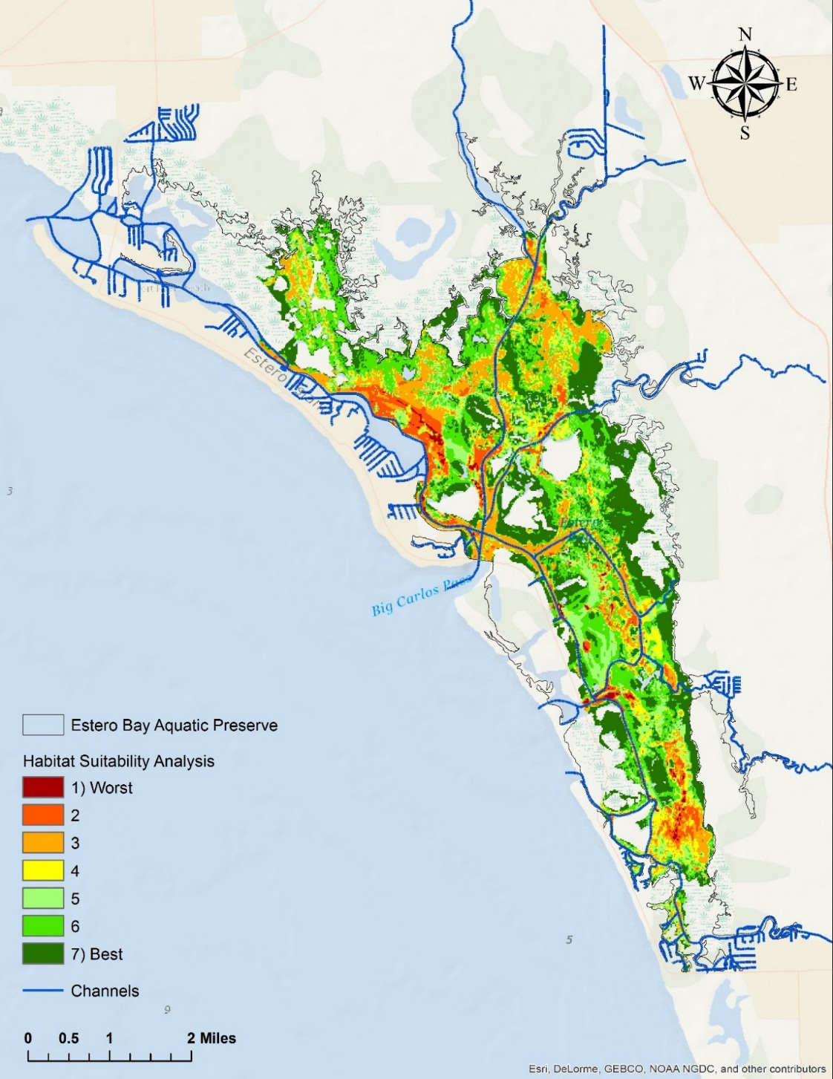
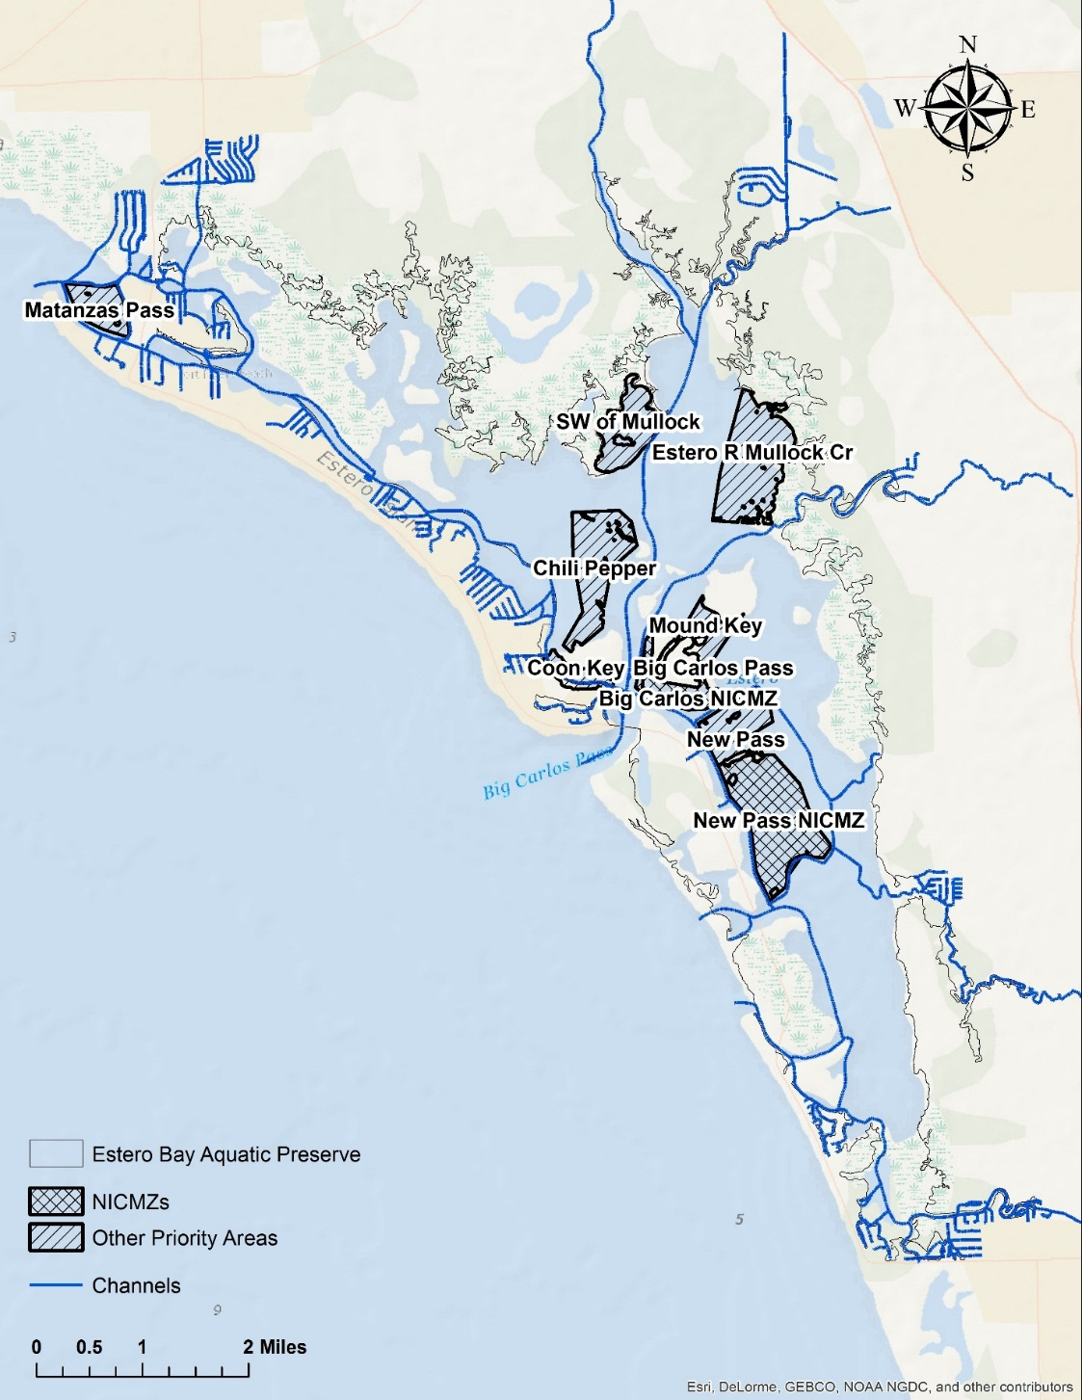
Various projects may be undertaken to benefit seagrass in EBAP. The primary intention of aquatic preserves is to maintain the submerged lands in their natural or existing condition, and so, seagrass protection projects are directly in line with EBAP’s goal. Lewis (1987) defines restoration as the return to the pre-existing condition from a disturbed or totally altered one by some action. There are areas of submerged lands in Estero Bay that have lost seagrass due to human activity and could benefit from restoration projects. Areas that have not, historically, had seagrass present, or damaged areas that have not had natural recolonization of seagrass, require a thorough analysis of habitat suitability to assess if seagrass growth will be possible. Seagrass growth is limited by water quality and light attenuation, and is influenced by boating traffic.
Map 10: Habitat suitability ranking for Estero Bay obtained by combining the predicted amount of bottom light, the percent of the year sufficient light is available, and the boating density outside of channels.
Map 11: Priority areas designated by the EBAP seagrass stakeholder group for seagrass restoration.
Hotaling (2014) created a habitat suitability map for seagrass growth by combining the predicted amount of bottom light, the percent of the year sufficient light is available, and the boating density outside of channels (Map 10). Based on both the extent of prop scarring throughout the bay and Hotaling (2014) habitat suitability map, the Estero Bay seagrass stakeholder group designated priority areas in the bay for restoration projects (Map 11). Choosing from the priority areas outlined in the map, ensures that areas with heavy prop scarring and those with the proper growth conditions for seagrass, will be selected for restoration. Areas in the bay that does not have historical presence of seagrass, but are deemed suitable for seagrass growth after considering seasonal fluctuations in water quality, light attenuation, and boat traffic, may be considered for restoration projects.
Once a site is selected for restoration, this modification of Calumpong & Fonseca’s (2001) protocols need to be considered:
- Assess the extent of seagrass damage at the selected site pre-restoration.
- Determine bed history, exposure, substrate type, rate of sedimentation, boat traffic, and presence of animal disturbance
- Select a sediment type and/or seagrass source that matches the planting site
- Determine time frame and the available budget
- Select the appropriate restoration technique (described in section 5.5)
- Select a protective measure to prevent future damage
- Create a monitoring schedule for post-restoration
- Obtain appropriate permits to begin the project
  - Seagrass Extent and Damage Assessment
Mapping seagrass habitats to delineate boundaries and to detect propeller scars is essential for designing and implementing habitat management programs (Lee Long &Thom, 2001; Kirsch et al., 2005). Appropriate seagrass coverage and propeller scar mapping methods discussed in section 3.3.

Proposed Restoration Techniques
This section outlines the suggested methods that can be used to restore seagrass communities in Estero Bay Aquatic Preserve. Numerous methods have been used to successfully establish seagrass beds for restoration purposes (Fonseca, 1994; Fonseca et al., 1998, Fonseca et al., 2000). The Estero Bay Aquatic Preserve seagrass stakeholder group deemed the following techniques appropriate for implementation in Estero Bay based on the biological features of the area: sediment tubes and seagrass transplantation. Since EBAP is a nutrient rich area, the addition of nutrients through the use of bird stakes is discouraged.

Sediment Tubes
When a prop scar is present, the newly damaged area is unstable; it has steep sides that are likely to expand as their walls erode over time. Sediment tubes are biodegradable sediment-filled fabric mesh tubes created by Seagrass Recovery, Inc., a private company based in Ruskin, Florida. This is an environmentally friendly tube that is approximately 1.5 meters long, 15-20 cm in diameter, and weighs about 13.6-18.2 kg; and it is laid directly into the prop scar.
The tubes need to be filled with sediments similar to those found in the existing scar and surrounding seagrass beds. Over time, the tube’s fabric decomposes and leaves the area covered with sand (FWC, 2015). The sediment placement allows for the seafloor to return to its original grade, stabilizes the substrate to prevent erosion, and prepares the area for colonization by neighboring or transplanted seagrass.

Seagrass Transplantation
Seagrass transplantation is used only to restore seagrass beds lost due to human activities; this includes reduction in water clarity, mining, dredging, filing, and fishing gear and vessel related activities. Natural disturbances have an ecological and evolutionary function, and in most cases, the bed recovers.
To begin seagrass restoration, one must clearly identify the objective of the project. It is imperative that the persons involved in a planting project are familiar with techniques, as planting inexperience is one of the most common causes of planting failures in seagrass restoration (Fonseca et al., 1998). Site selection for planting is an important factor, and the following criteria that has been modified from Fonseca et al. (1998) should be employed in EBAP.
- The site must be at a depth similar to nearby grass beds
- There is a history of seagrass growth
- Anthropogenic disturbance that leads to seagrass loss has ceased.
- It is not an area subject to chronic storm damage
- It is not undergoing excessive natural recolonization of seagrass
- Restoration has been successful at similar sites
- There is a sufficient space to conduct the planting
- A similar quality habitat would be restored as was lost.
- The sediments, salinity regime, and hydrodynamic conditions are suitable (Byrne & Gabaldon, 2008).
- The potential loss to grazing and bio-turbation is low, otherwise, grazer enclosures would be needed.
Although there are five species of seagrass found in EBAP, it has been shown that restoration efforts are more successful when planting a pioneer species like Shoalgrass or Ruppia first, especially for restoring slower-growing seagrass species (Calumpong & Fonseca, 2001). Ruppia has shown to be a successful species to plant in this region (Rick Bartleson, personal communication, June 12, 2015; Beth Fugate, personal communication, June 08, 2015). Once these plants have been successfully integrated, other species can be introduced. Following this sequence allows for more suitable conditions for recolonization of other species while still stabilizing the sediment and establishing a functional seagrass habitat (Fonseca et al., 1998). For this reason, planting efforts in EBAP should begin with shoal grass or widgeon grass.
There are several factors that influence transplanting success. These include the uprooting of plant material due to waves and tidal action, sediment instability, and highly organic sediment. Other factors that could affect the project inlcude desiccation of plant material during transport and bioturbation (Calumpong & Fonseca, 2001).
There are four basic sources of plant material that can be used to begin restoration: plugs, sprigs, seeds, and cultivated plants. Seagrass plugs are intact units of sediment, roots, rhizomes, and leaves (Lewis, 1987). Plugs have been used extensively with good results, but the use of plugs is at the cost of disturbing healthy seagrass beds (Fonseca et al., 1998). For this reason, this transplanting method is excluded from this plan.
Anchoring the planting material to protect them from wave action also needs to be considered, and so, combining any of these planting methods with the placement of sediment tubes is necessary in order to bring the restoration site to grade. It is important to note that no planting material can be obtained from the sediments within the aquatic preserve (Rule 5B-64, FA.C).
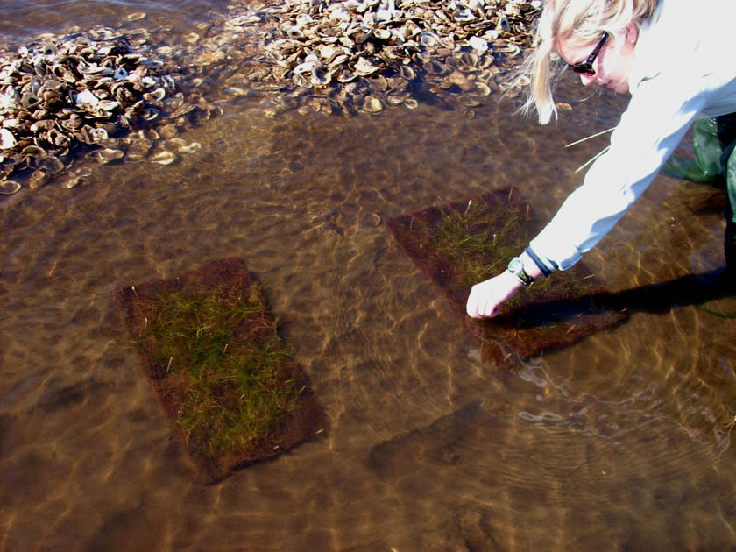
Figure 9: Lab propagated widgeon grass coconut mats being secured on site (Photo Credit: DEP Northwest District).

Sprigs
Sprigs include the root, rhizomes, and leaves of the seagrasses, and no sediment. They can be collected from wrack lines (Lewis, 1987) or as they drift near the surface. When fragments are collected, healthy seagrass beds are protected, and there is no damage to any donor sites. EBAP suggests using DEP’s low cost, highly effective, and non-destructive restoration technique using sprigs and coconut-fiber mats (DEP, 2013c). The sprigs are cloned to produce thousands of plants, and they are placed on top of a coconut-fiber mat that is about the size of a placemat (Figure 10). The sprigs grow through the mats, and then they can be placed on top of sediment that has already been returned to grade. The mat is secured to the bottom using landscape fabric staples, and the roots can then grow into the sediment. The coconut-fiber mat eventually breaks down, leaving a healthy seagrass bed. Coconut mats may also be used on a smaller scale using the collected sprigs without the cloning process. The Northwest Florida Aquatic Preserve for these processes can be found in Appendix 2 and Appendix 3.

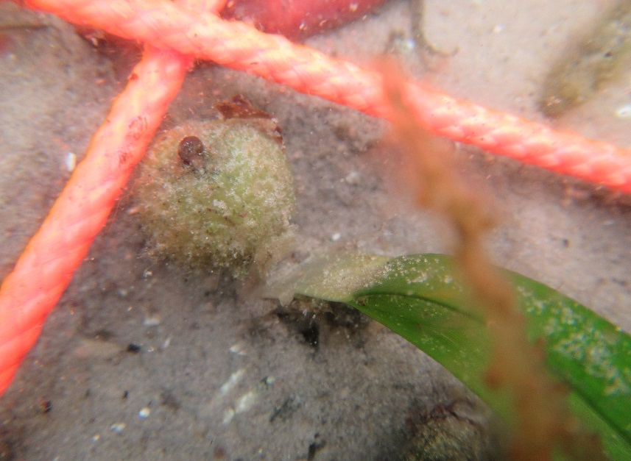
Seeds
Figure 10: Photograph of a turtle grass seed in Estero Bay.

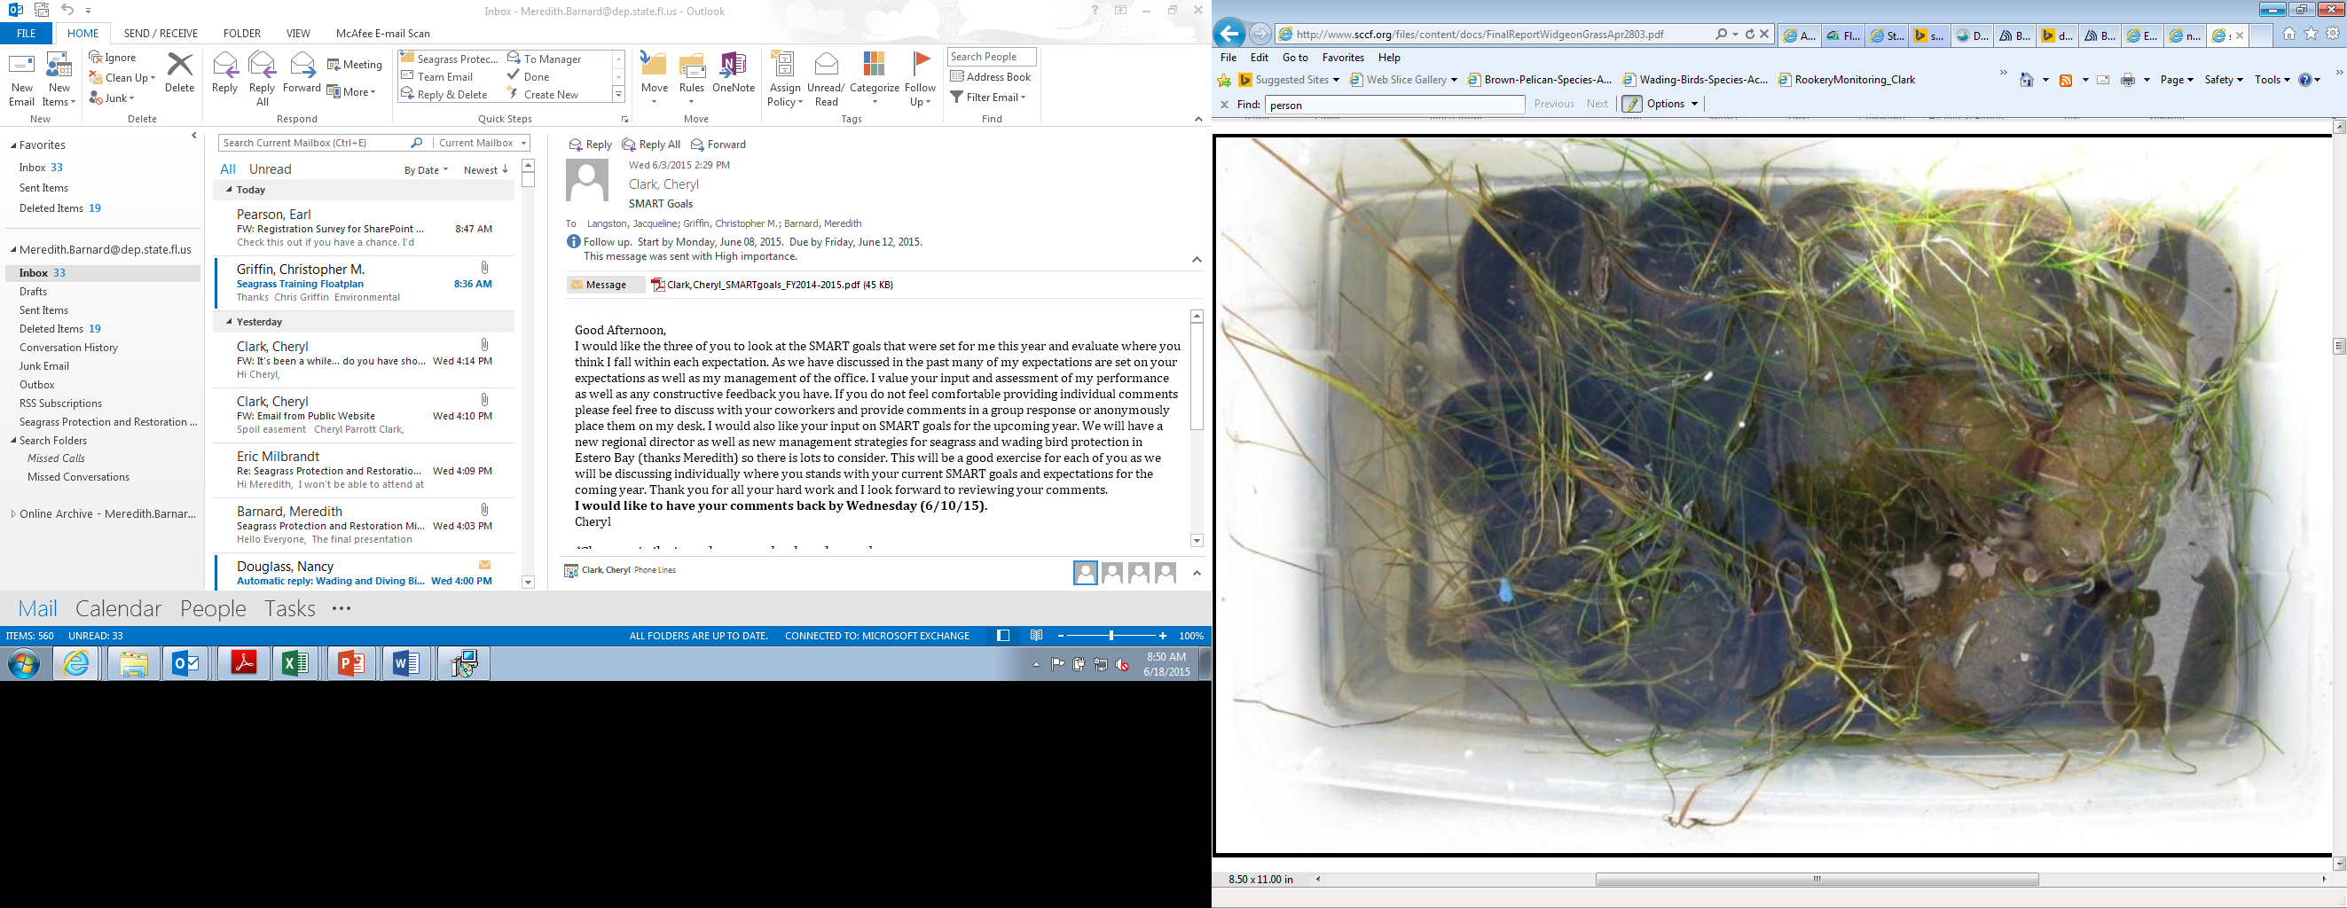
Seed distribution is only applicable in low energy areas so that the seeds can settle and germinate (Calumpong & Fonseca, 2001). Even though all of the seagrass species found in Estero Bay are documented to produce seeds, only Turtle grass (Figure 11) and widgeon grass have been documented to be found in a quantity sufficient for use in restoration efforts. The use of Turtle grass seeds has been implemented with success following the initial establishment of shoalgrass in a restoration site (Durako & Moffler, 1981). However, since seeds are not prevalent in Estero Bay, the use of seeds will be costly, and it is not recommended. If a distributor for widgeon grass seeds is available, this may be pursued, but it is otherwise discouraged for use in Estero Bay due to the associated cost and time commitments.
Figure 11: Example of SCCF’s peat pots before being transplanted on site (Photo Credit: Richard Bartleson, SCCF)

Cultivated Plants
Seeds planted in peat pots or plastic containers help minimize seed loss. Peat pots may be held in greenhouse tanks until after germination (Treat & Lewis, 2006). Pots with newly sprouted seeds with one short shoot (seedling) can be cultivated and planted in a restoration site (Figure 10). Durako & Moffler (1981) suggested that the use of the use of peat pots allows for greater anchoring ability than bare root seedlings. Regardless, a major problem with peat pots is that they are susceptible to being washed out during periods of high wave action (Treat & Lewis, 2006). A method used successfully by the Sanibel Captiva Conservation Foundation (SCCF) involves planting sprigs (seagrass fragments) into sediment in plastic containers, which are placed in an outdoor tank to grow into sods. Sods can be transplanted at the restoration sites.

Proposed Methods to Monitor Post Restoration
There are several factors that need to be considered when monitoring seagrass post restoration. EBAP will require the measurement of seagrass coverage and persistence. This is in line with Fonseca et al.’s (1998) definition of seagrass planting success as ‘the unassisted persistence of the required acreage of seagrass coverage of a prescribed period of time (suggested minimum of five years).’ Additionally, the aforementioned propeller scar survey methods need to be utilized to assess the extent of propeller scars after restoration.
For the monitoring of restored areas, EBAP will measure survival, aerial coverage and shoot length (Fonseca et al., 1998; Fonseca, Kenworthy, Julius, Shutler, & Fluke. 2002). Monitoring needs to be conducted quarterly for the first year after planting and bi-annually thereafter for a minimum of four more years; this equals the 5 year total recommendation from Fonseca et al. (1998).

Survival
The number of planting units that survive should be recorded. In a sufficiently small planting site (<10m²), every single planting until should be surveyed for presence or absence of seagrass shoots. The presence of a single shoot on a planting unit indicates survival. If the planting site is large, then randomly selected subsections should be sampled, with at least 10 replicate samples (<10m²⁾ being taken for each subsection.

Aerial Coverage
A random sample of a planting site should be taken until coalescence is noted. Coalescence occurs when the planting units come together and can no longer be distinguished from the original planting unit. The area covered by a planting unit should be recorded, either by taking perpendicular width measurements of the bed and computing the area, or by using a quadrat method. This method should be used in conjunction with counting the number of shoots described in section 5.5.3 to more accurately assess growth.

Number of Shoots
Random areas of the planting units should be visited to count the number of shoots per planting unit. When the shoot density of a planting unit is equal to that of reference sites, the plants are occupying space that is consistent with long-term establishment and so, successful colonization has occurred. Obtaining the number of shoots is recommended in addition to the aerial coverage because shoot numbers are more accurate means of assessing the success of the project.

Future Habitat Protection Methods
Recolonization of seagrass can occur when damaged seagrass beds are protected from future injuries. The regrowth of seagrass in propeller scarred areas is slow, and areas in the midst of natural recolonization as well as those that have undergone a restoration project would benefit from protection. For any initiatives taken to protect areas of the bay from future scarring, pre- and post-propeller scar surveys must be conducted. Sargent et al. (1995) suggests a four point approach to protect seagrass from propeller scaring.

Education
It is imperative that all boaters, both tourists and residents, know where shallow seagrass beds are located, how to avoid them, and to understand the ecological and economical importance of these sensitive ecosystems. The boaters can be educated through a number of different initiatives. It has been documented that graphically displaying seagrass scars through aerial photography is useful in educating managers, decision-makers, and the public (Sargent et al., 1995). With this in mind, Sargent et al. (1995) suggests that this method could be used to educated seasonal residents and tourists at locations that they are likely to visit like boat-launching ramps and boat rental marinas.
EBAP will work to create quality outreach programs to better educate the public regarding seagrass protection in Estero Bay. Existing outreach vehicles will also be utilized to educate the public, this includes promoting the Pine Island Sound Seagrass Protection Project that has been developed by Sea Grant and providing information about seagrass protection in local educational resources (i.e.: Boater’s Guide, pamphlets, etc.). Additionally, EBAP and EBB will seek involvement in local events to promote seagrass protection and restoration (i.e.: fishing tournaments, boat shows, boating classes, public seminars, etc.).

Channel marking and signage
Channels that are marked in compliance with FWC’s uniform Waterway guidelines and in coordination of the U.S. Coast Guard surely aid boaters in taking the correct passages. This not only minimizes incidental scarring, but promotes boating safety as well. For this reason, evaluating existing channel markers, determining channel marker ownership, and the placement of new/relocation of existing signs (where necessary), is a goal of this protection and restoration plan.
In general, markers should be placed away from the edges of shallow seagrass beds, they should be paired, and they should extend well beyond the end of the channel. Following these parameters provide a wider buffer against scarring. With sufficient funding, EBAP will post boundary signs at boat ramps and channels within Estero Bay. These will let boaters know that they are entering an aquatic preserve, and seagrass scarring is henceforth prohibited. Another important task that EBAP will take on with sufficient funding will be to catalogue the permit holder and the ownership of privately owned channel markers in Estero Bay; this will, in turn, aid in their proper maintenance.
EBAP will evaluate existing channel marker placement throughout the bay; seagrass scar maps will be compared to locations of existing channels. From this comparison, EBAP can determine if action is required to move or improve those existing markers, and action can be taken pending funding and channel ownership.

Effective Enforcement of Boating Regulations
Warnings and citations for seagrass scarring must be issued for enforcement to be effective. If enforcement personnel are consistently active in areas of heavy boating activity, Sargent et al. (1995) suggests that this would be an effective tool in reducing the potential impacts from the boaters in shallow waters. With this in mind, EBAP will foster its relationship with local stakeholders, like FWC, to increase the presence of legal authority actively patrolling the bay. Once the NICMZ are marked and the boundary signs that indicate to boaters that seagrass scarring is prohibited in the aquatic preserve are installed, these signs can be enforced.

Limited-motoring-zones
Limiting access and the closure of areas with shallow seagrass beds is an effective way to reduce scarring (Sargent et al., 1995). Estero Bay has two designated NICMZ, but the zones are currently not marked. Proper signage to mark the NICMZ is a goal of this protection and restoration plan. In addition to conducting propeller scar surveys both before and after the NICMZ are marked (Section 3.3.2), the marked zones need to be monitored over time to determine the effectiveness of the designation, and methods to do so can be found in section 5.5. Once marked, these zones can be enforced.

Review and Permitting
Protection and restoration projects are subject to state and federal regulations that require project review and issuance of appropriate permits. Any project must be approved by the EBAP manager and state permits must be acquired from Florida DEP and the SFWMD when necessary. Any projects involving sediment fill or dredging will need a permit from the U.S. Army Corps of Engineers. If seagrass transplantation is being carried out with seagrass fragments collected from within the aquatic preserve, an Aquatic Plant Permit, FDACS Form 08450 will also be required under Florida Statutes Chapter 369.

References
Altsman D. (2004). Seagrass Habitat in the Northern Gulf of Mexico: Degradation, Conservation and Restoration of a Valuable Resource. Gulf of Mexico Program. http://gulfsci.usgs.gov/gom_ims/pdf/pubs_gom.pdf
Berne, S., Casting, P., Drezen, E. L., and Lericolais, G., (1993), Morphology, international structure, and reversal of asymetry of large subtidal dunes in the entrance to Gironde Estuary (France). Journal of Sedimentary Petrology, 63, 780-793.
Boswell, J. G., Contractor, I., Birch, A., Cobb, D., & Council, S. F. R. P. (2012). Charlotte Harbor National Estuary Program Oyster Habitat Restoration Plan.
Byrne, M. J., & Gabaldon, J. N. (2008). Hydrodynamic Characteristics and Salinity Patterns in Estero Bay, Lee County, Florida (No. 2007-5217). Geological Survey (US).
Calumpong H.P., Fonseca M.S. (2001) Seagrass transplantation and other seagrass restoration methods. In: Short FT, Coles RG (eds) Global seagrass research methods. Elsevier, pp 425–443
City of Fort Myers. Fort Myers History. Retrieved March 24, 2015. http://www.cityftmyers.com/
Code, F. A. Rule 5B-64. Aquatic Plant Importation, Transportation, Non-nursery Cultivation, Possession, and Collection.
Costanza, R., de Groot, R., Sutton, P., van der Ploeg, S., Anderson, S. J., Kubiszewski, I., Farber, S., and Turner, R.K. (2014). Changes in the global value of ecosystem services. Global Environmental Change 26:152–158.
Duffey, R., Leary, R., Ott, J. (2007). Charlotte Harbor and Estero Bay Aquatic Preserves Water Quality Status and Trends for 1998-2005. CHAPs Technical Report #2. Retrieved April 2, 2015. http://www.dep.state.fl.us/coastal/sites/charlotte/volunteer/2007_CHEVWQMN_ eport.pdf
Durako, C.M., Hall, M.O., Sargent, F., Peck, S.(1992). Propeller scars in seagrass beds: an assessment experimental study of recolonization in Weedon Island State Preserve Florida. Pp.42-53 in Webb, F. Proceedings from the 19th Annual Conference of Wetlands Restoration and Creation. Hillsborough Community College, Tampa, Fl.
Durako, M. J., and Moffler M.D. 1981. Variation in Thalassia testudinum seedling growth related b geographic origin.Pp. 100-11'7 in R. H. Stovall, ed. Proc.8th Ann. Conf. Wetlands Restoration and Creation. Hillsborough Community College,Tampa, Florida.
Erftemeijer, P. L., & Lewis, R. R. R. (2006). Environmental impacts of dredging on seagrasses: a review. Marine Pollution Bulletin, 52(12), 1553-1572.
Erftemeijer, P. L., & Middelburg, J. J. (1995). Mass balance constraints on nutrient cycling in tropical seagrass beds. Aquatic Botany, 50(1), 21-36.Estero Bay Agency on Bay Management (EBABM). (2014). State of the Bay Report. North Fort Myers, FL: Southwest Florida Regional Planning Council. Retrieved: April 2, 2015. http://www.swfrpc.org/content/Natural_Resources/ABM/2014StateoftheBayUpd eFinal20150105.pdf

Estero Bay Aquatic Preserve. (2014). Florida Department of Environmental Protection. Estero Bay Aquatic Preserve Management Plan. Management Plan.
Everglades West Coast BMAP Policy Briefing. (2012) South Florida Regional Planning Council. Ft. Myers Florida
Fonseca, M. S. (1992). Restoring seagrass systems in the United States. Restoring the nation’s marine environment. Maryland Sea Grant Book, College Park, Maryland, 71, 79-110.
Fonseca, M. S., Kenworthy, W. J., Courtney, F. X., & Hall, M. O. (1994). Seagrass planting in the southeastern United States: methods for accelerating habitat development. Restoration Ecology, 2(3), 198-212.
Fonseca, M. S., Kenworthy, W. J., & Thayer, G. W. (1998). Guidelines for the conservation and restoration of seagrasses in the United States and adjacent waters NOAA Coastal Ocean Program Decision Analysis Series (pp. 222). Silver Spring, MD: NOAA Coastal Ocean Office.
Fonseca, M. S., Julius, B.E., & Kenworthy, W.J. (2000). Integrating biology and economics in seagrass restoration: How much is enough and why? Ecological Engineering 15:227–237.
Fonseca, M.S., Kenworthy, W.J., Julius, B.E., Shutler, S., and Fluke, S. (2002). Seagrasses. Pages 149-170 in MR Perrow and AJ Davy (Eds). Handbook of EcologicalRestoration, Vol. 2. Cambridge University Press, NY.
Florida Department of Environmental Protection. (2013a) Florida Department of Environmental Protection. Coastal Habitats. Retrieved March 23, 2015. http://www.dep.state.fl.us/coastal/habitats/seagrass/
Florida Department of Environmental Protection. (2013b) Florida Department of Environmental Protection. Florida Pays Tribute to the State's Seagrasses Retrieved March 23, 2015 http://www.dep.state.fl.us/coastal/news/articles/2013/1303_Seagrass.htm
Florida Department of Environmental Protection. (2013c) Florida Department of Environmental Protection. Seagrass Restoration. Retrieved March 23, 2015. http://www.dep.state.fl.us/northwest/ecosys/section/restorationseagrass.htm
Florida Department of Environmental Protection. (2015). Total Maximum Daily Loads Program. Retrieved June 18, 2015. http://www.dep.state.fl.us/water/tmdl/index.htm
Florida Fish and Wildlife Conservation Commission. (2003). Florida Fish and Wildlife Conservation Commission. Florida Marine Research Institute. Florida Seagrass Manager’s Toolkit. http://myfwc.com/media/204091/toolkit20040726_3858.pdf
Florida Fish and Wildlife Conservation Commission. (2011). Florida Fish and Wildlife Conservation Commission. Recommended Survey Protocols for Estuarine and Marine Submerged Aquatic Vegetation (SAV) related to Permitting Applications (DRAFT). Retrieved April 2, 2015. http://myfwc.com/media/1626941/SeagrassSurveyProtocol.pdf
Florida Fish and Wildlife Conservation Commission. (2015). Florida Fish and Wildlife Conservation Commission. Seagrass Projects, Accelerating Recovery of Seagrass Habitats. Retrieved April 2, 2015. http://myfwc.com/research/habitat/seagrasses/projects/active/seagrass-habitat recovery/
Garrote-Moreno, A., McDonald, A., Sherman, T. D., Sánchez-Lizaso, J. L., Heck, K. L., & Cebrian, J. (2015). Short-term impacts of salinity pulses on ionic ratios of the seagrasses Thalassia testudinum and Halodule wrightii. Aquatic Botany, 120, 315-321.
Gallegos, M., Menno, M., Rodriguez, A., Marba, N., Duarte, C.M. (1994) Growth patterns and demography of ploneer Caribbean seagrasses (Halodule wrightii and Syringodium filiforme). Mar Ecol Prog Ser 109:99-104
Grabowski, J.H. and C.H. Peterson. 2007. Restoring oyster reefs to recover ecosystem services, pp. 281-298. In Cuddington, K. et al. (eds.), Ecosystem Engineers: Concepts, Theory and Applications. Elsevier-Academic Press.
Gray, W., Beever, J. W., III, & Beever, L. B. (2009). State of the Bay Update. North Fort Myers, FL: Southwest Florida Regional Planning Council, Estero Bay Agency on Bay Management.
Hemminga, M. A., & Duarte, C. M. (2000). Seagrass ecology. Cambridge University Press.
Hotaling, A. (2014). Seagrass Restoration in a Boating Environment (Doctoral dissertation, University of Florida).
Hudson, J.H. and W.B. Goodwin. 2001. Assessment of vessel grounding injury to coral reef and seagrass habitats in the Florida Keys National Marine Sanctuary, Florida: Protocol and methods. Bulletin of Marine Science 69(2):509-516.
Kenworthy, W. J., and M. S. Fonseca. (1996). Light requirements of seagrasses Halodule wrightii and Syringodium filiforme derived from the relationship between diffuse light attenuation and maximum depth distribution. Estuaries 19:740–750.
Kirsch, K. D., Barry, K. A., Fonseca, M. S., Whitfield, P. E., Meehan, S. R., Kenworthy, W. J., & Julius, B. E. (2005). The Mini-312 Program—An Expedited Damage Assessment and Restoration Process for Seagrasses in the Florida Keys National Marine Sanctuary. Journal of coastal Research, 109-119.
Leary, Raymond. (2012). Seagrass dynamics within Estero Bay Aquatic Preserve Along Fixed Transects (2002-2009).
Lee Long, W., & Thom, R. M. (2001). Improving seagrass habitat quality. Global Seagrass Research Methods, 407-424.
Lewis, RR. 1987. The restoration and creation of seagrass meadows in the southeastern United States. Pages 153-173 in MJ Durako, RC Phillips and RR Lewis (eds.), Proceedings of the Symposium on Subtropical Seagrasses of the Southeastem United States. Fla. Dept. of Natural Resources Mar. Res. Pub. No.42. St. Petersburg, Florida. 209 pp.
Lewis III, R. R., & Estevez, E. D. (1988). The ecology of Tampa Bay, Florida: an estuarine profile (No. BR-85 (7.18)). Mangrove Systems, Inc., Tampa, FL (USA); Mote Marine Lab., Sarasota, FL (USA).
Lirman, D., & Cropper, W. P. (2003). The influence of salinity on seagrass growth, survivorship, and distribution within Biscayne Bay, Florida: field, experimental, and modeling studies. Estuaries, 26(1), 131-141.
Madley K, Krolick J, Sargent B (2004) Assessment of boat propeller scar damage within the Greater Charlotte Harbor region. Fish and Wildlife Research Institute, Florida Fish and Wildlife Conservation Commission, St. Petersburg, Florida
McCarthy, E. M., & Sabol, B. (2000). Acoustic characterization of submerged aquatic vegetation: military and environmental monitoring applications. In OCEANS 2000 MTS/IEEE Conference and Exhibition (Vol. 3, pp. 1957-1961). IEEE.
McMillan, C. (1984). The distribution of tropical seagrasses with relation to their tolerance of high temperatures. Aquatic botany, 19(3), 369-379.
Mills, Brenda (2010). South Florida Water Management District. South Florida Environmental Report. Chapter 3: 2011 Priority Water Bodies List and Schedule\ http://www.sfwmd.gov/portal/page/portal/pg_grp_sfwmd_sfer/portlet_prevreport/ 011_sfer/v2/chapters/v2_ch3.pdf
Missimer, T. M. (2011) Late Neogene geology of northwestern Lee County, Florida. In Geology and Hydrogeology of Lee County, Florida: Durward H. Boggess Memorial Symposium (Florida Geological Survey Special Publication No.49). Talahassee, FL: Florida Geological Survey.
Moore, D. (1963). Distributiono f the sea grass, Thalassia, in the United States. Bull. Mar. Sci. Gulf Caribb., 13(2): 329-342
Newell, R. C., Seiderer, L. J., & Hitchcock, D. R. (1998). The impact of dredging works in coastal waters: a review of the sensitivity to disturbance and subsequent recovery of biological resources on the sea bed. Oceanography and Marine Biology: An Annual Review, 36, 127-178.
Orth, R. J., T. J. Carruthers, W. C. Dennison, C. M. Duarte, J. W. Fourqurean, K. L. Heck Jr, A. R. Hughes, G. A. Kendrick, W. J. Kenworthy, and S. Olyarnik. (2006). A global crisis for seagrass ecosystems. Bioscience 56:987–996.
Phillips, R. C. (1960). Observations on the ecology and distribution of the Florida seagrasses. St. Petersburg: Florida State Board of Conservation, Marine Laboratory.
Sargent, F. J., T. J. Leary, D. W. Crewz, and C. R. Kruer. (1995). Scarring of Florida’s Seagrasses: Assessment and Management Options. Page 37. Florida Marine Reserach Institute Technical Reports, Florida Department of Environmental Protection, St. Petersburg, Florida.
Short, F. T., & Coles, R. G. (Eds.). (2001). Global seagrass research methods (Vol. 33). Elsevier.
Stevenson, J.C., Staver, L. W., & Staver, K. W. (1993). Water quality associated with survival of submersed aquatic vegetation along an estuarine gradient. Estuaries, 16(2), 346-361.
Swett, R. A., Listowski, C., Fry, D., Boutelle, S., & Fann, D. (2009). A regional waterway management system for balancing recreational boating and resource protection. Environmental management, 43(6), 962-971.
Tabb, D.,C., Rehrer, R.G., Larse, P., Berkley, S., Heald, E. J., Roessler, M.A., Alexander, T.R. (1974). Ecological Inventory of Coastal Waters and Adjacent Uplands of Lee County, Florida, in the Vicinity of the Estero Bay Marine Preserve. University of Miami Rosenstiel School of Marine and Atmospheric Science. Miami, Florida
Thayer, G.W., Fonseca, M.S. & Kenworthy, J.W. 1997. Ecological value of seagrasses. Pp. 5-10 in C.D. Stephan and T.E. Bigford (eds.) Atlantic Coastal Submerged Aquatic Vegetation: a Review of its Ecological Role, Anthropogenic Impacts, State Regulation, and Value to Atlantic Coastal Fish Stocks. Atlantic States Marine Fisheries Commission Habitat Management SeriesNo. 1. ASMFC. Washington, DC
Texas Parks and Wildlife, 1999. Seagrass Conservation Plan for Texas, Resource Protection Division, Austin, TX.
Treat, SF, and RR Lewis (Eds.). 2006. Seagrass Restoration: Success, Failure and the Cost of Both. Proceedings of the conference, March 2003. Proceedings of the Conference. Mote Marine Laboratory, March, 2003. Lewis Environmental Services, Inc., Tampa, Florida. 175 p
Yarbo, L.A. and P.R. Carlson, Jr. eds. (2013). Seagrass integrated mapping and monitoring program: Mapping and monitoring report No. 1. Florida Fish and Wildlife Conservation Commission, FWRI Technical Report TR-17, St. Petersburg, Florida).
U.S. Fish and Wildlife Service. (2014). U.S. Fish and Wildlife Service. South Florida Multi-Species Recovery Plan - Ecological Communities http://www.fws.gov/verobeach/MSRPPDFs/Seagrass.pdf

Vis, C., Hudon, C., & Carignan, R. (2003). An evaluation of approaches used to determine the distribution and biomass of emergent and submerged aquatic macrophytes over large spatial scales. Aquatic Botany, 77(3), 187-201.
Zieman, J. C. 1976. The ecological effects of physical damage from motor boats on turtle grass beds in southern Florida. Aquat. Bot. 2: 127–139.

Zieman, J.C., & Zieman, R.T. 1989. The ecology of the seagrass meadows of the west coast of Florida: a community profile. U.S. Fish Wildlife Service Biol. Rep. 85(7.25) Washington

Appendix 1: Matrix detailing Goals, Objectives, and Strategies and the associated time, cost, and possible funding.
Goals, Objectives,  and Strategies | Activity | Partners | Time | Cost | Possible Funding  Source | Comments
Goal 1 | Monitor seagrass health in  Estero Bay
Objective 1 | Evaluate  existing seagrass  monitoring program
Strategy 1 | Continue in house seagrass monitoring | DEP/Seagrass  working group | Continuous | In house | DEP, CZMA (See EBAP Management Plan)
Strategy 2 | Expand seagrass monitoring program as staff and funding allows | DEP/Seagrass  working group | Annually | $1,000/transect | DEP, CZMA | Add additional transects and update methods if necessary.
Objective 2 | Map existing seagrass extent
Strategy 1 | Support collection of aerial imagery over seagrass areas | SFWMD, SWFWMD,DEP, Lee  County, FGCU, SCCF | Biannually | $12,000/1,500 | WCIND, SFWMD, SWFWMD Lee County | Lee County flies aerials annually, high res every 3 years; could explore options to support their aerials to include Estero Bay. Support bi-annual aerial imagery by SWFWMD. SFWMD only conduct flights every 5 years. Conduct site water quality and provide weather conditions for flight days. Cost indicates Lee County and SWFWMD flights over Estero Bay, respectively. Cost reflects that needed to support Lee County and the additional money needed to extend SWFWMD flights to include Estero Bay, respectively

Goals, Objectives,  and Strategies | Activity | Partners | Time | Cost | Possible Funding  Source | Follow Up
Strategy 2 | Map and validate seagrass mapping from aerials | SFWMD, FGCU, Private firm | AS SFWMD  completes mapping | $10,000 | DEP, WCIND, FGCU | Seagrass mapping can be completed by the same firms used by the SWFWMD. Cost reflects the estimate of adding Estero Bay aerials to the firm's SWFWMD mapping project. EBAP will conduct groundtruthing post mapping with available funding. Options are being explored to work with FGCU by including groundtruthing tasks in service learning requirements and/or the inclusion of groundtruthing tasks in existing curriculum. An outreach program will be explored in which members of the community could participate in groudtruthing tasks.
Strategy 3 | Conduct other technologies like shallow-water side scan sonar and hydro-acoustic sensors to map seagrass | DEP, Lee County, WCIND, SCCF | 3-6 months | $75,000 + $25,000 | WCIND | Biosonics makes several products that would hydroacoustically map by adding an underwater drop camera. Subcontract SCCF if funding allows. WCIND may be willing to provide funding for the initial equipment investment. Cost reflects initial investment in equipment then the amount to survey 75 acres of seagrass. Time represents the estimated time frame needed to get equipment and carry out surveys after funding is obtained.

Goals, Objectives,  and Strategies | Activity | Partners | Time | Cost | Possible Funding  Source | Follow Up
Strategy 4 | Map Prop Scars in EBAP | DEP, FGCU, Sea Grant,  FWC, Lee County, Private Firm | Biannually | ? | WCIND | Once accurate boundary maps are completed, extent of scarring should be assessed. Bob Swett (Sea Grant) is currently working on seagrass mapping and propeller scar mapping. Possible collaboration with FGCU, Sea Grant, and/or hiring an outside environmental consultant to complete work depending on urgency and funding. Small scale prop scar mapping can be conducted by member of the seagrass stakeholder group once mapping scale and methodologies have been set. Scar mapping should be focused along channels and priority areas for seagrass protection and restoration.
Objective 3 | Evaluate criteria to designate priority areas for habitat restoration
Strategy 1 | Continue in house resource monitoring collection and analysis and collaboration with local stakeholders to monitor resources in Estero Bay | DEP, Seagrass working group, Lee County, Bonita Springs | Continuous | In house | DEP, CZMA (See EBAP Management Plan) | Collaboration includes CHEVWQMN and local municipality water quality monitoring, mangrove and salt marsh mapping and monitoring, oyster mapping and monitoring with the SWF Oyster Working group.

Goals, Objectives,  and Strategies | Activity | Partners | Time | Cost | Possible Funding  Source | Follow Up
Strategy 2 | Expand in house water quality monitoring to two new sites | DEP | 6-12 months | $24,000 | DEP, CZMA | Two sites should be monitored SW of Mullock Creek; this area of the bay has suitable habitat for seagrass growth as per light attenuation studies, but there is little seagrass documented. There is also no consistent recording of water quality data in this area. Timing reflects the time frame necessary to obtain installing permissions and to carry out installation of the devices. Cost reflects the amount of funds needed outfit and repair existing YSI 6600 Data Sondes and the funding needed to add the two sites to the Data Sonde program including average maintenance for one year
Strategy 3 | Collect and analyze light attenuation and boating patterns | DEP, Sea Grant, Seagrass  working group | 3 year cycle | $3,400; $13,500 | WCIND, DEP, FGCU | Update of each criteria will occur on 3 year rotating basis (1/year), such that none of the criteria used in determining priority areas will be older than 3 years. Fund Master's and/or phD student research FGCU and UF/Seagrant. Cost reflects needed equipment and predicted cost to fund graduate student.
Goal 2 | Restore Seagrass in Estero Bay
Objective 1 | Restore Seagrass in priority areas Estero Bay

Goals, Objectives,  and Strategies |  | Activity |  | Partners | Time |  | Cost |  | Possible Funding  Source |  | Follow Up
Strategy 1 |  | Conduct restoration based on protocols in this plan as funding allows |  | DEP, SCCF, FGCU, Private | As funding allows. |  | Cost should be per planting unit and or area |  | DEP, Grants, mitigation, public interest |  | DEP sprigs and coconut fiber mats methods from the Northwest District, Peat Pot cultivation (SCCF), FGCU graduate student possible mecocosms. Public interest investment in projects.
Goal 3 |  | Protect seagrass in EBAP
Objective 1 |  | Protect seagrass from future scarring in Estero Bay
Strategy 1 |  | Mark NICMZ with enforceable  signs |  | Lee County, DEP, WCIND, FWC | 4 months |  | Dependent on sign plan |  | Lee County, WCIND, DEP |  | The NCIMZ are only required to be posted prior to any dredge work that is to be done under the approved NGP. The NICMZ can be marked without the implementation of the NGP with Lee County and WCIND support. Time represents the estimated time frame needed to obtain signs and install.
Strategy 2 |  | Post EBAP boundaries |  | Lee County, DEP, FWC | 3 months |  | Dependent on sign plan |  | Lee County, WCIND, DEP |  | The signs mark the boundary of the Aquatic Preserve and let boaters know that seagrass scarring is prohibited in the aquatic preserve. Time represents the estimated time frame needed to complete the activity once funding is obtained.
Goals, Objectives,  and Strategies | Activity |  | Partners |  |  | Time |  | Cost |  | Possible Funding  Source |  | Follow Up
Strategy 3 | Catalogue permit holder/  ownership of privately owned channel markers in EBAP |  | DEP, WCIND, US Coast  Guard |  |  | 6 months - 1 year |  | $12,000-15,000 |  | DEP |  | Water Management District or DEP may have issued original permits for creation of the channels. US Coast guards approved the installations. Time represents estimated time frame needed to complete tasks; cost represents the estimated amount of grant money needed to bring on someone to complete the cataloging.
Strategy 4 | Evaluate existing channel  marker placement to improve seagrass protection |  | EBAP, Lee County, Channel  permit holders |  |  | Annually |  | Dependent on action  needed |  | WCIND |  | Overlay seagrass scar maps on existing channels. This evaluation is negligible in cost. Depending on the actions needed to move/improve placements, cost will vary. For privately owned markers, depending on the permit, possible funding is unknown. WCIND is a possible funding source for county owned markers
Goal 4 | Seagrass Education and Outreach
Objective 1 | Provide information to public  regarding seagrass protection
Strategy 1 | Create and/or utilize quality educational information for the bay |  | DEP, local municipalities, Sea Grant |  |  | variable |  | Dependent on initiative |  | WCIND, local municipalities, DEP |  | Create new (with sufficient funding) or utilize existing outreach vehicles like the Pine Island Seagrass Protection Project website developed by Sea Grant.

Goals, Objectives,  and Strategies | Activity | Partners | Time | Cost | Possible Funding  Source | Follow Up
Strategy 2 | Promote seagrass protection  at events | DEP (EBB), Sea Grant, Multiple Partners | Continuous | Dependent on initiative | CZMA | A list of potential events/vehicles need to be identified. Below is a preliminary list of ideas for collaborative efforts on seagrass education.  Boater's Guide  Keep Lee County Beautiful  Boat Shows  Fishing Tournaments (i.e.: Ronald Mcdonald’s house fishing rodeo )  IGFA  Bone Fish Trust  Coastal Conservation Association (CCA)

Appendix 2: Northwest Florida Aquatic Preserve Ruppia maritima Subdivision Protocol
Ruppia maritima Subdivision Protocol
When plant cells and tissues are cultured in vitro they generally exhibit a high degree of plasticity allowing the initiation of cell division from almost any tissue of the plant. In this way whole plants can subsequently be regenerated. This regeneration of whole organisms depends upon the concept that all plant cells can express the total genetic potential of the parent plant. The maintenance of genetic potential is termed totipotency. The Ruppia propagules are divided until they begin to lose their genetic diversity. Symptoms of this include slow growth, no rooting after being placed on mats, and low immunity to fungus and disease; these symptoms generally do not occur until after at least the 15th division, upon this occurrence a new batch of Ruppia should be initiated into the lab.
- Spray laminar flow hood bench with 70% Isopropyl Alcohol and allow to dry, do not wipe bench with paper towel.
- Turn blower and light on to the flow hood. Switches are found underneath counter to the right. Blower should be on for at least 15 minutes before use of hood. The flow hood provides a sterile work space by taking in surrounding air through peripheral vents and blowing out clean air from the rear of hood. When working at the bench do not obstruct airflow to Petri dish, it is best to be fairly close to the back of the hood. Do not remove anything from the hood while working.
- In grow room choose 10 of the healthiest Ruppia propagules from the same division and date; try to select the lowest division. When selecting plants, the more branching and the greener the plant the better. Increased branching demonstrated on a plant allows for more cuts yielding more propagules from one plant.
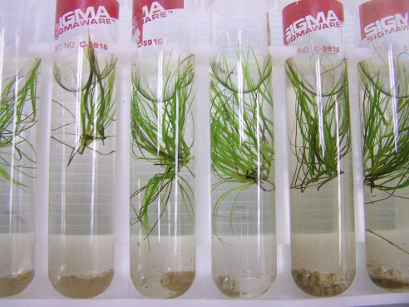
- Place slant rack of selected plants in hood, as well as a rack of sterilized media, jar of alcohol with tweezers and scalpel, and sterilized Petri dishes wrapped in aluminum foil. Scalpel blade should be changed every other subdivision. Blades are found in drawer directly to right of flow hood. Scalpel and tweezers are found in cup on dish rack next to sink. Jar of alcohol on top of cabinet next to flow hood.
- Turn gas valve to on position (perpendicular to wall). Light the Bunson Burner. With rubber gloves and face mask on, open aluminum foil being careful to not touch the interior or rim of any Petri dish.
- Remove the top of the Petri dish and place in front of you in direct flow of air from the rear of the hood
- Open test tube of one of your selected plants and remove plant with sterilized tweezers. Sterilize tweezers by removing them from alcohol jar and putting into direct flame. Let tweezers cool before making contact with plant.
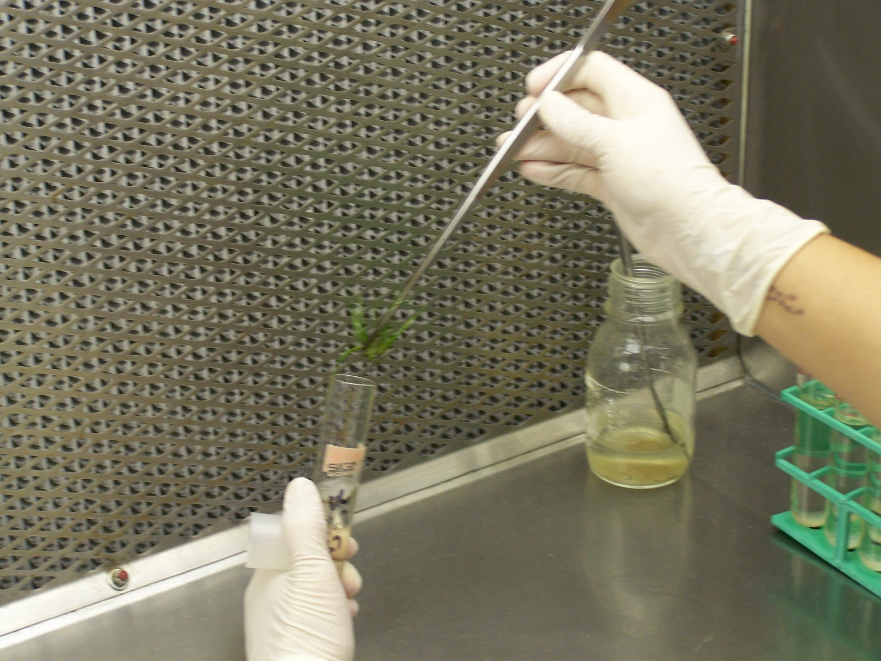
- Sterilize tweezers again and scalpel.
- Begin cutting Ruppia, making cuts every 2-3 nodes. Divide entire plant, cutting brown parts off and pushing to side.
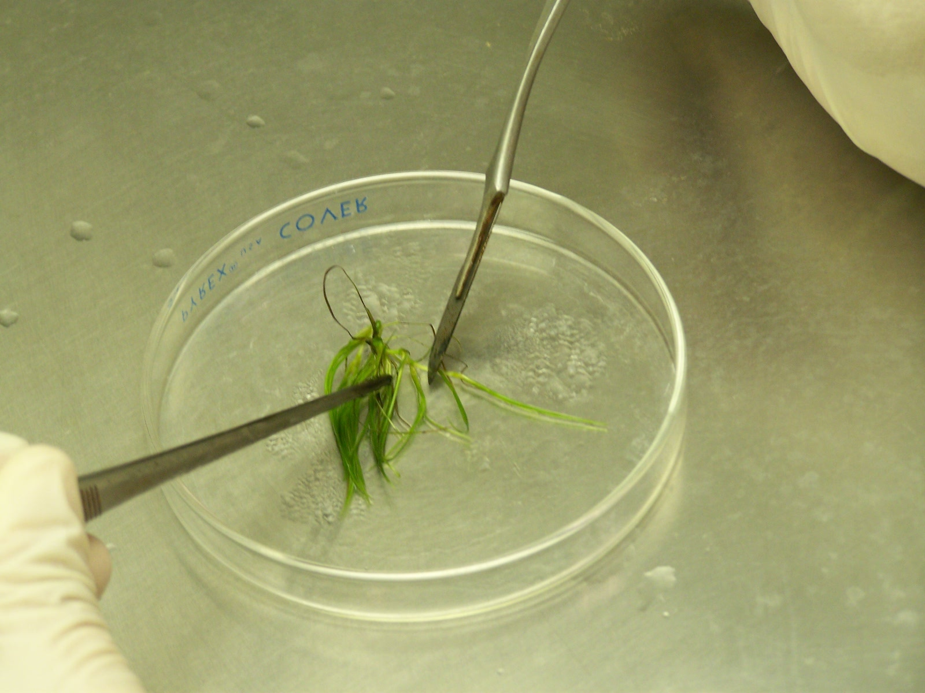
- Sterilize tweezers and put each new division into a separate test tube, being sure to sterilize tweezers in between each division.
- When finished push Petri dish to side, grab a new one being sure not to touch rim or interior of dish and follow steps 8-11 again.
- After all plants have been divided, place them in slant racks and label one test tube on each side of slant rack with your initials, the date, and the site/division number. All plants are from Bruce’s beach so the site number is 1, and if the plants you divided were at division 6 they would now be at 7. So the numbers you would write on the side of the test tube would be 1.7.
- Place racks in grow room with no more than four racks in a row. Keep all plants together with a little space between other divided grasses.
- Record number of plants divided on laminant paper on the grow room door and in lab log book. Also record the number of plants used to divide.
Petri Dish Sterilization
- Make stacks of 10 Petri dishes, 5 covers and 5 bottoms.
- Wrap each stack in aluminum foil and secure with autoclave tape.
- Place all stacks in autoclave.
- Flip switch on front of autoclave to fast (instruments).
- Fill bottom of autoclave with 1:1 ratio of Nanopure and tap water.
- Set timer for 15 minutes.
- Open sink cabinets for steam release.
Appendix 3: Northwest Florida Aquatic Preserve Protocol for Ruppia maritima Mats
Protocol for Ruppia maritima Mats
Ruppia plants are put on coconut fiber mats that act as substrate for the Ruppia to root into. The mats generally take 1-2 months in the grow pools until ready for planting; the Ruppia plants should be about 70-80% rooted into the mat.
Preparing Pool:
- Prepare a pool for the mats.
- Scoop 2 400mL beakers of salt into Nalgene container. Add hot water, put lid on, and shake.
- Add tap water from hose.
- Keep adding salt solution until 15-20 ppt is reached.
- Insert 1-2 clean pumps, depending on pump strength, in opposite corners to circulate water. Pumps need to be cleaned upon setting up a new pool and if not circulating water to full potential due to algae clog.
- Check on pools periodically to make sure water levels and salinity are in proper range.
Making Mats:
- Close air valve to tumbler tank so that all the grass floats to the top.
- Collect all grass from tank and put into pitcher of water.
- Cut 3-18 x 12 in coconut mats from the coconut fiber roll kept in the pool room under pool 5.
- Soak the mats in hot water to rinse the tannins out; this prevents the water from getting cloudy thus increasing light penetration to the seagrass.
- Evenly distribute the grass between the mats averaging 50 plants per mat.
- Place cut to size netting over grass and secure with paper clips on the perimeter and one in the middle.
- With valve still closed to tumbler tank remove air pump hose to valve attached to tumbler tanks. Attach long hose to valve and put other end in drain. Open tumbler tank valve and let water drain scrubbing with elongated toilet bowl at same time. Add hose water according to algae accumulation within tank. Drain all water.
Planting:
- Select donor site for seagrass mats depending on water depth, salinity, temperature, sediment type, littoral drift, upland erosion and turbidity.
- Secure mats to sediment using bamboo skewers or metal staples depending upon site conditions.
- GPS planting area and record in Seagrass Planting Log found in O/EcoRestoration/SeagrassLab/PlantingLog.

Appendix 4: Estero Bay Seagrass Restoration Workshop Attendees
ESTERO BAY SEAGRASS RESTORATION WORKSHOP September 19, 2013 Ft. Myers, FL
Facilitator - Carol Lippincott, Florida LLC Contact@FloridiaLLC.org 352-377-8693
 | Name | Stakeholder Group | Email | Phone
 | Al Durrett | Fish Tale Marina | ftmarina@aol.com | 239-470-1849
 | Bob Swett | University of Florida/IFAS Extension - Boating and Waterways Program | rswett@ufl.edu | 352-392-6233
 | Buddy Powell | Sea to Shore Alliance | jpowell@sea2shore.org | 941-661-2941
 | Christina Denegre | Good Time Charter &  Marine Resources FMB | cdenegre@gmail.com | 239-405-2060
 | Chuck Listowski | West Coast Inland Navigation District | Wcind200@aol.com | 941-485-9402
 | Connie Langmann | RGMC & Sierra Club, GAEA Guides | gaeakayaks@aol.com | 239-694-5513
 | Heather Stafford | Florida Department of Environmental Protection - Estero Bay Aquatic Preserve | Heather.stafford@dep.state.fl.us | 239-463-3240
 | Name | Stakeholder Group | Email | Phone
 | James Douglass | Florida Gulf Coast University | jdouglass@fgcu.edu | 239-590-1268
 | Jonathan Meyer | Florida Department of Environmental Protection – Estero Bay Preserve State Park | Jonathan.C.Meyer@dep.state.fl.us | 239-707-8910
 | Joy Hazell | University of Florida/IFAS Extension - Florida Sea Grant Program | hazellje@leegov.com | 239-533-7518
 | Judy Ott | Charlotte Harbor National Estuary Program | jott@swfrpc.org | 239-338-2556
 | Katie Tripp | Save the Manatee Club | ktripp@savethemanatee.org | 407-539-0990
 | Keith Laakkonen | Town of Fort Myers Beach - Environmental Sciences Division | keith@fortmyersbeachfl.gov | 239-765-0202 ext. 136
 | Lisa Beever | Charlotte Harbor National Estuary Program | lbeever@swfrpc.org | 239-338-2556
 | Marisa Carrozzo | Conservancy of Southwest Florida | marisap@conservancy.org | 239-262-0304 ext. 231
 | Name | Stakeholder Group | Email | Phone
 | Mark Sramek | National Oceanic & Atmospheric Administration - Habitat Conservation Division | Mark.Sramek@noaa.gov | 727-824-5311
 | Nicole Bailey | National Oceanic & Atmospheric Administration - National Marine Fisheries Service | Nicole.bailey@noaa.gov | 727-824-5336
 | Ray Judah | Florida Coastal and Ocean Coalition | Ray.judah@icloud.com | 239-218-7676
 | Reid Lichwell | National Oceanic & Atmospheric Administration - Habitat Conservation Division | Reid.Lichwell@noaa.gov | 207-522-0175
 | Robert Brooks | Florida Department of Environmental Protection - Koreshan State Park | Robert.brooks@dep.state.fl.us | 239-992-0311
 | Shelley Norton | National Oceanic & Atmospheric Administration- National Marine Fisheries Service, Protected Resources Division | Shelley.Norton@noaa.gov | 722-551-5781
 | Steve Boutelle | Lee County Department of Natural Resources | sboutelle@leegov.com | 239-533-8128
 | Tim Schwan | Florida Department of Environmental Protection | Timothy.Schwan@dep.state.fl.us | 239-344-5692
 | Name | Stakeholder Group | Email | Phone
 | Thea Hotaling | University of Florida/IFAS Extension - School of Natural Resources and Environment, Boating and Waterways Program | TheaHotaling@gmail.com | 352-502-3666

Appendix 5: Estero Bay Seagrass Protection and Restoration Plan Stakeholder Contact List
Estero Bay Seagrass Protection and Restoration Plan Stakeholder Contact List
 | Name | Stakeholder Group | Email | Phone
 | Al Durrett | Fish Tale Marina | ftmarina@aol.com | 239-470-1849
 | Bob Swett | University of Florida/IFAS Extension - Boating and Waterways Program | rswett@ufl.edu | 352-392-6233
 | Cheryl Clark | Florida Department of Environmental Protection – Estero Bay Aquatic Preserve | Cheryl.clark@dep.state.fl.us | 239-463-3240
 | Christina Denegre | Good Time Charter &  Marine Resources FMB | cdenegre@gmail.com | 239-405-2060
 | Chuck Listowski | West Coast Inland Navigation District | Wcind200@aol.com | 941-485-9402
 | Guy Carpenter | Florida Fish and Wildlife Commission | Guym.carpenter@myfwc.com | 239-240-9632
 | Heather Stafford | Florida Department of Environmental Protection - Charlotte Harbor Aquatic Preserve | Heather.stafford@dep.state.fl.us | 239-463-3240
 | James Douglass | Florida Gulf Coast University | jdouglass@fgcu.edu | 239-590-1268
 | Name | Stakeholder Group | Email | Phone
 | Jonathan Meyer | Florida Department of Environmental Protection – Estero Bay Preserve State Park | Jonathan.C.Meyer@dep.state.fl.us | 239-707-8910
 | Joy Hazell | University of Florida/IFAS Extension - Florida Sea Grant Program | hazellje@leegov.com | 239-533-7518
 | Judy Ott | Charlotte Harbor National Estuary Program | jott@swfrpc.org | 239-338-2556
 | Justin McBride | West Coast Inland Navigation District | Justin@WCIND.net | 941-485-9402
 | Keith Laakkonen | Town of Fort Myers Beach - Environmental Sciences Division | keith@fortmyersbeachfl.gov | 239-765-0202 ext. 136
 | Kevin Cunniff | Florida Department of Environmental Protection - Rookery Bay National Estuarine Research Reserve | kevin.Cunniff@dep.state.fl.us | 239-530-5964
 | Mark Combs | Fish Tail Marina | gottimon24@gmail.com | 239-463-3600
 | Mark Sramek | National Oceanic & Atmospheric Administration - Habitat Conservation Division | Mark.Sramek@noaa.gov | 727-824-5311
 | Melynda Brown | Florida Department of Environmental Protection - Charlotte Harbor Aquatic Preserve | Meliynda.a.brown@dep.state.fl.us | 941-575-5861
 | Name | Stakeholder Group | Email | Phone
 | Michael Andriano | Florida Fish and Wildlife Conservation Commission | Michael.andriano@myfwc.com | 239-229-4418
 | Mike Campbell | Lee County Department of Natural Resources | MNCampbell@leegov.com | 239-533-8133
 | Rob Modys | Soul Mate Charter | captrobmodys@gmail.com | 239-851-1242
 | Steve Boutelle | Lee County Department of Natural Resources | sboutelle@leegov.com | 239-533-8128
 | Thea Hotaling | Clemson University | TheaHotaling@gmail.com | 352-502-3666

Methodologies and data analysis can be found in Hotaling, 2014.
Latitude, longitude, date, and time
All statistical operations were performed using R© (Ver 3.1.2, R Foundation for Statistical Computing, Vienna Austria) with the critical level of significance was set at α = 0.05.
Methodologies and data analysis can be found in Hoalting et al., 2105.
A contact list for all attendees of the workshop and a contact list for the local Estero Bay Seagrass Stakeholder Committee can be found in Appendix 5.
The Estero Bay seagrass stakeholder group set the following priority list based on prop scar extent and habitat suitibbility: 1= NICMZ, 2= Estero R Mullock Cr, 3= Mound Key, 4= Chili Pepper, 5= Northern portion of New Pass, 6= Matanzas Pass, 7= SW of Mullock and Hendry Creek, 8= Coon Key

