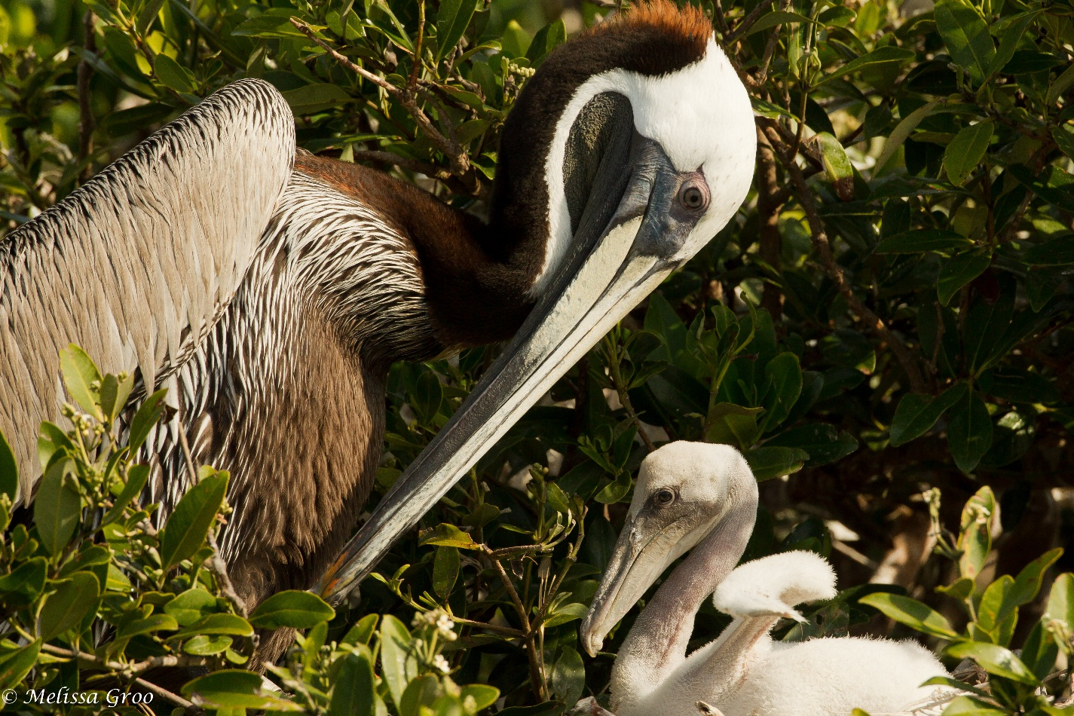
Wading and Diving Bird Management Strategy
June 30, 2015

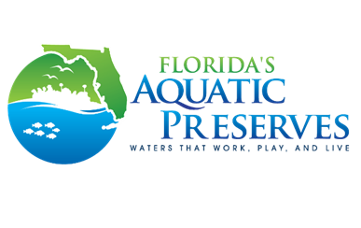
Estero Bay Aquatic Preserve
700-1 Fisherman’s Wharf
Fort Myers Beach, FL 33931
(239) 530-1001


www.dep.state.fl.us/coastal/estero

Florida Department of Environmental Protection
3900 Commonwealth Boulevard, MS 41
Tallahassee, Florida 32399-3000
www.dep.state.fl.us
Table of Contents
1.0 Introduction 6
2.0 Biological Background 7
2.1 Habitat 7
2.2 Breeding 7
2.3 Food 8
3.0 Conservation History 9
3.1 Habitat Degradation 10
3.2 Human Disturbance 11
3.2.1 Brown Pelican 12
3.2.2 Reddish Egret 12
3.2.3 Tricolored Heron 12
3.2.4 Snowy Egret 13
3.2.5 Great Blue Heron 13
3.2.6 Great Egret 13
3.2.7 Cattle Egret 13
3.2.8 Yellow-Crowned Night Heron 13
3.2.9 Black-Crowned Night Heron 14
3.2.10 Green Heron 14
3.2.11 White Ibis 14
3.2.12 Double-Crested Cormorant 14
3.2.13 Anhinga 15
3.3 Threats to Wading and Diving Birds in Estero Bay 15
4.0 Current Management 18
4.1 Resource Monitoring 18
4.1.1 Water Quality 18
4.1.2 Seagrass Monitoring 21
4.1.3 Oyster Mapping and Monitoring 21
4.1.4 Saltmarsh and Mangrove Mapping 22
4.1.5 Rookery Monitoring in Estero Bay 23
4.1.5.1 Rookery Monitoring Objectives 24
4.1.5.2 Methods 24
4.1.5.3 Wading and Diving Bird Monitoring Data and Discussion 25
4.3 Education 30
5.0 Management Strategy 31
5.1 Education 32
5.1.1 Outreach 32
5.1.2 Stakeholder Engagement 32
5.2 Enforceable Protection of Wading and Diving Birds 34
6.0 Critical Wildlife Area Designation 34
7.0 State Park Boundary Signage 35
6.0 Evaluation 35
7.0 Conclusion 36
References 37

LIST OF FIGURES
Figure 1: Bird mortality due to fishing line entanglement by species on nesting islands in Estero Bay Aquatic Preserve from 2008 to 2014. 15
Figure 2: Monitoring sites in EBAP including CHEVWQMN water quality, datasonde water quality, tributary monitoring, rookery monitoring, and seagrass monitoring transects. 20
Figure 4: Photographs of the various nesting stages. 25
Figure 5: Peak Nesting Season (February – August) total nest counts for all colonies within the Estero Bay Aquatic Bay basin (includes areas outside of Estero Bay Aquatic Preserve boundaries). Red horizontal line indicates period of record (i.e. 2009 – 2014) average nesting season mean. 26
Figure 7: Linear regression of peak nest counts conducted in Estero Bay between 2009 and 2013, by species.. 28
Figure 8: Comparison of May Brown Pelican (BRPE) historic perimeter surveys (1977-2001) and modern perimeter count (2008-2011) show a loss of 94 nesting pairs. 29
Figure 9: Islands of concern marked with the proposed buffer and/or state park boundary sign. 33

LIST OF TABLES
Table 1: Incubation periods and the amount of time for a chick to fledge the nest for all species discussed in this strategy. 7
Table 2: Recommended set-back distances for each of the species discussed in this strategy. 11
Table 3: Kendall’s τ nesting season annual total bird count trend analysis result for each colony using data between 2009 and 2015. Statistically significant ρ-values are italicized 27
Table 4: Mean nest count, standard error, and percent mean difference, by species, for April historic surveys (1998 and 2001) and modern surveys (2007–2011).. 29
LIST OF APPENDICES
Appendix 1: Historic map noting the locations of rookery monitoring carried out by the Audubon Society. From this study, both Matanzas Pass and Coconut Point East were marked with ‘closed’ signs. 44
Appendix 2: EBAP’s ownership inquiry of Matanzas Pass Island and the information detailing the perpetual spoil disposal easement for this island. 45
Appendix 3: Email correspondences to inquire about Coconut Island East ownership 51
Appendix 4: Draft Best Management Practices recognition system for a FCO education program to engage stakeholders 56
Appendix 5: Matrix detailing Goals, Objectives, and Strategies and the associated time, cost, and possible funding 58

Executive Summary
Estero Bay Aquatic Preserve (EBAP) has significant wading and diving bird habitats including mangroves, intertidal flats, seagrass meadows, and salt marshes. Aquatic preserves were ‘established for the purpose of being preserved in an essentially natural or existing condition so that their aesthetic, biological and scientific values may endure for the enjoyment of future generations’ (Chapter 18-20, F.A.C). With this in mind, it is imperative that efforts are made to implement management strategies that will foster a healthy ecosystem for wading and diving birds. This document outlines background information, conservation history, and current management practices regarding the wading and diving birds found in Estero Bay. EBAP staff gratefully acknowledge the receipt of Coastal Zone Management funds that provided the resources necessary to coordinate this management strategy.
The strategy calls for expansion of outreach programs and stakeholder engagement. For islands with large aggregations of nesting birds and high levels of disturbance, it promotes a collaborative effort with Florida Fish and Wildlife Conservation Commission and Estero Bay Preserve State Park to mark these specific islands.
Each of the proposed strategies can be implemented as funding allows. A matrix of projected partners, time commitments, costs, and potential funding resources is presented in Appendix 1 to assess feasibility and tangibility of projects.

Introduction
Estero Bay was established as Florida’s first aquatic preserve in 1966. The bay has significant wading and diving bird habitats including mangroves, intertidal flats, seagrass meadows, and salt marshes. These habitats provides areas for roosting, feeding, and breeding. Established by law, aquatic preserves are submerged lands of exceptional beauty and biological, aesthetic, and scientific value that are to be maintained in the existing conditions (DEP, 1997). Estero Bay Aquatic Preserve (EBAP) covers 11,000 acres of submerged lands, and protection of these lands is critical in managing the wading and diving bird populations that inhabit Estero Bay.
There are state species action plans that provide a framework for managing wading and diving birds in coastal regions, but are not specific to regional concerns (Florida Fish and Willife Conservaion Commission [FWC], 2013a; FWC, 2013b). This strategy provides guides management for the protection of Estero Bay’s wading and diving bird populations by managing potential threats to their survival. Wading and diving birds are important ecological indicators, and their health reflect the health of the whole ecosystem (Kushlan, 1993). Given the aesthetic attraction to wading and diving birds, the economy is also influenced through ecotourism (Sekercioglu, 2002). Birdwatchers are one of the best sources of ecotourism income since they form the largest single group of ecotourists, they are typically educated, and they have above average incomes (Ceballos-Lascuráin, 1996; Cordell & Herbert, 2002).
There are many species of birds that nest on islands in Estero Bay: Brown Pelican (Pelecanus occidentalis), Reddish Egret (Egretta rufescens), Little Blue Heron (E. caerulea), Tricolored Heron (E. tricolor), Snowy Egret (E. thula), Great Blue Heron (Ardea herodias), Great Egret (A.alba), Cattle Egret (Bubulcus ibis), Yellow-Crowned Night Heron (Nyctanassa violacia), Black-Crowned Night Heron (Nycticorax nycticorax), Green Heron (Butorides virescens), Double Crested Cormorant (Phalacrocorax auritus), White Ibis (Eudocimus albus), and Anhinga (Anhinga anhinga). Of the species addressed, the Brown Pelican, Double Crested Cormorant, and Anhinga are classified as diving birds, and the remaining species are wading birds. Collectively, this management strategy refers to all of the species as wading and diving birds. These birds provide biological, aesthetic, and economic values to Estero Bay Aquatic Preserve, and they are part of the unique diversity of the site that was recognized as significant to establishing its protection in 1966. Many of these species are state listed species of special concern. An up to date list of these species can be accessed on the FWC website (FWC, 2015a).

Biological Background

Habitat
Wading and diving birds occupy shallow-water habitats in both fresh and salt water conditions. Wading birds are able to keep their bodies dry by using their long, thin legs to walk through the water. Diving birds, although they still utilize shallow water habitats, they occupy slightly deeper waters than the wading species, as these birds will dive after fish, and they have the adaptations necessary for diving efficiency (U.S Fish and Wildlife Service [USFWS], 2012, 2009). Both wading and diving birds depend on healthy, coastal ecosystems suitable for resting, foraging, and breeding; this means ample space, abundant food sources near nesting sites, and protection from predators and disturbance (Lott, Ewell, & Volansky., 2009).

Breeding
Species | Incubation (days) | Fledging (days)
Brown Pelican¹ | 29-35 | 77-84
Reddish Egret² | 27 | 42-48
Little Blue Heron³ | 22-23 | 35-49
Tricolored Heron⁴ | 21-25 | 35
Snowy Egret⁵ | 24-25 | 20-24
Great Blue Heron⁶ | 25-29 | 64-91
Great Egret⁷ | 23-27 | 21-25
Cattle Egret⁸ | 22-28 | 14-21
Yellow-Crowned Night Heron⁹ | 24-25 | 25-35
Black-Crowned Night Heron¹⁰ | 24-26 | 29-34
Green Heron¹¹ | 19-21 | 16-17
Double Crested Cormorant¹² | 25-28 | 21-28
White Ibis¹³ | 22 | 9-16
Anhinga¹⁴ | 25-30 | 42
Table 1: Incubation periods and the amount of time for a chick to fledge the nest for all species discussed in this strategy. ¹Shields, 2002; ²Green et al., 2011; ³Rodgers & Smith, 2012; ⁴Frederick, 1997; ⁵Parsons & Master, 2000; ⁶Pratt, 1970; ⁷Mccrimmon et al., 2012; ⁸Telfair, 2006; ⁹Watts, 1995; ¹⁰Hothem, Brussee, & Davis, 2010; ¹¹Davis and Kushlan, 1994; ¹²Hatch & Weseloh, 1999; ¹³FWCa, 2015; ¹⁴Kearns, 2009)

Breeding among wading and diving birds in Estero Bay has been documented year round since 2008. These birds nest asynchronously so, they do not all breed at the same time. Even within a single nest, eggs are laid in intervals (Sizemore, Main, & Pearlstine, 2012). The proximity of the breeding sites to foraging sites is also an important factor. If the energetic costs of long-distance travel exceeds the benefit of accessing a high quality foraging habitat, then nesting activity may decline (Wittenberger & Hunt, 1985; Bryan & Coulter, 1987). Wading and diving birds tend to nest during periods of high food availability to increase the likelihood of successfully raising their young (Sizemore et. al., 2012). That is to say that breeding is resource-dependent; breeding times may vary from year to year and periods of high vulnerability for the individuals will vary accordingly. The incubation and chick rearing durations varies among the species (Table 1).
Wading and diving birds typically roost in multi-species colonies at or above the high tide mark. They nest in a variety of woody vegetation (FWC, 2013b), and in Estero Bay this includes mangroves (Rhizophora mangle) and Seagrape (Coccoloba uvifera). Some species of wading and diving birds nest in exotic plants. EBAP is working with state parks to remove exotic species outside of nesting periods. Roosting areas are often located conveniently close to feeding areas. If there is a plentiful food source near the nest, then the individuals are able to conserve energy. Nesting over water also provides some protection from predators (Sizemore et. al, 2013).

Food
Wading and diving birds are carnivores. They have a wide range of food types and have distinct feeding habits. Wading birds, in general, prey on fish, but invertebrates, like crayfish, can also be important prey species (Sizemore et al, 2012). They can find food by stirring the water with their feet, and they can use their beaks to filter food. Larger bird species that have a great enough height also have the ability to reach for food below the water’s surface (FWC, 2013b).
Nearly all heron species feed at times by standing and waiting for prey and by walking slowly after prey. But they also may use their feet, head, wings, or full body in various ways to access particular prey opportunities (Kushlan, 2011). The reddish egret actively pursues its prey by chasing schools of fish in shallow waters, an adaptation that allows it to forage in the shallow flats typical of its coastal habitat (Lowther & Paul, 2002). Other egret species are also active foragers; they stalk wetland fish, vertebrate and invertebrate prey (Trocki & Paton, 2006). The white ibis preys primarily on aquatic crustaceans and insects in both wetland and upland habitats (Bjork & Powell, 1996).
Diving birds, however, typically dive or plunge underwater to catch fish. Both the Double-Crested Cormorant and Anhinga feed primarily on fish, but also eat insects, crustaceans and amphibians. The Double-Crested Cormorants generally feed in shallow water that is less than 8 m deep and within 5 km of shore. They may swallow small fish while underwater, but they bring larger prey up to the surface before consuming them (Kearns, 2009). The Anhinga is not a particularly fast swimmer, however, they are still effective aquatic hunters. They target slower-moving species of fish and stalk them underwater, and using its long neck, it spears the fish with its pointed beak, and brings the catch to the surface to swallow (Owre, 1967). The Brown Pelican is a plunge diver. If the dive is successful, the pelican will use its gular pouch to squeeze out and release water before swallowing the captured prey (FWC, 2013a). The plumage of these three diving birds is not water resistant, a characteristic that is rare among waterbirds and allows them to sink and dive with ease.

Conservation History
Hunting for both plumes and food had a devastating impact on wading and diving bird populations both from direct take and from recurring disturbance to their breeding locations (FWC, 2013). This impact was reduced in 1918 with the establishment of the Migratory Bird Treaty Act (16 U.S.C 703-711). This provided measures to prohibit the take of birds, nests, or eggs, native to North America, including all of the wading and diving birds discussed in this management strategy. Many of these species have added protection through their listing on Florida’s Endangered and Threatened Species List (FWCa, 2015).
In the 1950’s and 1960’s, the use of chlorinated hydrocarbon pesticides, predominantly, dichlorodiphenyltrichloroethane (DDT), became popular. Research being conducted during this time period showed that DDT was harmful to bird populations both through a reduced reproductive success and direct toxic intake from their prey. In 1972, the United States Environmental Protection Agency banned the use of DDT allowing for the recovery of the wading and diving bird populations (FWC, 2013).
Several organizations work to implement protective measures for wading and diving bird habitats in the South Florida regions. These include local government agencies, Everglades National Park, USFWS, and Audubon Florida. Conservation planning by The North American Waterbird Conservation Plan and the Southeast United States Waterbird Conservation Plan both identify goals and priorities for wading and diving birds. Wading and diving bird habitats are also protected by federal and state regulations. Both the Clean Water Act (CWA) and Florida’s Environmental Resource Permit (ERP) Program regulate the activities involved in surface waters and minimize the adverse impacts to wetlands, including Estero Bay. Site-specific protection of nesting and foraging habitats for wading and diving birds is carried out by EBAP and Estero Bay Preserve State Park (EBPSP). Wading and diving birds utilize the nesting ground year after year, and as an aquatic preserve and buffer preserve, protecting these habitats is the main priority for Estero Bay.
The Florida Fish and Wildlife Conservation Commission (Formerly known as Florida Game and Fresh Water Fish Commission) developed the Coastal Wildlife Conservation Plan which identified wading and diving birds as target groups in need of conservation (Millsap, Gore, & Feiertag, 1991). From this plan, FWC developed the Florida Bird Conservation Initiative to promote the sustainability of native Florida birds and their habitats through conservation planning, delivery of conservation programs, research and monitoring, education and outreach, and public policy (FWC, 2015b). The decline of wading and diving bird populations in South Florida is well documented (Robertson & Kushlan, 1974, Frederick & Collopy, 1989, Frohring, Voorhees, & Kushlan, 1988), and habitat degradation (Sizemore et al., 2012) and human disturbance to wading and diving birds (Millsap et al., 1991) are important factors in this decline.

Habitat Degradation
Previous studies have documented that wading and diving birds are sensitive to habitat degradation (Alexander & Hepp, 2014, Ma, Cai, Li, & Chen, 2010). Wetland degradation throughout the Estero Bay watershed has occurred, and this is of concern since wading and diving birds are dependent on this ecosystem. Several environmental variables influence habitat use for wading and diving birds and these include hydro-chemical (i.e.: water quality), structural (i.e.: wetland size and depth), and anthropogenic (i.e.: human disturbance) variables. With regard to the first two variables, resource monitoring is essential in tracking the habitat quality, and thus, managing the wading and diving bird populations in Estero Bay. Human disturbance is described in more detail below.

Human Disturbance
Species | Recommended Set-Back Distance (m)
Species | Walk | Motor
Brown Pelican | 75 | 65
Double-Crested Cormorant | 96 | 71
Anhinga |  | 89
Great Blue Heron | 100 | 82
Great Egret | 91 | 87
Snowy Egret | 91 | 87
Tricolored Heron | 88 | 59
Little Blue Heron |  | 71
Cattle Egret | 70
Black Crowned Night Heron | 97
White Ibis | 76
Table 2: Recommended set-back distances for each of the species discussed in this strategy. Adapted from Rodgers and Smith, 1995

The rapid growth of nature-based tourism places increased pressure on ecosystems and wildlife (Giannecchini, 1993; Boo, 1990). Estero Bay offers extensive recreational opportunities and, hence, is subject to these pressures. Wading and diving birds are sensitive to human presence, and human disturbance has detrimental effects on foraging and nesting behavior and breeding success (Carney & Sydeman, 1999, Ellison & Cleary, 1978; Tremblay & Ellison, 1979; Burger, 1981, Parsons & Burger, 1982, Rodgers & Smith, 1997; Manuwal, 1978). Disturbances may cause depressed foraging and nesting rates since many individuals will spend more time displaying anti-predator behaviors, such as scanning or fleeing (Stolen, 2003). These behavioral alterations often result in decreased productivity due to discouraging nesting, nest abandonment, nest predation, and chick mortality (Tremblay & Ellison, 1979; Bouton, Frederick, Rocha, Barbosa Dos Santos, & Bouton, 2005). Changes in food availability due to feeding by humans at boat ramps and fish cleaning stations, may also influence behavior and nesting success (Perrins, 1970, Hostetler, Main, & Voigt, 2003).
In general, when a perceived threat (i.e.: humans, watercraft) approaches, nesting wading and diving birds often flee their nests in an attempt to intimidate a potential predator or to protect themselves from danger (Carney & Sydeman, 1999; Burger, 1982). During this time the eggs can be spilled or exposed. When unprotected by adults, predation of the eggs by fish crows (Corvus ossifragus), and other predators, may occur and lead to egg loss (Schreiber & Risebrough, 1972, Shields & Parnell, 1986, Frederick & Collopy, 1989). Chicks are also susceptible to predation and exposure when left unattended (Kury & Gochfeld, 1975; Anderson & Keith, 1980). Additionally, excessive boat traffic could influence the selection of resting and foraging sites (Bratton, 1990), and increased disturbance may cause a reduction in clutch size and hatching success (Schreiber & Risebrough, 1972, Carney & Sydeman, 1999, Ellison & Cleary, 1978). Studies that investigated human disturbance on individual species of wading and diving birds were examined and are discussed below. Table 2 refers to the recommended set-back distances as per outlined in Rodgers and Smith (1995) for several species discussed in this strategy.

Brown Pelican
Disturbance to Brown Pelicans may result in reduced nesting success; eggs or chicks may be crushed or knocked from the nest when he parent flushes in a panic (Schreiber & Risebrough, 1972; Kushlan & Frohring, 1985). Once the parent has flushed the nest, unattended eggs or nestlings are susceptible to predators and hypothermia (Anderson and Keith 1980). Larger, more mobile young that are displaced from the nest may starve if they are unable to return (Schrieber, 1979; Anderson & Keith, 1980).
In Florida, the mean flushing distance for approaching on foot is 19.2 m (n=63), motor boat approach is 9.4 m (n= 14; Rodgers & Smith, 1995). The flushing distance may become progressively shorter as adults become habituated to regular visits (Schreiber, 1979). Therefore, adverse impacts from frequent disturbance may be minimized if visits are made in a routine manner over time (Schreiber, 1979).

Reddish Egret
There is little information known about the effect of disturbance on the Reddish Egret. Presence of humans near colonies may cause adults to leave or abandon nests, leaving eggs or young unprotected from potential predation and susceptible to exposure. Disturbance may also cause the premature fledging by nestlings (Toland, 1999).

Tricolored Heron
Rodgers and Smith found that Tricolored Herons flushed from their nests a mean distance of 30 m when approached by foot and 12 m when approached by canoe (1995). Bratton reported that 19 of 20 foraging groups flushed in response to the approach of a motor boat within 25m (1990). Studies have also documented that disturbance can result in egg predation and consequent nest failure and reduced clutch size of Tricolored Herons (Bancroft, Jewell, & Strong, 1990).

Snowy Egret
Rodgers and Smith (1997) found that Snowy Egrets flushed their nests from, on average, 23m (n=19) when approached by foot, and they recommend an 87 m buffer distance for this species. Response to human disturbance like boats and noise at foraging and nesting sites are minimal compared to that of other waterbirds (Bratton, 1990; Klein, 1993).

Great Blue Heron
Great Blue Heron response to disturbance can vary between sites and time of breeding, but it is documented that nest and colony abandonments increases with visitation by humans (Frederick & Callopy, 1989). Early in the season, they will flush the nests with the slightest disturbance. After the eggs are laid, the adults flee reluctantly and quickly return to build new nests, but few adults will flush while chicks are in the nest (Parker, 1980; Vos, Ryder, & Graul, 1985).This species will often select nesting locations that are further away from human activity (Werschkul, McMahon, & Leitschuh, 1976; Watts & Bradshaw, 1994).

Great Egret
Historically, there have been chronic patterns of human disturbance to Great Egrets (Ogden, 1978; Thompson, 1978). Rodgers and Smith found that Great Egrets flushed their nests from, on average, 30 m (n=28) when approached by foot, and they recommend a 91 m buffer distance for this species (1995). For approach by motorboat, the Great Egret flush their nests from approximately 36 m (n=11), and a 107 m buffer is recommended (Rodgers & Smith, 1995). It has also been noted that Great Egrets can habituate to disturbances and tolerate it (Klein, 1993).

Cattle Egret
Cattle egrets are relatively tolerant of human disturbance. This may be attributed to their long association with and habituation to human activities in Florida; Cattle Egrets frequently follow farm machinery and readily forage and roost along busy highways and canals (Rodgers & Smith, 1995; Rodgers & Schwikert, 2002).

Yellow-Crowned Night Heron
There is little information regarding the Yellow-Crowned Night Heron’s response to disturbance. Generally, they are less sensitive to human presence than many other species of wading birds. Klein (1993) noted that this species tolerated the presence of people and remained relatively undisturbed until approached closely.

Black-Crowned Night Heron
Information on disturbance of the Black-Crowned Night Heron is limited to those presented by scientific investigators. Tremblay and Ellison (1979) found that nest checking and marking individuals increased incidents of abandonment and predation of the nests by gulls and ravens. Parsons and Burger (1982), however, suggested that this species can habituate to investigator disturbance and handling.

Green Heron
Kaiser and Fritzell (1984) reported that Green Herons exhibit a reduced foraging success and limited use of habitat with high levels of disturbance. For this reason, they suggested that the Green Heron can serve and an indicator of human disturbance (Kaiser & Fritzell, 1984). Klein (1993), however, suggests that some Green Herons seemingly tolerated human presence, but more sensitive individuals were flushed.

White Ibis
Mueller and Glass (1988) noted that the White Ibis is more adversely affected by disturbance than other species of wading birds. Klein (1993) noted that this species quickly fled the area when disturbed. Rodgers and Smith (1995) also state that the White Ibis is highly sensitive to disturbance and they suggest a 76 m buffer when being approached by foot.

Double-Crested Cormorant
The Double-Crested Cormorant is highly susceptible to disturbance, and when disturbed, adults often flush their nests exposing the contents to predation and/or the elements (Kury & Gochfeld, 1975; Ellison & Cleary, 1978; DesGranges & Reed, 1981). Hasty departures caused by sudden disturbances may lead to eggs being tossed from the nests because the incubating parent maintains the eggs on their feet. Young cormorants are especially vulnerable to disturbance because they are unable to thermoregulation during their first two weeks of life. Therefore, flushing of the adults from the nests before this time may lead to significant mortality of young due to exposure; small chicks may die within 11 minutes of exposure (Weseloh et al., 1995)

Anhinga
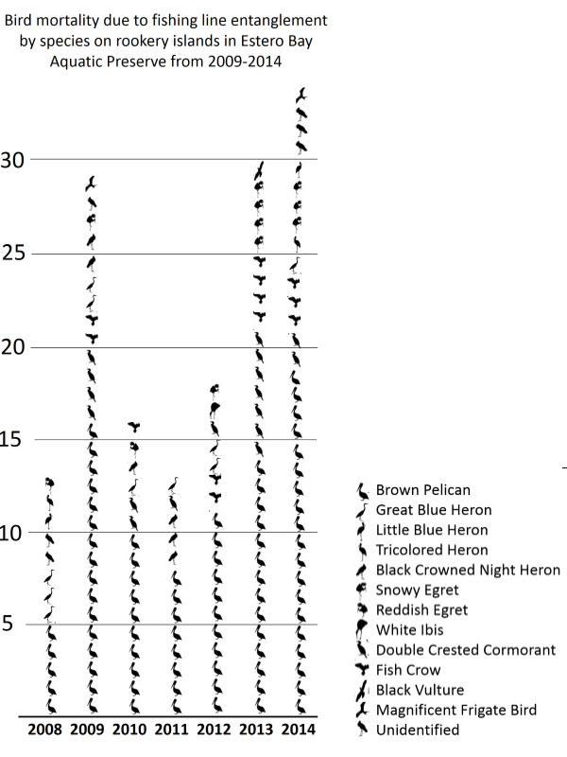
Klein (1993) reports that when exposed to disturbance, Anhingas often become attentive, but seldom move away from the area, unless approached by foot. Buffer distance recommendations have been made for Anhingas from 89 m to 149 m depending on the time of year and type of watercraft (Rodgers & Smith, 1995; 1997; Rodgers & Schwikert, 2002).

Figure 1: Bird mortality due to fishing line entanglement by species on nesting islands in Estero Bay Aquatic Preserve from 2008 to 2014.

Threats to Wading and Diving Birds in Estero Bay
Disturbance on nesting islands has been documented through the history of Estero Bay monitoring (Clark & Leary, 2013). To cite, in 1998, biologists noted excessive commercial and recreational boat traffic, and DEP, in conjunction with Audubon Society, posted ‘closed’ signs on the bank side on four active colonies in Estero Bay (Appendix 1).They were marked with 12’x1.5’’ TX PVC posts; these did not specify a setback distance, but marked the area as ‘closed’ to advise readers of the detrimental effects of close boat approach on wading and diving bird nesting success. Records indicate that the islands monitored for disturbance in April 1998 and April 2001. The signs are no longer present. The same four islands are listed below, and they have been documented to receive the highest levels of disturbance in Estero Bay to date. For this reason, these four island (Matanzas Pass Island, Big Carlos Pass M-52, Coconut Point East, and Big Carlos M-43) are addressed in this strategy.
Also, in 2010, a specific local tour company began bringing boat tours to an active colony several times per day. This boat tour was observed flushing birds from nests throughout the nesting season, and this colony has shown a decline from 77 active nests in 2010 to 3 nests in 2011 (Clark and Leary, 2013). In April 2015, FWC hosted a meeting at the EBAP field office. It was open to paraglide and hang-glide operators in Lee County, and one component of this meeting was to inform attendees of the presence of nesting wading and diving birds and rules regarding set-back distances that are enforced over state lands. There also has been camping on active nesting islands, noise disturbances, and photographers entering colonies. It is important to note that kayak tours frequently visit nesting islands and Jet Ski tours are also seen circling nesting islands regularly.
Given that wading and diving birds forage for food in productive waters and tend to nest close to their forage sites, anglers often utilize the waters around nesting islands. Discarded fishing line also poses a threat to wading and diving birds throughout the bay. There have been 153 documented bird fatalities on the nesting islands due to entanglement since 2009, an average of 22 birds annually (Figure 1). The Brown Pelican have accounted for 56-59 percent of fishing line fatalities since 2009 (Clark & Leary, 2013).
EBAP has noted high levels of disturbance on the following nesting islands:
- Matanzas Pass Island: This is an island located northwest of the Matanzas Pass Bridge that connects San Carlos Island and Fort Myers Beach, Florida. The island is currently under a spoil easement under the Army Corp of Engineers (Appendix 2).
Matanzas Pass Island was first documented as an active nesting colony in 1983, however survey numbers were not documented by island. In 1998, 199 active nests were documented, including 80 Brown Pelican. This island has been documented as active during all years 17 years that is has been surveyed since 1983.
There has been documented disturbance to this island including a local photographer entering the nesting colony to photograph the nests and noise disturbance from local tour boats and operators. There have been 54 reported bird fatalities since 2009; this is 34% of all recorded fatalities in the bay.
- Big Carlos Pass M-52: This is a natural mangrove island, and it is managed by Estero Bay Preserve State Park. It is located north of Big Carlos Pass on Fort Myers Beach, Florida.
This island was first documented as active nesting colony in 1983. In 1986, 107 active nests were documented. Nesting has been documented for the 18 year duration of rookery monitoring. American Oystercatchers have also been documented nesting on this island in both 2011 and 2012.
This island is located in an area with deep water access and its proximity to channels provide desirable access for large eco-tour operators and other vessels. Disturbance by boats was documented in 2010. Eco-tour disturbance was noted in 2011, and in response, citizens posted signs around the island. This however contributed to the disturbance. Additionally, in 2015 kayak tours were documented approaching this nesting island. There have been 11 reported fatalities due to fishing line entanglement since 2009; this is 7% of all recorded bird fatalities in the bay.
Given that this island is under EBPSP management, action to mark the island in coordination with the state park is a priority. If this is unsuccessful, CWA designation will be requested.
- Coconut Point East: This is a natural mangrove island, and it is located within the EBAP boundaries. This island was first noted as an active nesting colony in 1983. In 1998, there were 222 active nests, including 59 Brown Pelicans. This island has had active nesting on it 15 of the 17 years it has been surveyed.
Coconut Point East continues to be an area frequented by PWC and kayak tours. This island experiences high fishing line fatalities- 19 reported; this is 12% of all recorded bird fatalities in the bay. The ownership of this island is unknown, and e-mail correspondences documenting EBAP’s effort to determine ownership can be found in Appendix 3.
- Big Carlos M-43: This is a small mangrove key located within EBAP, and is under EBPSP management. This island has a high level of disturbance (i.e.: frequent camping activity and mangrove cutting). It was first noted as an active colony in 1989, but only monitored for a total of 13 years. From those years monitored, this island does not have a significant number of nesting birds present like that of the former three islands.

Current Management
EBAP currently conducts resource monitoring, engages in education and outreach programs, and coordinates with local stakeholder to protect wading and diving bird habitat and populations in Estero Bay.

Resource Monitoring
Water quality and seagrass, oyster, and mangrove health all influence the habitat use and foraging efficiency of wading and diving birds. Seagrass beds and oyster reefs provide food resources for many of the wading and diving birds in Estero Bay, either directly or indirectly. Water quality could also have direct impacts on wading and diving bird survival. Therefore, any changes in the health of these resources affect the species abundance and distribution of wading and diving birds. Programs are in place to monitor these resources, and these are discussed below. EBAP also maintains a species inventory.

Water Quality
During the 1990’s, the aquatic preserve began collecting data through several long-term water quality monitoring programs. One such program, the Charlotte Harbor Estuaries Volunteer Water Quality Monitoring Network (CHEVWQMN), began in 1996 and it continues to monitor the waters of Estero Bay and the greater Charlotte Harbor area. Based out of the Charlotte Harbor Aquatic Preserves (CHAP) office, the CHEVWQMN program was created as a joint effort between CHAP, the Charlotte Harbor National Estuary Program (CHNEP), and the Charlotte Harbor Environmental Center. This program has more than 80 water quality volunteers and they sample 46 fixed stations within the Greater Charlotte Harbor area (Figure 2). All of the volunteers collect samples once a month at sunrise, using the same techniques, and testing for the same parameters including: wind speed, water surface conditions, tide, water depth, color, clarity, temperature, salinity, DO, pH, nitrogen levels, phosphorus, chlorophyll a, and fecal coliform. The data collected is upload into the Charlotte Harbor Water Atlas online database and STORET national database for use by private citizens and local, state, and federal agencies. EBAP works as a regional coordinator for this program and oversees the seven sites in Estero Bay.
In the most recent CHEVWQMN water quality report that analyzed seasonal data from 1998-2005, Estero Bay ranked moderately compared to the other regions in the study (Duffey, Leary, & Ott, 2007). Estero Bay had the highest turbidity levels in the region studied; this ranks Estero Bay in the 60th percentile for Florida estuaries. There were spatially and temporally isolated instances of fecal coliform bacteria; this indicates that increased levels are due to specific events or watersheds. In Estero Bay, the DO level was below average and well below the Florida Surface Water Standards of 4.0 and 5.0 mg/L. These three disparities are the major concern for the bay, but it is also noted that the pH, temperature, and salinity levels significantly decreased over the study period.
There has also been an ongoing local water quality monitoring effort in Estero Bay by the Lee County Environmental Laboratory (LCEL) since 1991. EBAP, in conjunction with the LCEL and the Florida DEP’s Division of Environmental Assessment and Restoration (DEAR) began a tributary monitoring program in 2003. The cooperative effort allows for the collection of water samples at seven fixed locations in the tributaries of Estero Bay. The sites were strategically chosen to complement those already being monitored by CHEVWQMN and locations that have been sampled in the past by LCEL. EBAP staff originally collected data monthly. This was reduced to bi-monthly monitoring in 2005, with duties being shared between both EBAP and DEAR staff. The parameters tested reflect those of the CHEVWQMN program. The analyzed data from both the CHEVWQMN and EBAP water quality monitoring programs are entered into STORET, and it is used in DEAR’s determination of impaired waters.
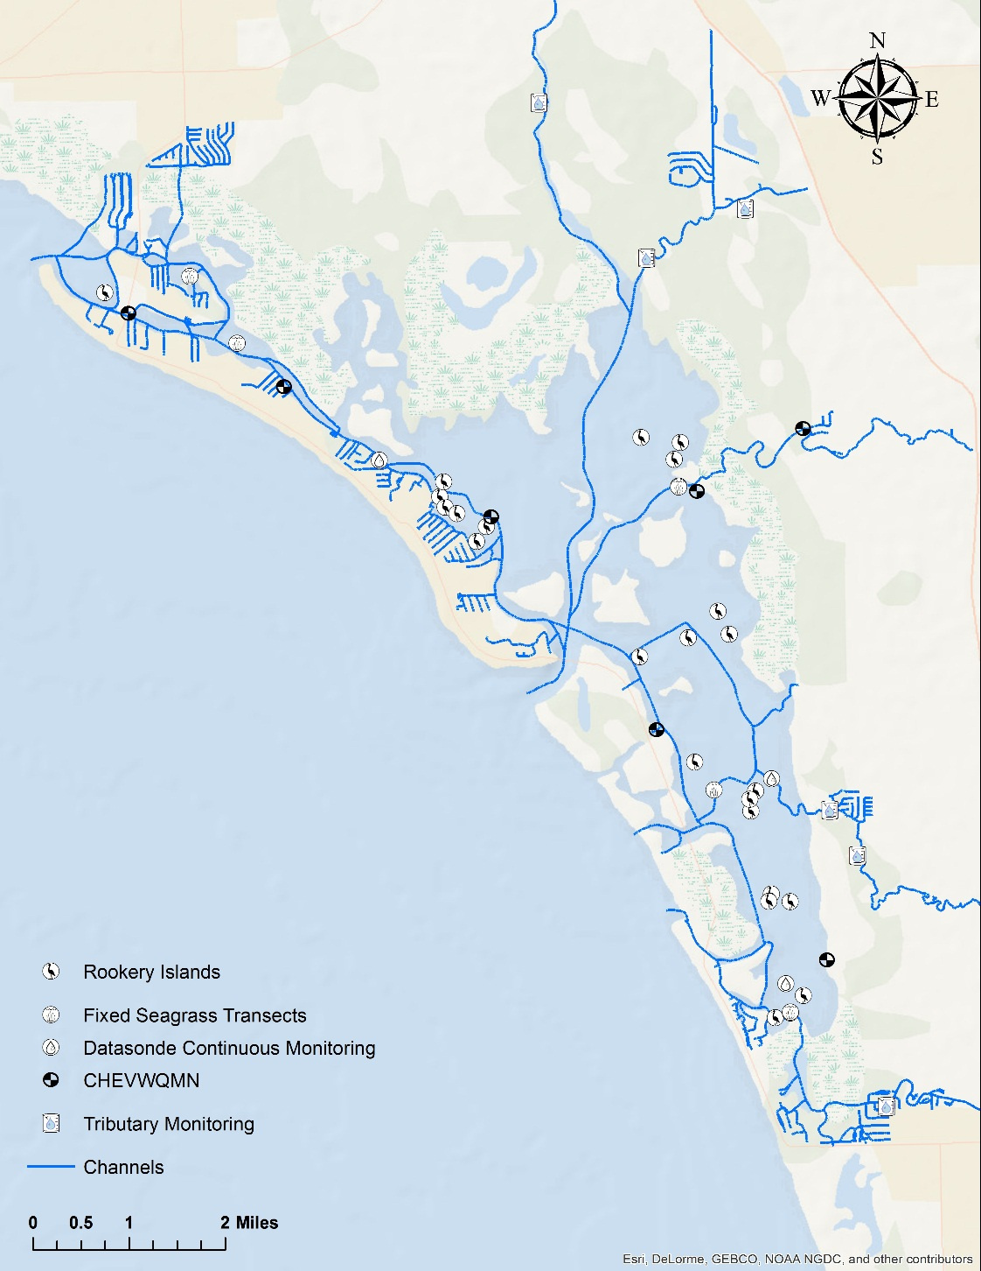
Most recently, in 2004, EBAP began a project to establish a water quality baseline to determine the overall health of Estero Bay with the use of monitoring devices called datasondes. The monitoring sites were selected with several factors in mind including salinity gradients, water depths, freshwater inputs, tidal circulation, and the location of navigational markers. Three datasondes were deployed in Estero Bay in null zones (Figure 2); these are areas with reduced water mixing. The datasondes record data every 15 minutes for parameters including depth, temperature, salinity, specific conductance, pH, DO, and turbidity.
Figure 2: Monitoring sites in EBAP including CHEVWQMN water quality, datasonde water quality, tributary monitoring, rookery monitoring, and seagrass monitoring transects.

Seagrass Monitoring
There are five transects throughout the bay used to monitor seagrass; these were chosen to reflect the conditions at various locations within the preserve (Figure 2). These transects are monitored twice a year—once in the summer, growing season and again in the winter, dormant season. This allows the data collection to coincide with the yearly minimum and maximum seagrass densities. The transect lengths at each of the sites vary from 100 meters to more than 400 meters. Most of the transect lines begin on the shoreward side of the seagrass bed and they are tagged with flagging tape; one of the transects falls between two channel markers.
Data is collected every 50 meters along the transect, or every 10 meters depending on the total length of the transect. The parameters recorded at each station along the transect include the distance from the transect, shore, time, water depth, sediment type, epiphytic type and density, blade lengths, species present, species abundance, total abundance, shoot count, and any additional comments. The Braun-Blanquet (BB) method, a rapid, visual assessment of seagrass abundance, is used to estimate the total and individual percent coverage.
For the most recent analysis of EBAP seagrass monitoring data, variations in seagrass coverage, expressed as growing season total SAV abundance BB score, as a function of sampling location was analyzed using the Chi-squared test. Temporal trend analysis was conducted using Kendall tau (τ) correlation analysis with mean growing season total SAV abundance BB scores and year as variables. Both regional (i.e. bay-wide) and site specific correlation trend analyses were performed. Regionally, growing season seagrass coverage has significantly declined during the eight year monitoring period (Figure 3; τ = -0.64, N = 8, ρ<0.05). A more detailed description of the seagrass monitoring data analysis can be found in the EBAP Seagrass Protection and Restoration plan (2015).

Oyster Mapping and Monitoring
A lack of oyster field mapping was identified as a data gap by CHNEP in 2012. For this reason, Intertidal oyster bars throughout the bay are currently being mapped. EBAP staff walk along the edge of each intertidal oyster bed utilizing a Trimble GPS device to map the perimeter. Mangrove areas within an oyster bed are also delineated. Oyster health is monitored using a quadrat that measures ¼ m x ¼ m. All oysters that fall within the quadrat are measured with calipers, and the length (mm) of live oysters is recorded. To date, EBAP has documented an average of 742 live oysters per meter.

Saltmarsh and Mangrove Mapping
In 2012, South West Florida Regional Planning Council conducted an inventory study to determine the extent of salt marshes throughout the CHNEP study area. There was a total of 14,856.18 acres of salt marsh within the CHNEP boundary; this included 2,773.92 acres of salt marsh in Estero Bay (Beever, Gray, Beever, Cobb, & Walker, 2012).
Sudden and chronic mangrove die-offs of mangroves can be common in Florida. Most of these are small and attributed to natural events. Larger mortality areas are a greater concern, and these can cover often covering hundreds of acres. Adjacent areas to these die offs often show signs of stress and long term trends indicate little or no natural recovery (USEPA Grant, 2014). The events are known as “mangrove forest heart attacks.” There are two projects working on mangrove mapping and health within Estero Bay.
There is a collaborative effort among the University of Virginia, DEP, United States Fish and Wildlife Service, and Sanibel Captiva Conservation Foundation to describe the spatial distribution of mangrove communities in southwest Florida, assess the impacts of mangrove biological activity on adjoining subaqueous soils, and understand the effects of mangrove mortality on soil health (Neafsey, 2015). For this project, mangroves will be inventoried using a combination of active remote sensing, digital image processing and interpretation, and ground-based surveys. This will aid in producing two-dimensional and three-dimensional distribution maps of species within the study area and estimates of biomass for each species. The interaction between mangrove species and subaqueous soils will be measured by assessing significant differences between the soils underneath, bordering and far away from them. From this data there are several expected products including maps of soil properties adjoining mangrove ecosystems, visualizations of soil properties by depth, and soil property prediction models for the region’s subaqueous soils.
The effects of mangrove mortality on soil health will be evaluated by comparing key soil properties (including % sand, total sulfide, % SOC, salinity, and pH) for samples collected under dead, injured, and healthy individuals. This will lend to the formation of a framework for assessing soil health in mangrove soils, quantitative measures of soil health based on this framework, and a spatial analysis comparing soil and mangrove health.
CHNEP is also currently working on a project to define the distribution, abundance, and composition of mangrove ecosystems in Southwest Florida. This study will look at mangrove response to human caused hydrologic and climate changes stressors, identify mangrove forest die-offs and location of potential future loss, document changes of landward and waterward edges of fringing mangrove ecosystems, and document changes in the relative proportions of mangrove ecosystem types in Southwest Florida. Additionally, the Florida Coastal Office (FCO) is presently exploring shoreline surveys to be conducted state wide, and EBAP is set to be the pilot study for the 2015/2016 year.
Wading and diving birds have been documented directly in salt marsh channels within the CHNEP study area (Beever et al., 2012). Additionally, wading and diving birds nest in woody vegetation, including mangroves (FWC, 2013b), monitoring the health of salt marshes and mangroves in Estero Bay is critical in the management of the wading and dicing bird populations.

Rookery Monitoring in Estero Bay
The rookery monitoring program in Estero Bay provides peak estimates of nesting effort for each species of wading and diving birds, monitors population trends, maintains a current atlas of historic and active colonies, documents human disturbance, and records the number of fishing line entanglements and fatalities. The program began in 1977, but up until 2008, monitoring was only conducted sporadically and a variety of survey methods were utilized throughout this time period. From 1977-1982 only May perimeter nest counts were conducted, and only for Brown Pelicans. From 1983-1987 May perimeter nest counts were conducted, and all wading and diving birds were included. However, the survey protocol was not available. Written correspondence suggests that for this time period ground surveys were employed. In 1989 and 1997 the method changed back to perimeter surveys. The survey schedule was changed in 1998 for all monitoring to be conducted in April. This schedule persisted until 2007. The EBAP manager then identified that regular rookery monitoring was necessary in managing the preserve ecosystem as a whole. Monthly rookery monitoring began in 2008 for all active and historically active islands using a direct count, perimeter method.

Rookery Monitoring Objectives
There are five main objectives for the current monitoring program.
- Provide peak estimates of nesting effort for each species of colonial nesting bird
- Monitor population trends.
- Document movement of colonies.
- Document human disturbance to nesting colonies.
- Record and reduce the instances of bird fatalities due to fishing line entanglements due to fishing-line and trash within the Bay.

Methods
Staff and volunteers monitor wading and diving bird nesting colonies throughout the year. Since 2012, surveys have been conducted year-round due to the extended period of nesting. Surveys are conducted by boat using a direct count method as described by Audubon of Florida (2004).
The direct count surveys are conducted by slowly circling each of the 25 nesting islands (Figure 2) on a boat at a distance of about 30-45 m, so that the nesting birds will not be disturbed. Two observers are used to document species and nesting stage. The primary observer is an aquatic preserve staff member and has remained consistent throughout the study period. Trained volunteers act as secondary observers, and the numbers from both observers are averaged. All wading and diving birds discussed in this strategy are documented. The nesting stages recorded are as follows:
- Empty: No birds nor eggs present.
- Unknown: Adult is present at the nest, but no eggs or chicks are visible or if the pair was copulating.
- Incubating: Adult is in an incubating position or if eggs are visible
- Chicks: Chicks are present in or near the vicinity of the nest.
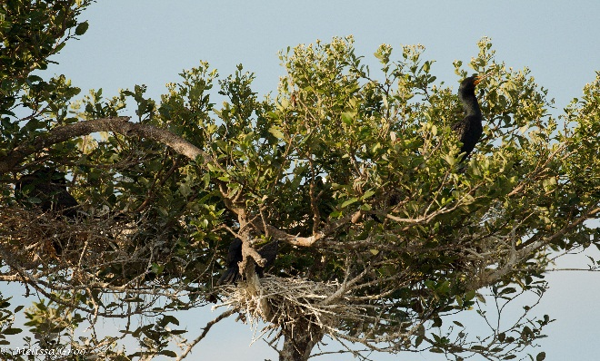
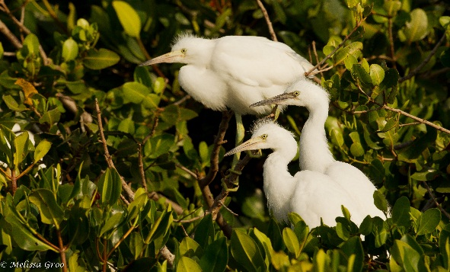
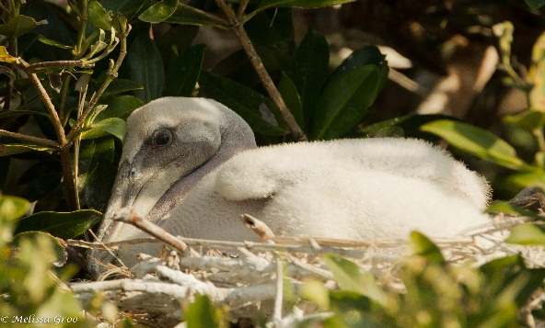
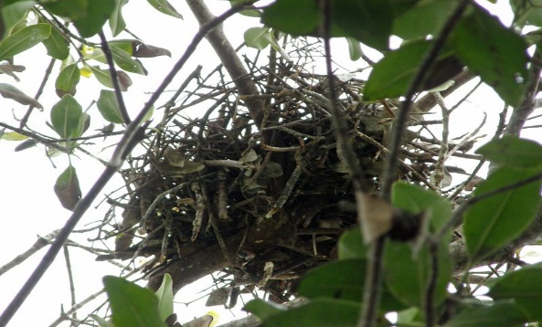
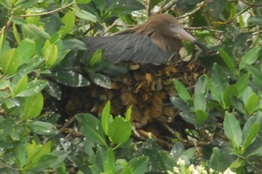
All of the data collected from these monthly surveys is analyzed and sent annually to the South Florida Water Management District (SFWMD) for inclusion in the South Florida Wading Bird Report. Also, the Brown Pelican data is provided to FWC through the shorebird database.
Figure 4: Photographs of the various nesting stages: top left: empty nest, top right: unknown; (Double-Crested Cormorant is present, but state of the nest is unknown), center: incubating Reddish Egret, bottom left: Snowy Egret chicks (Photo Credit: Melissa Groo), bottom left: Brown Pelican chick (Photo Credit: Melissa Groo).

Wading and Diving Bird Monitoring Data and Discussion
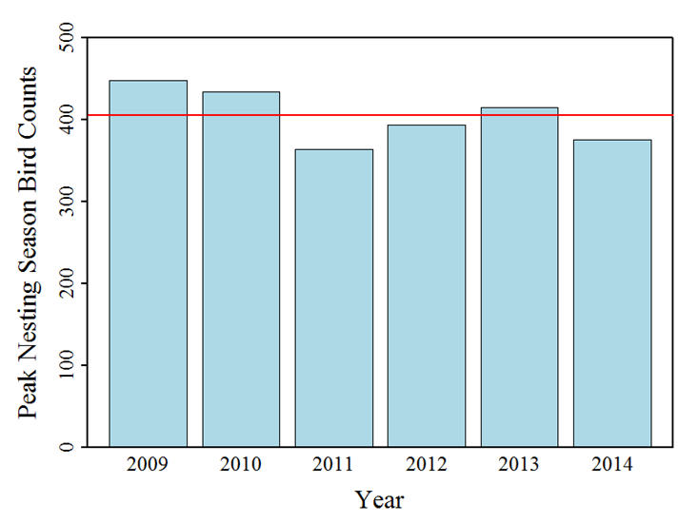
Temporal trend analysis was conducted using the Kendall tau (τ) correlation analysis total peak nesting season (February to August) wading bird count and year on both a regional and colony specific basis for colonies with greater than three years of data. Regionally throughout Estero Bay there was no significant trend in total peak nesting season wading bird counts between 2009 and 2014 (Figure 4; τ = -0.5, N = 6, ρ=0.27). Total nest counts ranged from 364 birds in 2011 to 448 birds during 2009 with an average (± standard error) of 404.8 ± 13.6 birds between 2009 and 2014. Total nest count in 2010, 2012, 2013, and 2014 were 428, 394, 416, and 350, respectively. Even though there was no significant regional trends some colonies were determined to be significantly declining (Table 3, Figure 5). Significant declines in peak nesting counts were observed at four rookery islands including Big Carlos Pass M-43, Big Hickory Pass M-49 3 NW, Houge Channel M-78, and New Pass M-21. Variations in total bird counts could be attributed to variations in hydrologic cycles (i.e. wet versus dry, La Nina versus El Nino, etc.) which has the potential to influence primary prey abundance, availability of nesting habitat, activity around colony islands and other factors.
Figure 5: Peak Nesting Season (February – August) total nest counts for all colonies within the Estero Bay Aquatic Bay basin (includes areas outside of Estero Bay Aquatic Preserve boundaries). Red horizontal line indicates period of record (i.e. 2009 – 2014) average nesting season mean.
Peak Nesting Season Nest Counts
Colony | Kendall τ | ρ value | N | Result
619038c | 0.30 | 0.42 | 6 | Not Statistically Significant
Big Bird Island | 0.84 | 0.05 | 4 | Not Statistically Significant
Big Carlos Pass between M-50&52 | -0.33 | 0.38 | 7 | Not Statistically Significant
Big Carlos Pass M-43 | -0.78 | <0.05 | 7 | Statistically Decreasing
Big Carlos Pass M-48 | 0.05 | 0.87 | 7 | Not Statistically Significant
Big Carlos Pass S of M-48 | -0.23 | 0.50 | 7 | Not Statistically Significant
Big Carlos Pass W of M-46 | -0.16 | 0.63 | 7 | Not Statistically Significant
Big Carlos Pass W of M-52 | 0.05 | 1.00 | 7 | Not Statistically Significant
Big Hickory E of M-85 | -0.62 | 0.07 | 7 | Not Statistically Significant
Big Hickory M-83 Seagrass Island | -0.41 | 0.21 | 7 | Not Statistically Significant
Big Hickory Pass M-49 2 NW | -0.60 | 0.11 | 6 | Not Statistically Significant
Big Hickory Pass M-49 3 NW | -0.89 | <0.05 | 6 | Statistically Decreasing
Coconut Point East | 0.43 | 0.24 | 7 | Not Statistically Significant
Coconut Point West | -0.49 | 0.13 | 7 | Not Statistically Significant
Houge Channel M-78 | -0.78 | <0.05 | 7 | Statistically Decreasing
Matanzas Pass | -0.24 | 0.56 | 7 | Not Statistically Significant
New Pass M-21 | -0.85 | <0.05 | 7 | Statistically Decreasing
New Pass M-9 | -0.29 | 0.36 | 7 | Not Statistically Significant
North Coconut E of M-3 | -0.59 | 0.07 | 7 | Not Statistically Significant
North Coconut M-4 Monkey Joe Key | 0.23 | 0.50 | 7 | Not Statistically Significant
* Not enough data was available for Denegre Key, Estero River North, Estero River South and Ruth’s Island colonies to conduct trend analysis.

Table 3: Kendall’s τ nesting season annual total bird count trend analysis result for each colony using data between 2009 and 2015. Statistically significant ρ-values are italicized
EBAP also maintains a current atlas of historic colonies. Comparisons of historic surveys to modern surveys for brown pelicans during the month of May show a mean decrease of 56.9 percent; this represents a significant decrease in nesting pairs of brown pelicans in Estero Bay for this time period (Clark & Leary, 2013; Figure 6). Note that since the historic ground survey data were significantly different from the historic perimeter surveys, the ground survey data was not included in Clark and Leary’s analysis. An analysis of all April surveys show that nest counts for some species differed substantially between the historic and modern data (Table 4).
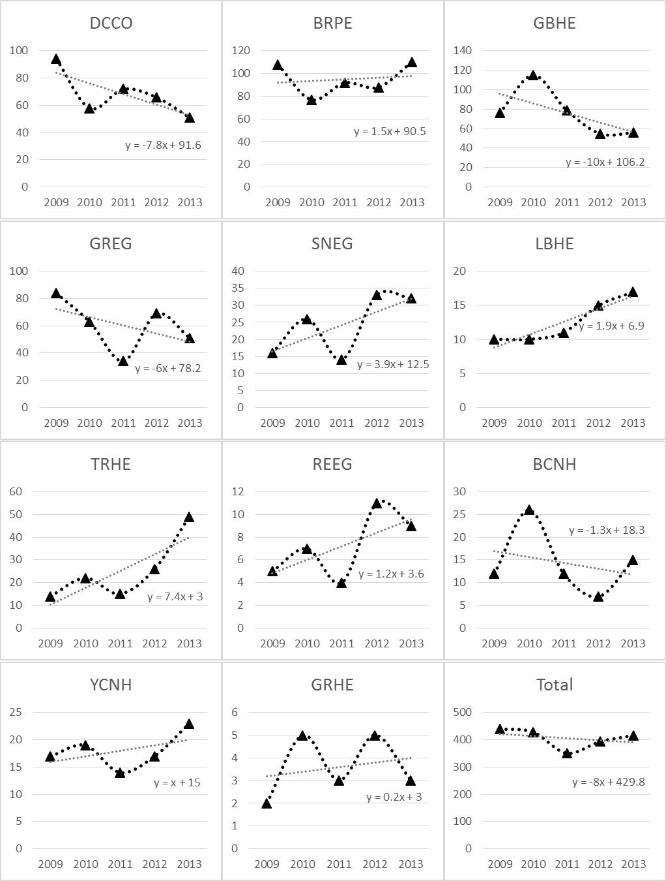
A data analysis was also conducted using EBAP rookery monitoring data for the 2014 State of the Bay report. A qualitative trend analysis was performed using a simple linear regression to compute a rate of change over time (i.e. slope) in an effort to estimate nesting trends between 2009 and 2013, but no formal statistical analysis was performed. Peak nest counts over the five year period showed an increasing trend in nesting activity for brown pelican, snowy egret, little blue heron, tricolored heron, reddish egret, yellow-crowned night heron, and green heron. Double-crested cormorant, great blue heron, great egret, and black-crowned night heron showed a decreasing trend in nesting effort. The overall nesting effort in Estero Bay showed a slight decline (Figure 7).

Figure 7: Linear regression of peak nest counts conducted in Estero Bay between 2009 and 2013, by species. Total nest counts include ANHI and CAEG which were not graphed separately due to small sample size. (BRPE= brown pelican, DCCO= double-crested cormorant, ANHI=anhinga, GBHE=great blue heron, GREG=great egret, SNEG=snowy egret, LBHE=little blue, TRHE=tri-colored heron, REEG=reddish egret, CAEG=cattle egret, YCNH=yellow-crowned night-heron, BCNH=black-crowned night-heron, GRHE=green heron).

Figure 8: Comparison of May Brown Pelican (BRPE) historic perimeter surveys (1977-2001) and modern perimeter count (2008-2011) show a loss of 94 nesting pairs (Clark & Leary 2013).
Table 4: Mean nest count, standard error, and percent mean difference, by species, for April historic surveys (1998 and 2001) and modern surveys (2007–2011). For the historic period, standard error that is null indicates that nest counts for that species only occurred in one of the two years, and SE that is equivalent to its respective mean results from a species that had a positive nest count in one year and a count of zero in the other (BRPE=brown pelican, DCCO=double-crested cormorant, ANHI=anhinga, GBHE=great blue heron, GREG=great egret, SNEG=snowy egret, LBHE=little blue, TRHE=tri-colored heron, REEG=reddish egret, CAEG=cattle egret, YCNH=yellow-crowned night-heron, BCNH=black-crowned night-heron, GRHE=green heron).
 | Historic Surveys |  |  | Modern Surveys |  | Percent Difference
 | Mean | Std. Error |  | Mean | Std. Error | Percent Difference
BRPE | 158.0 | 32.0 |  | 83.2 | 28.6 | -47.3
GBHE | 23.5 | 11.5 |  | 60.6 | 6.7 | 157.9
TRHE | 95 | – |  | 2.8 | 1.5 | -97.1
LBHE | 6 | – |  | 3.2 | 1.3 | -46.7
SNEG | 46.0 | 39.0 |  | 6.8 | 3.1 | -85.2
GREG | 35.0 | 20.1 |  | 39.8 | 8.7 | 13.7
REEG | 9 | – |  | 2.2 | 1.2 | -75.6
CAEG | 50.0 | 50.0 |  | 1.4 | 1.0 | -97.2
YCNH | 2.5 | 2.5 |  | 7.6 | 1.0 | 204.0
BCNH | 6.5 | 6.5 |  | 3.0 | 1.0 | -53.9
GRHE | 0.0 | 0.0 |  | 0.6 | 0.4 | –
DCCO | 27.0 | 4.0 |  | 56.8 | 9.7 | 110.4
ANHI | 4.5 | 0.5 |  | 0.4 | 0.4 | -91.1

Education
EBAP staff work to improve awareness and educate the public through citizen science and stakeholder engagement. Along with the Estero Bay Buddies (EBB), a non-profit Citizen Support Organization (CSO) for EBAP and EBPSP, EBAP also participates in outreach programs and fishing line clean-ups. Additionally, all rookery monitoring data is shared in the South West Florida Wading Bird Report, State of the Bay, and other publications available to the public and to the scientific community.
    - Citizen Science Programs
EBAP offers volunteer opportunities for all of the resource monitoring programs this includes water quality monitoring, seagrass monitoring, oyster mapping and monitoring, and, of course, rookery monitoring. All of the resource monitoring programs at Estero Bay engage and educates the public since they are active volunteer programs. For rookery monitoring, the volunteers play an integral role in conducting nest counts, recording data, and noting instances of disturbance, entanglements, and fatalities.
    - Outreach
EBAP also offers wading trips to the public. These trips invite the public to wade into mudflats and seagrass beds at low tide while an environmental specialist teaches them the Estero Bay ecosystem. This program allows staff to maintain a species inventory of the bay, and it also educates the public with regard to the plants and organisms that are an integral part of wading and diving bird habitats. EBAP staff present relevant information at events (i.e.: boat shows) and to home owners associations, boating groups and schools when possible.
    - Stakeholder Engagement
EBAP staff work with several eco-tour operators to educate boat captains on ways to reduce disturbances to nesting colonies. This includes approach tactics and providing their patrons with binoculars. Specifically, EBAP staff worked with a local pirate tour boat operator to reduce the discharge of cannons and to maintain a buffer around nesting islands to reduce noise disturbance to the birds.
EBAP also provides educational materials on wading and diving birds in kiosks bordering the preserve and at the EBAP office. These inform local boaters about the aquatic preserve and the value of its resources, including wading and diving birds. There is a collaborative effort among EBAP, Lee County, and FWC to educate campers regarding the laws protecting wading and diving birds, and if necessary, asking campers to leave nesting islands. Additionally, EBAP assists in the distribution of informational signage, and Fort Myers Beach rental boat companies also display decals on their vessels regarding wading and diving bird habitat protection
    - Fishing Line Clean Ups
EBAP staff and volunteers remove fishing line and trash monthly while conducting rookery monitoring surveys. It is important to note that staff consider nesting status and numbers of nesting birds present before approaching and entering nesting islands. Those islands not safe to enter are documented so that they may be re-visited after nesting season. The amount of fishing line, hooks, and trash removed are noted by island. If birds are found entangled in fishing line, they are brought to either the Center for the Rehabilitation of Wildlife (CROW) in Sanibel or Von Arx Wildlife Sanctuary at the Conservancy of Southwest Florida in Naples.
EBB regularly organize local clean-ups. Also, EBAP staff and volunteers, and the EBB participate in Keep Lee County Beautiful’s (KLCB) annual clean up event called Monofilament Madness. This is an annual event where volunteers go out in boats, kayaks, canoes, and jet skis, to remove monofilament fishing line and other harmful debris from the mangrove areas of Lee County. The boaters begin working at dawn and continue until noon. The collected trash is weighed and documented.

Management Strategy
This strategy aims to enhance the protection of the wading and diving bird habitats and populations in Estero Bay. All of the current management programs will continue. Additionally, expanding the Educational outreach and stakeholder engagement programs, as well as actively seeking enforceable protection to nesting birds in Estero Bay are discussed in detail below. It is important to note that actions to be taken from this management strategy are contingent on funding and staff availability.
The data collected through EBAP’s resource monitoring programs provides valuable information on the health of the whole ecosystem; and in turn, will also aid in the effective management of wading and diving birds in Estero Bay. With advances in technologies, and as funding allows, EBAP’s resource monitoring programs can be modified and/or expanded to increase protection.

Education
EBAP will continue all citizen science programs and wading trips. Fishing line clean-ups will continue during the rookery monitoring program, EBB will organize local clean-ups, and EBAP and EBB will participate in KLCB’s for Monofilament Madness.

Outreach
EBAP will expand upon Rookery Bay National Estuarine Research Reserve’s (RBNEER) Team OCEAN program. Team OCEAN (Ocean Conservation Education Action Network) is a boat-based volunteer program in which volunteers make weekly visits to high-use areas in the RBNEER; they set an example for fellow boaters, and they provide information regarding ‘leave no trace’ ethics, boating safety, fisheries conservation, and marine recreation practices. Expanding this program to EBAP will promote good stewardship and safe boating practices. Additionally, since Team OCEAN can alert visitors of the presence of nesting birds, this program will effectively reduce disturbance to wading and diving birds in Estero Bay.

Stakeholder Engagement
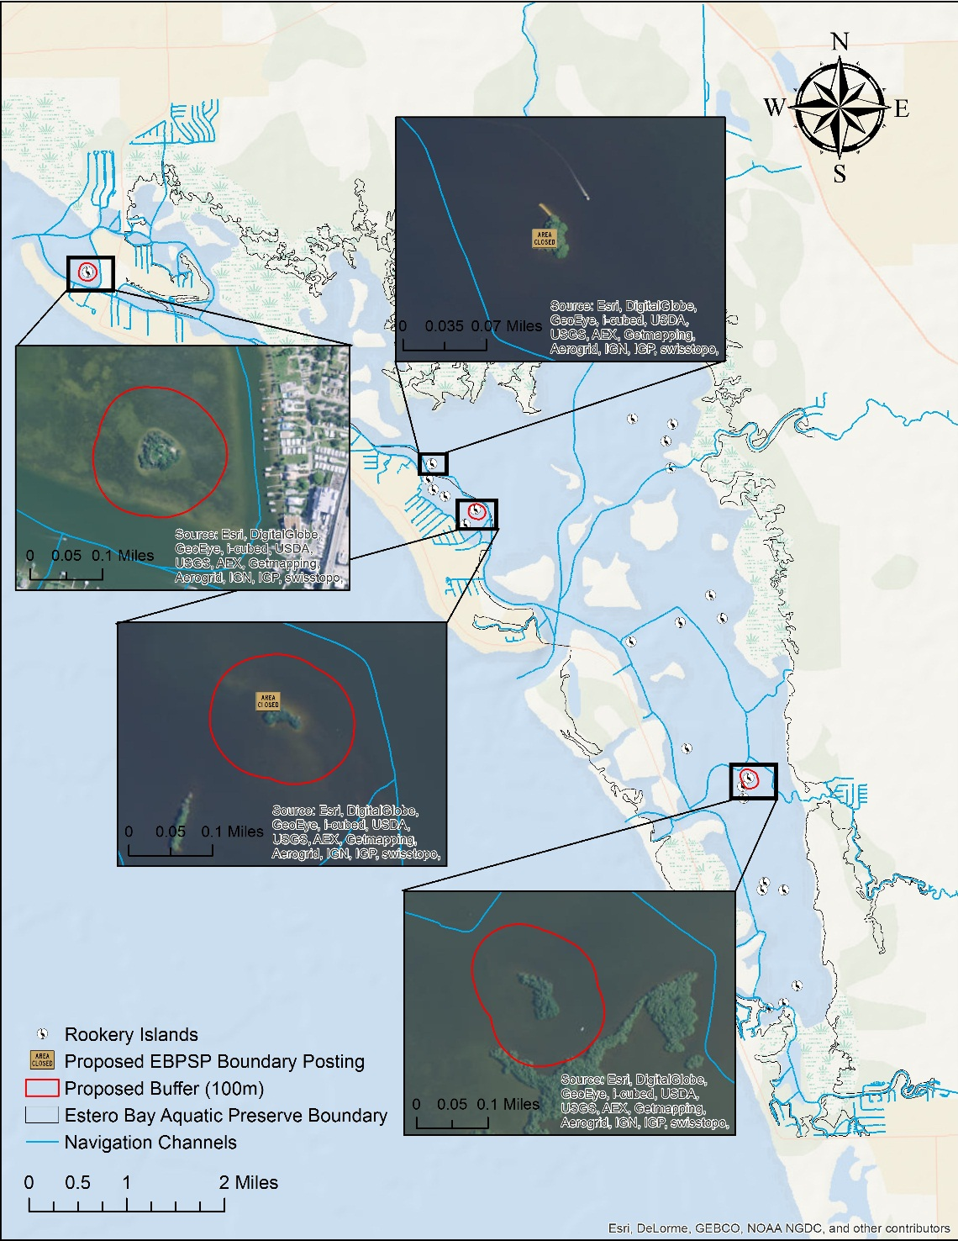
EBAP will collaborate with the local community to increase educational programs for eco-tour operators. This can include creating quality educational videos to promote boating practices specific to reducing disturbance to both nesting birds and their habitat. Staff will work to air existing and create new, public service announcements with assistance from local municipalities, including Bonita Springs. Additionally, EBAP will explore options to create a recognition program for local operators. The Florida Coastal Office (FCO) is currently in the early stages of developing an educational program for local operators, and has considered implementing a Best Management Practices (BMP) recognition system. A draft of the early stages of this program can be found in Appendix 4. There is also a local organization in Fort Myers, Florida called the Florida Society for Ethical Ecotourism (SEE) that maintains a professional code of ecotourism ethics through a recognition program. Collaboration with FCO’s BMP program and/or Florida SEE, if implemented, this will promote coastal stewardship among both operator and recreators in Estero Bay.
Figure 9: Islands of concern marked with the proposed buffer and/or state park boundary sign.

Figure 9: Islands of concern marked with the proposed buffer and/or state park boundary sign.

Enforceable Protection of Wading and Diving Birds
Currently there is no enforceable signage to protect wading in diving birds from threats in Estero Bay. Installation of enforceable signage at breeding sites will assist in implementing current protections for wading and diving birds for islands that warrant posting based on nesting and disturbance data. Options to further reduce impacts from disturbance and minimize loss of birds and eggs include posting islands in collaboration with EBPSP and pursuing designation of specific nesting islands as CWAs, if appropriate.
Several studies have been conducted to determine the buffer zone distances required to protect nesting wading and diving birds. In defining these zones, it is important to note that there are various buffer recommendations for different modes of disturbance (i.e.: motor boat, kayak, walking etc.) (Borgmann, 2010; Chatwin, Joy, & Burger, 2013; Rodgers & Smith, 1995). The buffer distances vary because, depending on the mode, the birds are flushed from the nest to varying degrees. Although fast moving disturbances, like those in a motor boat, are a major cause to birds flushing from their nests, slow moving vessels, especially those that make frequent stops (kayaks, paddleboards, etc.) are more likely to flush some species, like Great Egrets and Snowy Egrets, compared to a vessel passing at constant speeds (Borgmann, 2010). Considering the literature (Borgmann, 2010; Carney & Sydeman 1999; Erwin, 1989; Rodgers & Smith 1995) and site specific nesting data and disturbance, it is recommended that if areas are marked, a set-back distance of 100 m be included for those identified islands. This distance is approximated and it is dependent on proximity to channels and other navigation restrictions.

Critical Wildlife Area Designation
Critical Wildlife Areas (CWAs) are established by FWC under a Florida Administration Code rule 68A-14.001 to protect important wildlife concentrations from human disturbance during critical periods of their life cycles, such as nesting or migration. Public access is prohibited within designated CWAs to minimize take or disturbance to individuals or populations (FWC, n.d.). The following criteria need to be met for a CWA establishment:
- There is a significant aggregation of sensitive species
- There is a high level of disturbance
- The area is accessible and manageable
- The landowner of the area approves protection
As noted, EBAP staff documents active nests, disturbances, and fatalities due to entanglements in fishing line through the monthly rookery monitoring program. The CWA will place a buffer zone into effect (Borgmann 2010; Carney and Sydeman 1999; Erwin 1989; Rodgers and Smith 1995). The establishment of these CWAs will create a buffer around nesting bird colonies in Estero Bay and protect wading and diving bird populations from human disturbance and fishing line entanglement. EBAP staff is actively engaged with FWC in pursuit of adequate protections for the sites with highest levels of disturbance, including a CWA designation. These specific islands are: Matanzas Pass, Big Carlos M-52, and Coconut Point East (listed in section 3.3). It is important to note that all efforts will be made to collaborate with EBPSP mark Big Carlos M-52 as described in section 6.0 before pursuing a CWA designation.

State Park Boundary Signage
There are seven bird nesting islands that are within the boundary of and managed by state parks. Estero Bay Preserve State Park (EBPSP) encompasses more than 10,000 acres of land bordering Estero Bay. The land was originally purchased to protect EBAP from impacts associated with development. There are six nesting islands that are under their management: Big Carlos M-43, Big Carlos M-46, Big Carlos M-48, Big Carlos M-52, Big Hickory Pass M-49 2nd island, and Big Hickory Pass M-49 3rd island. Lovers Key State Park is a 1,616 acre Florida State Park and currently manages one of the islands with documented nesting activity in Estero Bay, New Pass M-21.
As stated in section 62D, Florida Administrative Code (F.A.C.), §258 F.S., the Division of Recreation and Parks may close any park or section to the public at any time and for any interval of time for various reasons including resource protection. Long term wading and diving bird nesting data and disturbance has been documented on Big Carlos Pass W of 52. With EBPSP approval, boundary signs will be placed around this nesting island. Also, provided the documented camping and mangrove cutting on Big Carlos M-43, EBAP will work with EBPSP to post boundary signs to address these issues and reduce disturbance.

Evaluation
The overall objective of this strategy is to maintain a healthy ecosystem and reduce loss of wading and diving birds though minimizing disturbance and other threats; this will allow for the successful management of the Estero Bay wading and diving bird populations. In order to do so, EBAP staff will evaluate the effectiveness of the resource monitoring programs for this strategy annually; data collected from the resource monitoring programs are to be analyzed and compared from year to year. The effectiveness of both marking the nesting areas in collaboration with EBPSP and the CWA designations will be determined through monitoring both before and after the protective measures are put into effect. Additionally, after the areas are marked, monitoring will continue annually.

Conclusion
This strategy will encourage collaboration among those interesting in the protection of wading and diving birds in Estero Bay. EBAP will monitor habitats of nesting populations and will engage in educational and citizen science programs to further protect the species. All efforts will be made to educate the public and reduce disturbance to nesting wading and diving birds without posting signs; this will minimize the signage in the water and preserve the bay in its essentially natural condition (Chapter 18-20, F.A.C). Reducing instances of disturbance to wading and diving birds is a priority, in order to promote robust populations of wading and diving birds in Estero Bay.

References
Alexander, B.W. and Hepp, G.R., (2014). Estimating effects of habitat characteristics on abundances of three species of secretive marsh birds in central Florida. Waterbirds 37, 274–285.
Anderson, D. W. and 0. Keith. (1980). The human influence on seabird nesting success: conservation implications. Biological Conservation 18: 65-80.
AUDUBON OF FLORIDA. 2004. Project Colony Watch a colonial waterbird protection project. http://www.tbep.org/pdfs/FinalColonyWatchHandbook.pdf.
Bancroft, G. T., Jewell, S. D., & Strong, A. M. (1990). Foraging and nesting ecology of herons in the lower Everglades relative to water conditions. Final report to the South Florida Water Management District, West Palm Beach, Florida, USA.
Beever III, J., Council, S. F. R. P., Gray, W., Cobb, D., & Walker, T. (2012). Climate Change Vulnerability Assessment and Adaptation Opportunities for Salt Marsh Types in Southwest Florida.
Bjork, R., and G. V. N. Powell. (1996). Roseate spoonbill (Ajaia ajaja). Pages 295-308 in J. A. Rodgers, Jr., H. W. Kale II, and H. T. Smith, editors. Rare and endangered biota of Florida, Volume V. Birds. University Press of Florida, Gainesville.
Boo, E. (1990). Eco-tourism: the potentials and pitfall. Volume 1. World Wildlife Fund, Washington DC.
Borgmann, K. L. (2010). A review of human disturbance impacts on waterbirds. Audubon California, 376.
Bouton, S. N., Frederick, P. C., Rocha, C. D., Barbosa Dos Santos, A. T., and Bouton, T. C. (2005). Effects of tourist disturbance on Wood Stork nesting success and breeding behavior in the Brazilian Pantanal. Waterbirds, 28(4), 487-497.
Bratton, S. P. (1990). Boat disturbance of Ciconiiformes in Georgia estuaries. Colonial Waterbirds, 124-128.
Bryan Jr, A. L., & Coulter, M. C. (1987). Foraging flight characteristics of Wood Storks in east central Georgia, USA. Colonial Waterbirds, 157-161.
Burger, J. (1981). Effects of human disturbance on colonial species, particularly gulls. Colonial Waterbirds, 28-36.
Burger, (1982). An overview of proximate factors affecting reproductive success in colonial birds: concluding remarks and summary of panel discussion. Colonial Waterbirds 5: 58 65.
Clark, C. P., & Leary, R. E. (2013). Monitoring Colonial Nesting Birds in Estero Bay Aquatic Preserve. Florida Scientist, 76(2).
Code, F.A Chapter 18-20. Florida Aquatic Preserves.
Carney, K. M., & Sydeman, W. J. (1999). A review of human disturbance effects on nesting colonial waterbirds. Waterbirds, 68-79.
Ceballos-Lascuráin, H. (1996) Tourism, Eco-tourism and Protected Areas. Gland, Switzerland: IUCN Publication ServicesUnit.
Chatwin, T. A., Joy, R., & Burger, A. E. (2013). Set-back distances to protect nesting and roosting seabirds off Vancouver Island from boat disturbance. Waterbirds, 36(1), 43-52.
Cordell, H.K. & Herbert, N.G. (2002). The popularity of birding is still growing. Birding 34: 54 59.
Davis, Jr., W. E. and Kushlan, J.A. (1994). Green Heron (Butorides virescens), The Birds of North America Online (A. Poole, Ed.). Ithaca: Cornell Lab of Ornithology; The Birds of North America, Ithaca, New York.
DesGranges, J. L., & Reed, A. (1981). Disturbance and control of selected colonies of Double crested Cormorants in Quebec. Colonial Waterbirds, 12-19.
Duffey, R., Leary, R., Ott., J. (2007). Charlotte Harbor and Estero Bay Aquatic Preserves Water Quality Status and Trends for 1998-2005. Charlotte Harbor National Estuary Program. CHAPS Technical Report #2.
Ellison, L. N., & Cleary, L. (1978). Effects of human disturbance on breeding of double-crested cormorants. The Auk, 510-517.
Erwin, R. M. (1989). Responses to human intruders by birds nesting in colonies: experimental results and management guidelines. Colonial Waterbirds, 104-108.
Florida Department of Environmental Protection. (1997). Florida Department of Environmental Protection. Chapter 18-20 of the Florida Administrative Code (44) Tallahassee, FL.
Florida Fish and Wildlife Conservation Commission. (2013a). Florida Fish and Wildlife Conservation Commission Imperiled Species, Species Action Plans online reports. Brown Pelican. http://myfwc.com/media/2720094/Brown-Pelican-Species-Action-Plan-Final-Draft.pdf
Florida Fish and Wildlife Conservation Commission. (2013b). Florida Fish and Wildlife Conservation Commission Imperiled Species, Species Action Plans online reports. Imperiled Wading Birds. http://myfwc.com/media/2738289/Wading-Birds-Species-Action-Plan-Final-Draft.pdf
Florida Fish and Wildlife Conservation Commission.. (2015a). Florida Fish and Wildlife Conservation Commission. Imperiled Species, Listed Species, Listed Birds.http://myfwc.com/wildlifehabitats/imperiled/profiles/birds/
Florida Fish and Wildlife Conservation Commission.. (2015b). Florida Fish and Wildlife Conservation Commission. Special Initiatives, Florida Bird Conservation Initiative. http://www.myfwc.com/conservation/special-initiatives/fbci/
Florida Fish and Wildlife Conservation Commission. (n.d.). Critical Wildlife Areas. Retrieved from http://myfwc.com/conservation/terrestrial/cwa/
Frederick, P. C., & Collopy, M. W. (1989). The role of predation in determining reproductive success of colonially nesting wading birds in the Florida Everglades. Condor, 860-867.
Frederick, Peter C. 1997. Tricolored Heron (Egretta tricolor), The Birds of North America Online (A.Poole, Ed.). Ithaca: Cornell Lab of Ornithology; Retrieved from the Birds of North America, Ithaca, New York
Frohring, P. C., Voorhees, D. P., & Kushlan, J. A. (1988). History of wading bird populations in the Florida Everglades: a lesson in the use of historical information. Colonial Waterbirds, 328 335.
Giannecchini, J. (1993). Eco-tourism: new partners, new relationships. Conservation Biology, 429-432.
Green, M. C., Hill, A., Troy, J. R., Holderby, Z., & Geary, B. (2011). Status of breeding Reddish Egrets on Great Inagua, Bahamas with comments on breeding territoriality and the effects of hurricanes. Waterbirds, 34(2), 213-217.
Hatch, J. J., and D. V. Weseloh. 1999. Double-crested Cormorant (Phalacrocorax auritus). In The Birds of North America, No. 441 (A. Poole and F. Gill, eds.). The Birds of North America Online, Ithaca, New York.
Hostetler, M.E., Main, M.B., and M. Voigt. (2003). Why Shouldn't We Feed Water Birds? University of Florida Cooperative Extension Service Fact Sheet WEC 179. 3 pp. University of Florida, UF/IFAS EDIS Database, http://edis.ifas.ufl.edu/UW193
Hothem, R. L., Brussee, B. E., & Davis Jr, W. E. (2010). Black-crowned Night-Heron (Nycticorax nycticorax). The Birds of North America Online. Ithaca, NY: Cornell Lab of Ornithology.
Kaiser, M. S., & Fritzell, E. K. (1984). Effects of river recreationists on green-backed heron behavior. The Journal of wildlife management, 561-567.
Kearns, L. 2009. "Anhinga anhinga" (On-line), Animal Diversity Web. Accessed June 19, 2015 at http://animaldiversity.org/accounts/Anhinga_anhinga/
Klein, M. L. (1993). Waterbird behavioral responses to human disturbances. Wildlife Society Bulletin, 31-39.
Kury, C. R. and M. Gochfield. (1975). Human interference and gull predation in cormorant colonies. Biological Conservation 8: 23-34.
Kushlan, J, (1993). Colonial Waterbirds as Bioindicators of Environmental Change. Colonial Waterbirds 16(1): 223-251
Kushlan, J. A. (2011). The terminology of courtship, nesting, feeding and maintenance in herons. [online] www.HeronConservation.org
Kushlan, J. A., & Frohring, P. C. (1985). Decreases in the brown pelican population in southern Florida. Colonial Waterbirds, 83-95.
Lewis III, RR. 2014. Mangrove forest restoration and the preservation of mangrove biodiversity. Pages 195-200 in Bozzano, M., Jalonen R., Evert, T., Boshier, D., Gallo, L., Cavers, S., Bordacs, S., Smith, P., and Loo, J. (eds). Genetic considerations in ecosystem restoration using native tree species. A thematic study for the State of the World’s Forest Genetic Resources. United Nations Food and Agriculture Organization, Rome, Italy. I-xi + 271 p.
Lott, C. A., Ewell Jr, C. S., & Volansky, K. L. (2009). Habitat associations of shoreline dependent birds in barrier island ecosystems during fall migration in Lee County, Florida (No. ERDC/EL-TR-09-14). AMERICAN BIRD CONSERVANCY.
Lowther, P. E., and R. T. Paul. (2002). Reddish egret (Egretta rufescens). The birds of North
Ma, Z., Cai, Y., Li, B., & Chen, J. (2010). Managing wetland habitats for waterbirds: an international perspective. Wetlands, 30(1), 15-27
Manuwal, D. A. (1978). Effect of man on marine birds: a review. In Wildlife and People: The Proceedings of the John S. Wright Forestry Conference. Department of Forestry and Natural Resources and the Cooperative Extension Service (pp. 140-160).
McCrimmon, Jr., Donald A., Ogden, J., and Bancroft, T. (2011). Great Egret (Ardeaalba). In The Birds of North America, No. 570 (A. Poole, ed.). The Birds of NorthAmerica Online, Ithaca, New York.
Millsap, B.A., Gore, J.A., Feiertag, J.A., 1991, Coastal wildlife conservation plan. FL Game and Fresh Water Fish Commission. Nongame wildlife program. Annu. Rel., Tallahassee FL.
Neafsey, E. J. (2015). Evaluating mangrove stress at Estero Bay Aquatic Preserve and Preserve State Park.
Ogden, J. C. (1978). Recent population trends of colonial wading birds on the Atlantic and Gulf coastal plains. Wading birds. National Audubon Society Research Report, 7, 135-153.
Owre, O. (1967). Adaptations for locomotion and feeding in the Anhinga and the Double-crested Cormorant. Ornithological Monographs, 6: 138-276.
Parker, J. (1980). Great blue herons (Ardea herodias) in northwestern Montana: nesting habitat use and the effects of human disturbance.
Parsons, K. C., & Burger, J. (1982). Human disturbance and nestling behavior in black-crowned night herons. Condor, 184-187.
Parsons, K. C., and T. L. Master. 2000. Snowy Egret (Egretta thula). In The Birds of North America Online, No. 489 (A. Poole, Ed.). Cornell Lab of Ornithology, Ithaca, New York.
Perrins, C. M. (1970). The timing of birds ‘breeding seasons. Ibis, 112(2), 242-255.
Pratt, H. M. 1970. Breeding Biology of Great Blue Herons and Common Egrets in Central California. The Condor. 72: 407-416.
Robertson, W. B., & Kushlan, J. A. (1974). The southern Florida avifauna.
Rodgers, J. A., & Schwikert, S. T. (2002). Buffer‐Zone Distances to Protect Foraging and Loafing Waterbirds from Disturbance by Personal Watercraft and Outboard‐Powered Boats. Conservation Biology, 16(1), 216-224.
Rodgers, J. A., & Smith, H. T. (1995). Set‐back distances to protect nesting bird colonies from human disturbance in Florida. Conservation Biology, 9(1), 89-99.
Rodgers Jr, J. A., & Smith, H. T. (1997). Buffer zone distances to protect foraging and loafing waterbirds from human disturbance in Florida. Wildlife Society Bulletin, 25(1), 1-39.
Rodgers, Jr., J. A. & Smith, H. T.(2012). Little Blue Heron (Egretta caerulea). In The Birds of North America Online, No. 145 (A. Poole, Ed.). Cornell Lab of Ornithology, Ithaca, New York.
Schreiber, R. W. (1979). Reproductive performance of the eastern brown pelican, Pelecanus occidentalis (No. 317). Natural History Museum of Los Angeles County.
Sekercioglu, C. H. (2002). Impacts of birdwatching on human and avian communities. Environmental Conservation, 29(03), 282-289.
Shields, M. 2002. Brown Pelican (Pelecanus occidentalis). In The Birds of North America, No. 609 (A. Poole and F. Gill, eds.). The Birds of North America Online, Ithaca, New York.
Shields, M. A., & Parnell, J. F. (1986). Fish crow predation on eggs of the white ibis at Battery Island, North Carolina. The Auk, 531-539.
Sizemore, G. C., Main, M. B., & Pearlstine, E. V. (2012). Florida's Wading Birds. University of Florida, IFAS Extension.
Stolen, E. D. (2003). The effects of vehicle passage on foraging behavior of wading birds. Waterbirds, 26(4), 429-436.
Telfair, R.C. (2006). Cattle Egret (Bubulcus ibis). In The Birds of North America Online (A. Poole, Ed.). Cornell Lab of Ornithology, Ithaca, New York.
Thompson, D. H. (1978, January). Declines in populations of colonial waterbirds nesting within the floodplain of the upper Mississippi River. In Proceedings of the Colonial Waterbird Group (pp. 26-37). Colonial Waterbird Group.
Toland, B. (1999). Population increase, nesting phenology, nesting success and productivity of reddish egrets in Indian River County, Florida. Florida Field Naturalist, 27(2), 59-61.
Tremblay, J., and L. N. Ellison. (1979). Effects of human disturbance on breeding of Black crowned Night Herons. Auk 96:364–369.
Trocki, C. L., & Paton, P. W. (2006). Assessing habitat selection by foraging egrets in salt marshes at multiple spatial scales. Wetlands, 26(2), 307-312.
U.S. Fish and Wildlife Service (USFWS), (2012). Double-Crested Cormorants and Fisheries in the Great Lakes Basin Fact Sheet http://www.fws.gov/migratorybirds/CurrentBirdIssues/Management/Cormorant/greatlak s_facts.htm
USEPA Grant Agreement CD-00D23814 awarded November 21, 2014 to CHNEP for the project: Identifying and Diagnosing Locations of Ongoing and Future Saltwater Wetland Loss, US EPA Region 4 Wetland Program Development Grant.
U.S. Fish and Wildlife Service (USFWS), (2009). Brown Pelican Fact Sheet https://www.fws.gov/endangered/esa library/pdf/brown_pelican.pdf
Vos, D. K., Ryder, R. A., & Graul, W. D. (1985). Response of breeding great blue herons to human disturbance in northcentral Colorado. Colonial Waterbirds, 13-22.
Watts, B. D. 1995. Yellow-crowned Night-Heron (Nyctanassa violacea). In The Birds of North America, No. 161 (A. Poole and F. Gill, eds.). The Academy of Natural Sciences, Philadelphia, and The American Ornithologists Union, Washington, D.C.
Werschkul, D. F., McMahon, E., & Leitschuh, M. (1976). Some effects of human activities on the great blue heron in Oregon. The Wilson Bulletin, 660-662.
Weseloh, D.V., P.J. Ewins, J. Struger, P. Mineau, C.A. Bishop, S. Postupalsky, and J.P. Ludwig. (1995). Double-crested cormorants of the Great Lakes: Changes in population size, breeding distribution and reproductive output between 1913 and 1991. Colonial Waterbirds 18:48-59.
Wittenberger, J. F., & Hunt, G. L. (1985). The adaptive significance of coloniality in birds. Avian biology, 8, 1-78.

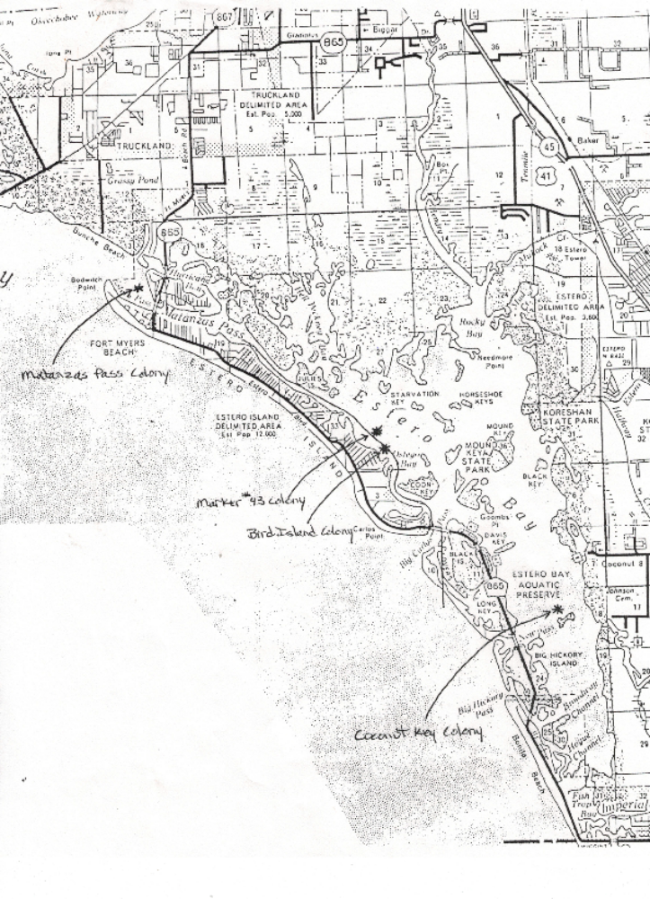Appendix 1: Historic map noting the locations of rookery monitoring carried out by the Audubon Society. From this study, both Matanzas Pass and Coconut Point East were marked with ‘closed’ signs.
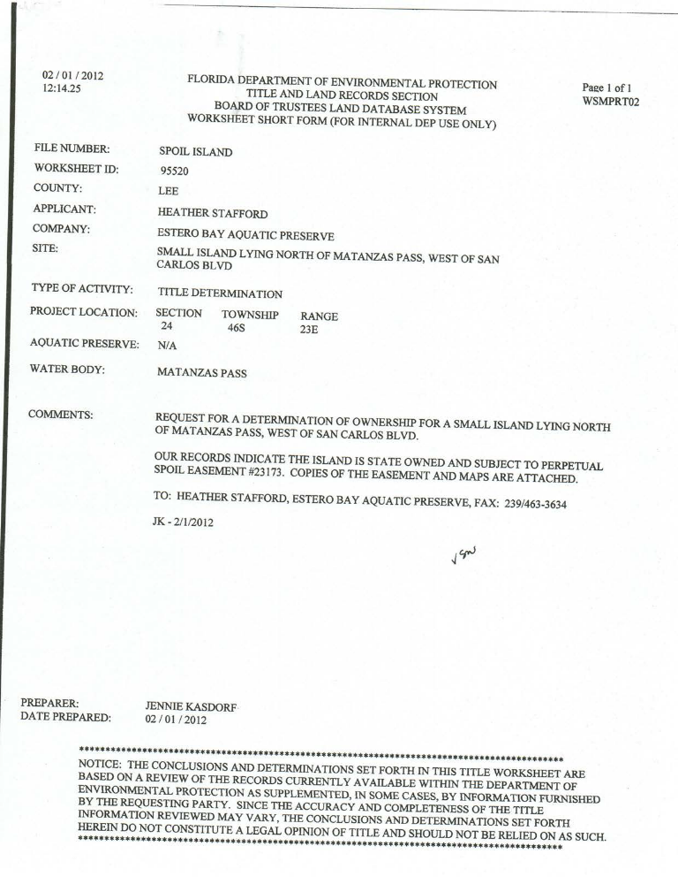
Appendix 2: EBAP’s ownership inquiry of Matanzas Pass Island and the information detailing the perpetual spoil disposal easement for this island.

Appendix 2: EBAP’s ownership inquiry of Matanzas Pass Island and the information detailing the perpetual spoil disposal easement for this island.

Spoil easement cont.
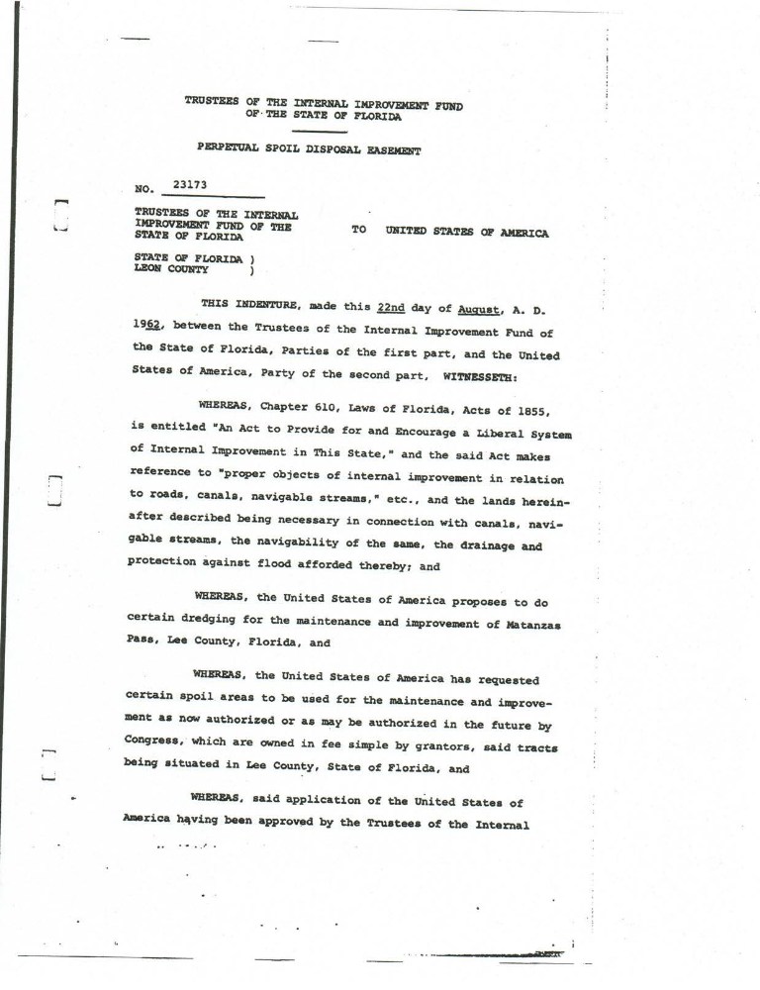
Spoil easement cont.
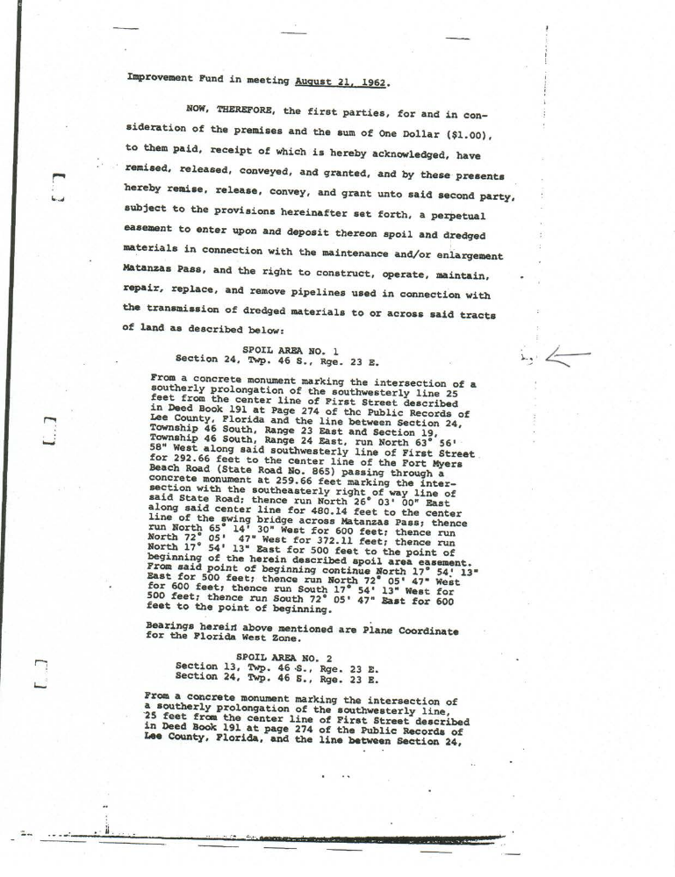
Spoil easement cont.
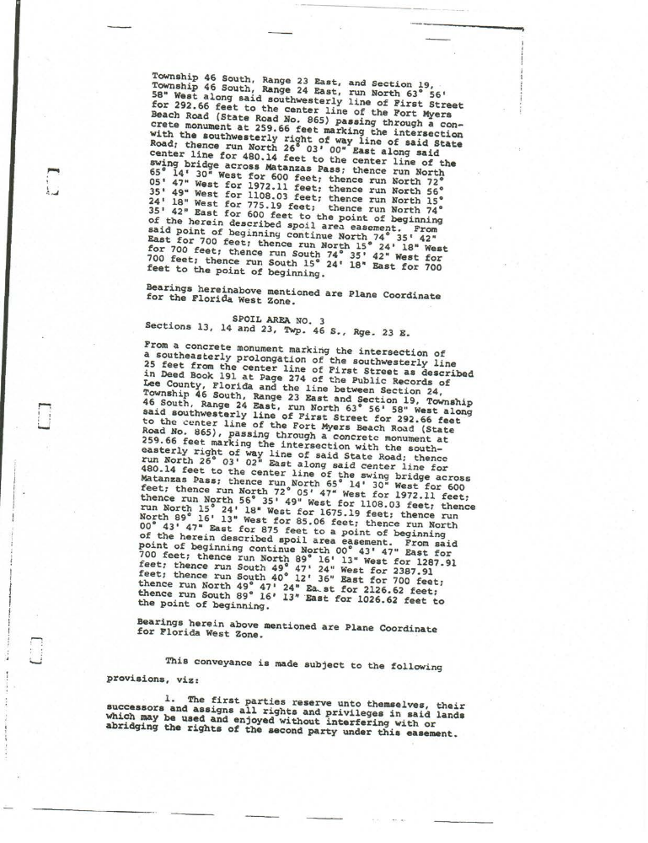
Spoil easement cont.
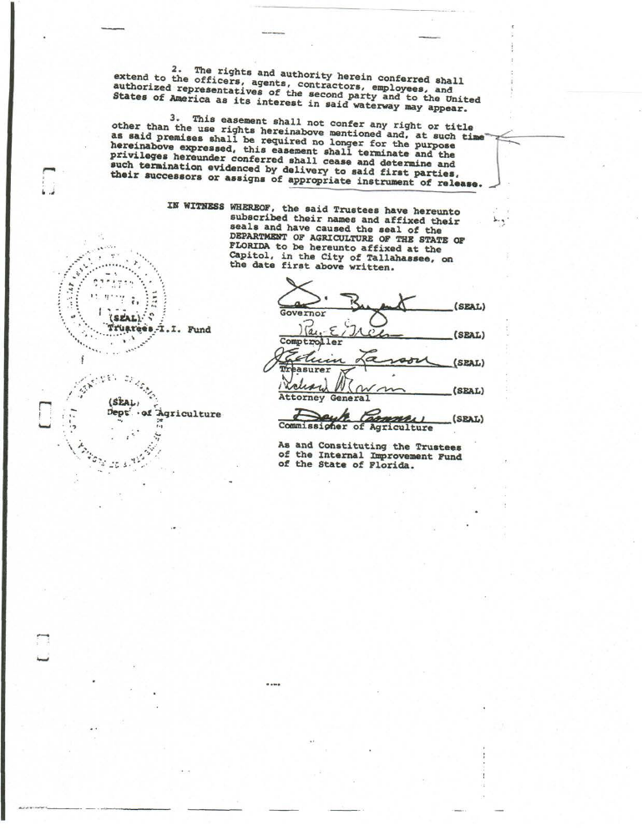
Spoil easement con
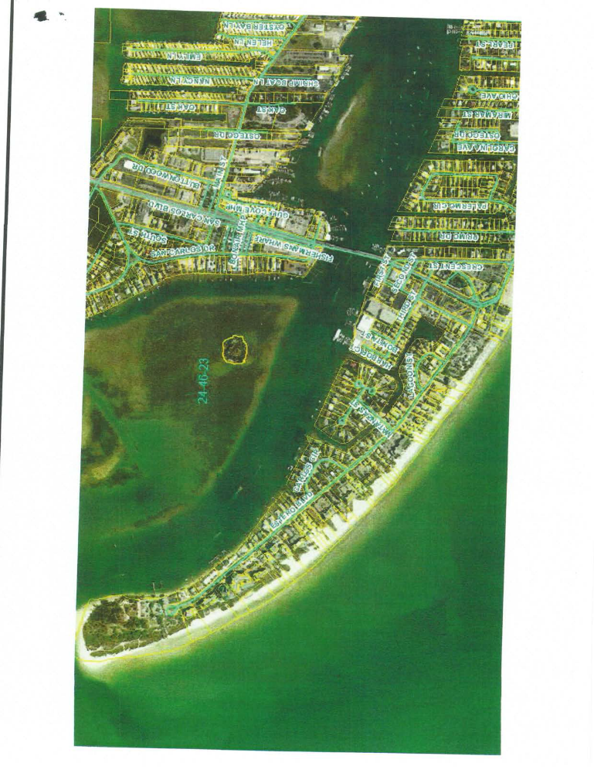
Appendix 3: Email correspondences to inquire about Coconut Island East ownership
To: <Susan_Trokey@fws.gov>
From: "Furnari, Sherry" <Sherry.Furnari@dep.state.fl.us>
Date: 11/03/2008 12:51PM
Subject: USFWS Managed Islands within Estero Bay Aquatic Preserve
Hi Susan,
So as not to confuse you, I also work here one day a week, not just with Lee Co. Conservation 20/20. I’m here working to begin updating the AP management plan and right now, I’m trying to identify other nearby conservation lands. I thought when I worked at “Ding,” there were also USFWS owned/managed islands within Estero Bay area, but I don’t see them identified within the FNAI GIS shape file or on the “Ding” website. I’m sure Richard Blackburn took us via boat into Estero Bay for rookery island monitoring & said that they were USFWS owned. I pulled up the Lee Co. PA parcels GIS shape file & it shows two Estero Bay islands/areas under USFWS (attached map-yellow locations). Is this correct, are there any other islands that you know of, and do these islands have a particular name associated with them? Does USFWS staff still perform yearly monitoring efforts for these islands? Appreciated any info you can provide.
Thanks,
Sherry Furnari
OPS Environmental Specialist I
FDEP Estero Bay Aquatic Preserve
700-1 Fisherman's Wharf
Ft. Myers Beach, FL 33931
E-mail: Sherry.Furnari@dep.state.fl.us
Phone: 239-463-3240
Fax: 239-463-3634
From: Susan_Trokey@fws.gov [mailto:Susan_Trokey@fws.gov]
Sent: Monday, November 03, 2008 1:01 PM
To: Furnari, Sherry
Subject: Re: USFWS Managed Islands within Estero Bay Aquatic Preserve
Sherry, the County showed several parcels throughout the county as owned by the FWS that were actually owned by another agency, including the Sanibel lighthouse, FM Beach Coast Guard Station and the lighthouse at Boca Grande.
They also showed several islands in Estero Bay as being ours, but I believe they belonged to BLM. Mary Weaver at the Jackson Mississippi office of BLM confirmed that. I had contacted the county several years back to get all the properties assigned over to the proper entities. We should not have any properties in or near the Estero Bay Buffer or Aquatic Preserves.
Take care, talk to you soon. Susan

From: Furnari, Sherry
Sent: Monday, November 10, 2008 1:43 PM
To: 'Mary_Weaver@blm.gov'
Subject: FW: USFWS Managed Islands within Estero Bay Aquatic Preserve
Hi Mary,
Susan Trokey (USFWS-J.N. “Ding” Darling NWR) recommend that I correspond with you about this. I’m trying to establish where other conservation lands are within/adjacent to the Estero Bay Aquatic Preserve to include in our management plan. There were a couple of islands within the bay that still show up under USFWS, but apparently your agency has them under ownership/management. Are there names associated with the groups of islands? Do they fall under a regional management/conservation plan for the federal government that may offer an extra layer of protection? Are there additional federally managed areas within Estero Bay that aren’t highlighted on the attached map?
Over the years, there has been intermittent rookery monitoring surveys in the bay. Over the past year, our office staff now regularly performs these surveys and hopes to continue with this monitoring effort. Just FYI, the southern set of “highlighted” island(s) have long been associated as a bird rookery. Some of the species noted nesting there recently include: double-crested cormorant, brown pelican, osprey, anhinga, and black-crowned night heron.
I appreciate any information you can provide,
Sherry Furnari
OPS Environmental Specialist I
FDEP Estero Bay Aquatic Preserve
700-1 Fisherman's Wharf
Ft. Myers Beach, FL 33931
E-mail: Sherry.Furnari@dep.state.fl.us
Phone: 239-463-3240
To<Duane_Winters@blm.gov>,11/17/2008 07:28 AM cc<Faye_Winters@blm.gov>
Subject: FW: USFWS Managed Islands within Estero Bay Aquatic Preserve

Hi Duane & Faye,
I tried sending this to Mary Weaver, but apparently she doesn’t work there anymore since my email was sent back not received. Susan said that maybe either one of you would be able to answer my questions for me. Please see attached email.
Thanks,
Sherry

Fax: 239-463-3634
Forwarded by Duane Winters/JFO/ES/BLM/DOI on 12/09/2008 01:14 PM
DuaneWinters/JFO/ES/BLM/DOI
To "Furnari, Sherry"12/04/2008 09:32 <Sherry.Furnari@dep.state.fl.us>
Subject: Re: FW: USFWS Managed Islands within Estero Bay Aquatic Preserve (Document link: Duane Winters)

Apologies for my delay in responding to you. I can't get a fix on the location of these islands. Do you have these islands on a map that has the public land survey grid?
Duane Winters, Supervisory Natural Resource Program Specialist
Phone: (601) 977-5403
FAX: (601) 977-5440
Duane_Winters@blm.gov
From: Duane_Winters@es.blm.gov [mailto:Duane_Winters@es.blm.gov]
Sent: Tuesday, December 09, 2008 2:21 PM
To: Furnari, Sherry
Cc: Vicky_Craft@es.blm.gov
Subject: Fw: USFWS Managed Islands within Estero Bay Aquatic Preserve
If you are able to find the additional information (see below) please send it to Ms. Craft as I will be out of the office until mid January.
Duane Winters, Supervisory Natural Resource Program Specialist
Phone: (601) 977-5403
FAX: (601) 977-5440
Duane_Winters@blm.gov
From: Furnari, Sherry"<Sherry.Furnari@d.state.fl.us>
Sent: Monday, December 15, 2008 4:44 PM
To: 'Kimberly_Eldridge@fws.gov'
Subject: FW: USFWS Managed Islands within Estero Bay Aquatic Preserve
Hi Kimberly,
You can refer back to my attached emails.
I spoke with Susan Trokey again earlier today & she spoke with Leon, who said to contact you regarding the "public land survey grid." I have ArcMap GIS 9.3, so if you have the shapefile you can send me, I can overlay it onto my map & send it back out to Ms. Craft & Mr. Winter. I've re-attached the original map I send to Mr. Winter (USFWS_islands) in case that helps any and just included another one that shows the conservation lands near Estero Bay (USFWS_BLM_islands). Just ignore the "hot pink" areas to the west, they're associated with Sanibel Island, I'm only trying to identify the ones within Estero Bay.
Thank you,
Sherry Furnari
OPS Environmental Specialist I
FDEP Estero Bay Aquatic Preserve
700-1 Fisherman's Wharf
Ft. Myers Beach, FL 33931
E-mail: Sherry.Furnari@dep.state.fl.us
Phone: 239-463-3240
Fax: 239-463-3634
From: Furnari, Sherry"<Sherry.Furnari@d.state.fl.us>
To<Kimberly_Eldridge@fws.gov>,02/02/2009 11:34 AM cc<Duane_Winters@blm.gov>, <Vicky_Craft@es.blm.gov>
Subject: FW: USFWS Managed Islands within Estero Bay Aquatic Preserve
To whom it may concern:
I still haven't received an answer back as to what/if any federal agency oversees these islands and if they are named. I was informed that BLM owned/managed them, but maybe that's not really the case. I never received an overlay for the "public land survey grid," so I'm not sure what more I can do, but provide another map with Lat/Lon for each of the unknown islands (USFWS_blm_ISLAND_lat_lon). Perhaps I haven't received your response because the state's email connection has been up/down going through system updates for the last 2 weeks and your email was lost? Is there another agency I should direct this question to since I don't have this "public land survey grid"? Would it help if I sent a map showing Lee County's Section/Township/Range information?
Sherry Furnari
OPS Environmental Specialist I
FDEP Estero Bay Aquatic Preserve
700-1 Fisherman's Wharf
Ft. Myers Beach, FL 33931
E-mail: Sherry.Furnari@dep.state.fl.us
Phone: 239-463-3240
Fax: 239-463-3634
From: Duane_Winters@es.blm.gov [mailto:Duane_Winters@es.blm.gov]
Sent: Monday, February 02, 2009 1:12 PM
To: Furnari, Sherry
Cc: Duane_Winters@blm.gov; Kimberly_Eldridge@fws.gov; Vicky_Craft@es.blm.gov
Subject: Re: FW: USFWS Managed Islands within Estero Bay Aquatic Preserve
Yes, a map with Section/Township/Range is what we need. That is what I meant by the "public land survey grid."
Duane Winters, Supervisory Natural Resource Program Specialist
Phone: (601) 977-5403
FAX: (601) 977-5440
Duane_Winters@blm.gov
Sherry,
After a very long and careful review of our plats of surveys and patent information stored on our GLO Database we are pretty certain that the island identified on your map as (36-46-24-00-00002.0000) and the Island now known as Key Mount were both patented out of federal ownership on
November 9, 1891 to Frank M. Johnson. Please see the attached patent Number 9353 that shows both island have left federal ownership. Now any subsequent conveyance of these islands are not maintained by our office.
It would have been almost impossible to derive at the above information without the invaluable assistance of our GIS Specialist, who had fortunately collected some of Lee County's GIS data layer, as part of our RMP effort which allowed us to overlay the land grid to determine the township and range and section of the first island. It was determined that the Island is in T. 46 S. R. 24 E., sec 36. Now, where we have run into problems are with the second island, which appears to be in T. 47 S.
, R. 25 E. section 18. When trying to overlay this data with our GIS layers. The T. and R. for this island cannot be identified. It appears that this island may not have been surveyed or is the remainder of what was once a larger island. We have looked at our plat of survey, dated 1876 for the islands near that area; such as the (Black Island). None of the islands that were surveyed during that time has and resemblance of the island that is depicted as (18-47-25-B4-0004.0000). Therefore, I have included Nate Felton from our state office on this email and I will be requesting that a Tract Book search be performed on T. 47 S. R. 25 E., Sect. 18 to see if any additional information can be located to reach a determination of this island.
(See attached file: Land Patent Image - Frank Johnson-Key MountF%5F%2E183 - GLO REcords.mht)
Nate,
Please research the Tract Book for T. 47 S., R. 25 E, Sect. 18 and see if any patents been issued in this area. Also, please see Sherry's attached map at the bottom of the page for reference. Thanks
Nate

Appendix 4: Draft Best Management Practices recognition system for a FCO education program to engage stakeholders
Recognition Level | Category | Color | Best Management Practice
1 | Resource Management and Respect | 1 | Build environmental and cultural awareness and respect
1 | Resource Management and Respect | 1 | Contribute to the conservation of the natural areas and natural resources of the region
1 | Resource Management and Respect | 1 | Adhere to “leave no trace” and "Pack In, Pack Out" policies
1 | Resource Management and Respect | 1 | Active staff involvement in minimizing environmental impacts
1 | Resource Management and Respect | 1 | Dependent on the vendor used
1 | Resource Management and Respect | 1 | Never remove native plant or animal life from the area
1 | Resource Management and Respect | 1 | Program will be used to benefit or enhance the conservation and preservation efforts in the area
1 | Reduction of Carbon Foot Print | 2 | Recycling of Paper/plastics/monofilament
1 | Stakeholder and Community Engagement | 3 | Employ members of the community to stimulate the local economy
1 | Interpretation | 4 | Provide positive interpretations for both visitors and hosts
1 | Interpretation | 4 | Conduct mid tour educational briefings (Plants, wildlife, surroundings)
1 | Interpretation | 4 | Hire and train operators with local knowledge of the environmental considerations and concerns for the area
1 | Interpretation | 4 | All eco-tour activities within or very near Florida’s Aquatic Preserve network will include 3 statements about the value of the APs
1 | Interpretation | 4 | Eco-tourist Pledge Cards (name pending) To encourage further stewardship
1 | Interpretation | 4 | Operators require patrons to watch educational videos (where available/applicable)
1 | Operations Logistics | 5 | Creation of emergency action plans for each eco-tour offered
1 | Operations Logistics | 5 | Hurricane/Storm Preparation Plan
1 | Operations Logistics | 5 | Meet FWCC Livery Standards when applicable
1 | Operations Logistics | 5 | Meet all Insurance Requirments
1 | Operations Logistics | 5 | Operation is consistent with all applicable Local, State and Federal Laws
1 | Be a Good Host | 6 | Enlist in and make use of the Visit Florida Program
Category | Color
Resource Management and Respect | 1
Reduction of Carbon Foot Print | 2
Stakeholder and Community Engagement | 3
Interpretation | 4
Operations logistics | 5
Be a Good Host | 6
Please note: The development of this Ecotourism Best Management Practices program is its early stages. This is a draft of potential requirements to gain ecotourism recognition through DEP. The ‘Recognition’ column indicates the level each best management practice represents [Levels 1 (least) -3 (most)]. Each color represents a specific category (1-5) for each management practice.

Please note: The development of this Ecotourism Best Management Practices program is its early stages. This is a draft of potential requirements to gain ecotourism recognition through DEP. The ‘Recognition’ column indicates the level each best management practice represents [Levels 1 (least) -3 (most)]. Each color represents a specific category (1-5) for each management practice.
Recognition Level | Category | Color | Best Management Practice
2 | Resource Management and Respect | 1 | Limit use to designated trails and tracks to ensure minimal disturbance to the ecosystem
2 | Resource Management and Respect | 1 | Operator reads and signs off on local managements strategies to minimize negative environmental impacts
2 | Reduction of Carbon Foot Print | 2 | Use of ecological and biodegradable products wherever possible
2 | Reduction of Carbon Foot Print | 2 | Recycling of oil (if applicable)
2 | Stakeholder and Community Engagement | 3 | Promote local businesses that actively support the environment
2 | Stakeholder and Community Engagement | 3 | Involve the local communities and make them aware of the conservation efforts and the benefits to be realized
2 | Interpretation | 4 | Consistently meet client and community expectations
2 | Interpretation | 4 | Each activity will provide a unique experience
2 | Operations Logistics | 5 | Evaluate programs and procedures to incorporate up-to-date knowledge and practices
2 | Operations Logistics | 5 | Display certification placard/sticker on tour vessels and within place of business
2 | Be a Good Host | 6 | Accurate marketing, leading to realistic expectations of the program
3 | Resource Management and Respect | 1 | Organization of local site clean ups and promotion of environmental stewardship
3 | Reduction of Carbon Foot Print | 2 | Encourage sustainable means of transportation
3 | Stakeholder and Community Engagement | 3 | Unite conservation, communities and sustainable travel (Clean Marinas, Green Lodging)
3 | Stakeholder and Community Engagement | 3 | Provide constructive and ongoing contributions to the local communities
3 | Interpretation | 4 | Raise sensitivity to the political, environmental and social climate (more for an International tour program)
3 | Building/Infrastructure Design Standards | 5 | Use of permeable sidewalks, driveways and parking areas where applicable
3 | Operations Logistics | 5 | Require all staff to attend continuing education (lectures, classes, ride-alongs)
3 | Be a Good Host | 6 | ADA accommodations when applicable
3 | Be a Good Host | 6 | Make best efforts to accommodate patrons from foreign countries to ensure an overall positive experience
3 | Be a Good Host | 6 | Provide information in many different languages (at least 3)

Appendix 5: Matrix detailing Goals, Objectives, and Strategies and the associated time, cost, and possible funding
Goals, Objectives,  and Strategies | Activity | Partners | Time | Cost | Possible Funding  Source | Follow Up
Goal 1 | Protect Wading and Diving Birds in Estero Bay
Objective 1 | Education and Outreach
Strategy 1 | Continue current management programs and expand these programs as funding allows (ie: resource monitoring, fishing line clean-ups, educational programs). | DEP, EBB | Continuous | In House | DEP, CZMA | As technologies advance and funding allows, programs may be expanded
Strategy 2 | Expand RBNERR's Team Ocean program | DEP, local municipalities, SeaGrant, FWC | 1 year; continuous | 40,000 | DEP, CZMA | EBAP will coordinate with the Coastal Training Program Coordinator at RBNERR to expand this program. EBAP will also consult with those involved in the Hillsborough County's Weekend Warrior program (Ann Paul and Mark Rachal). The time reflects the amount of time necessary to fully implement the program once funding is acquired. From then on, the program will be led by EBAP staff on a continuous bases. The cost reflects the annual cost to staff a coordinator for this program.

Goals, Objectives,  and Strategies | Activity | Partners | Time | Cost | Possible Funding  Source | Follow Up
Strategy 3 | Collaborate with the local community to increase educational programs for ecotour operators | DEP, LCPS, Local Operators | 6 months- 1 year | $3,000 | DEP, EBB, CZMA | This could include: creating quality educational videos to promote boating practices specific to reducing disturbance to both nesting birds and their habitat. The time reflects the initial time needed to establish a program/create media. After establishment, EBAP staff will re-evaluate such programs every 3 years. EBAP is in communication with Biscayne Bay Aquatic Preserve, who has experience creating such videos. Contact information received for the local company that produced their educational video: Paradise Key Media
Strategy 4 | Work to air existing and create new PSAs | DEP, Local municipalities | 6 months- 1 year | $8,000 | DEP, Local municipalities | Work with local municipalities to air PSAs. Cost reflects the estimated cost of producing a short video to be aired for up to 1 year.
Strategy 5 | Create and/or collaborate with an incentive program for local operators | DEP, Local Operators | 6 months-1 year | 15,000 | DEP, EBB, CZMA | EBAP will explore options of collaborating with the FCO BMP program and/or the Florida SEE program. Time reflects the time to set up a collaborative effort after funding is allocated. Cost reflects the amount of money needed to bring on staff to complete tasks.
Objective 2 | Implement enforceable protections for wading and diving birds in Estero Bay

Goals, Objectives,  and Strategies | Activity | Partners | Time | Cost | Possible Funding  Source | Follow Up
Strategy 1 | State Park Boundary Signs | DEP, EBPSP, FWC | 6 months | Dependent on sign plan | DEP | EBAP provides evidence of a significant aggregation of sensitive species and high levels of disturbance on 1 state park managed island: islands in Estero Bay: Big Carlos M-52. EBAP has also documented high levels of disturbance (ie: camping and mangrove cutting) on Big Carlos M-43. These islands are accessible and manageable. With EBPSP cooperation, boundary signs will address these Issues. Time reflects amount of time needed to collaborate and install signage.
Strategy 2 | Create CWAs in Estero Bay | DEP, FWC | 8- 9 months | Dependent on sign plan | DEP, FWC, Lee County | EBAP provides evidence of a significant aggregation of sensitive species and high levels of disturbance on 3 islands in Estero Bay: Matanzas Pass, Big Carlos M-52 (if marking with EBPSP is unsuccessful), and Coconut Point East. These islands are accessible and manageable. EBAP must obtain approval from the landowners prior to designation. Supported by the literature, EBAP recommends a 100m buffer.

Nn jhjfgh

All statistical operations were performed using R© (Ver 3.1.2, R Foundation for Statistical Computing, Vienna Austria) with the critical level of significance was set at α = 0.05.
All statistical operations were performed using R© (Ver 3.1.2, R Foundation for Statistical Computing, Vienna Austria) with the critical level of significance was set at α = 0.05. Thank you Thank you to Paul Julian with the Florida Department of Environmental Protection Office of Ecosystem Projects for completing data analysis for the 2009-2014 data.

